|  |
| --- |
| **2021**  **E-Project**  [Kitchen-Ware]  Aptech Computer Education |
| **Submitted By**  Ammarah Asif  Hiba Adnan  TASHA KITCHEN-WARE  **Project Instructor**  Sir Talha Qureshi  **Submitted To**  [eprojects@aptech.ac.in](mailto:eprojects@aptech.ac.in) |



**Curriculum Code**

6740

Content

**Table of Content**

Project Certification 3

ACKNOWLEDGMENT 4

WELCOME TO “Kitchen-Ware”4

PROBLEM STATEMENT 5

REQUIREMENT SUMMARY **9**

TASK SHEET **10**

Site Map 11

LIST OF VALIDATION 10

SUBMISSION CHECKLIST 9

**This is to certify that,**

**Ms.**

**Ammarah Asif, Enrollment no.1320093**

**Hiba Adnan, Enrollment no.1320091**

**Has successfully Designed & Developed:**

**KITCHEN-WARE**

**Submitted by: Ammarah Asif and Hiba Adnan.**

**Date of Issue: 18-Nov-2021**

Project Certification

Welcome To

Tasha Kitchen-Ware

**Problem Statement**

**TASHA**- the home store is Branded Company famous for home kitchen appliances. It provides collection of n number of appliances with different category to match the fast life of the generation. The Tasha group of companies had made huge profit in the year 2013. In order to enhance its business the organization wants you to develop the website.

Requirement Specification:

The Web site is to be created based on the following requirements.

1) The Home page must include images with slide show and links for navigation.

2) Proper template must be designed for the website, few section of the webpage can be included to show or advertise the upcoming products.

3) Categories like Cookware, Refrigeration, Appliances, food storage, Knives and tools, Laundry and other accessories

4) List such as:

- Cookware:

i. Cooking pots

ii. Cooking Pans

iii. Frying Pans

iv. Cookware Sets

v. Handis

vi. Kadais [Karahi]

vii. Grill pans

viii. Tawas

ix. Egg Poachers

x. Steamers

- Refrigeration

i. Freezers

ii. Refrigerators

- Appliances

i. Blenders

ii. Bread Makers

iii. Coffee Makers

iv. Ice-Cream and sorbet makers

v. Electric Kettles

vi. Food Choppers

vii. Toasters

- Food Storage

i. Flask

ii. Spice Jars

iii. Storage Bags

iv. Lunch Boxes

v. Vacuum bottles. And so on

5) Support Link can be added for proving aid services such as

- Manuals

- Expert Tips

- Register Complain

- Feedback

- Contact

6) Store Locators: must display the address location of all the branches available.

7) Navigation of the project must be made precise and uniformity must be maintained.

**Hardware/ Software Requirements**

Hardware

* A minimum computer system that will help you access all the tools in the courses is a Pentium 166 or better
* 64 Megabytes of RAM or better

Software

* Notepad/HTML editor
* Dreamweaver
* IE 5.0/ Netscape 6.0

**Project Duration**

1. Analysis-18 Hrs.
2. Design – 22 Hrs.
3. Development –20Hrs
4. Testing – 12 Hrs.
5. Documentation -11 hrs.

|  |  |  |  |  |  |  |  |  |  |  |  |  |  |  |  |  |  |  |  |  |  |  |  |  |  |  |
| --- | --- | --- | --- | --- | --- | --- | --- | --- | --- | --- | --- | --- | --- | --- | --- | --- | --- | --- | --- | --- | --- | --- | --- | --- | --- | --- |
| 23 | 24 | 25 | 26 | 27 | 28 | 29 | 30 | 31 | 1 | 2 | 3 | 4 | 5 | 6 | 7 | 8 | 9 | 10 | 11 | 12 | 13 | 14 | 15 | 16 | 17 | 18 |

ANALYSIS

DESIGN

TESTING

DEVELOPMENT

DOCUMENTATION

TASK SHEET

**TASK SHEET**

|  |  |  |  |  |  |
| --- | --- | --- | --- | --- | --- |
| **No.** | **Task** | **Actual Start Date** | **Actual Days** | **Team Mate Name** | **Status** |
| 1. | Case Study | 18th Nov 2021 | 2 | Ammarah Asif  Hiba Adnan | Completed |
| 2. | Graphics Designing | 21st Nov 2021 | 5 | Ammarah Asif  Hiba Adnan | Completed |
| 3. | Site Interface Designing | 26st Nov 2021 | 3 | Ammarah Asif  Hiba Adnan | Completed |
| 4. | Material Searching | 29st Nov 2021 | 4 | Ammarah Asif  Hiba Adnan | Completed |
| 5. | Site Testing/Publishing | 3rd Dec 2021 | 4 | Ammarah Asif  Hiba Adnan | Completed |
| 6. | Documentation | 7th Dec 2021 | 2 | Ammarah Asif  Hiba Adnan | Completed |

**SITE MAP**

Home

Cookware

Refrigerator

Appliances

Food Storage

Support

Cooking Pots

Frying Pans

Cookware Sets

Egg Poachers

Grill Pans

Steamers

Refrigerators

Freezers

Blenders

Bread Makers

Coffee Makers

Ice-cream and Sorbet Makers

Electric Kettles

Food Choppers

Toasters

Flask

Spice Jars

Storage Bags

Lunch Boxes

Vacuum

Storage Containers

Manuals

Expert Tips

Register Complain

Feed Back

Contact Us

Tasha Kitchen-Ware

**LIST OF VALIDATION**

|  |  |
| --- | --- |
| Option | Validation |
| Fields in Form should not be Null | Yes |
| Hyperlinks Have Alternating Text | No |
| Search Pages | Yes |
| Homepage Has Forward Only Link | Yes |
| All Web pages have link back to Homepage | Yes |
| Request Quote Form Included | No |
| All Functions Are Compatible with Firefox | Yes |
| All Functions Are Compatible with IE | No |

**SUBMISSION CHECKLIST**

|  |  |  |  |
| --- | --- | --- | --- |
| **S.NO** | **LIST OF ITEMS** | **Remarks** | **COMMENTS** |
| 1. | Do All Pages Linked together | **Yes** |  |
| 2. | All Hyperlinks working | **Yes** |  |
| 3. | Page Colors As Per Common Guidelines | **Yes** |  |
| 4. | Site Browser Compatible | **No** | Tested in only FireFox |
| 5. | Image Slicing | **Yes** | Using Adobe Photoshop,AdobeFlash |
| 6. | Feedback Form Included | **Yes** |  |
| 7. | Project Zip File | **Yes** | Created using WinRAR |

HOME

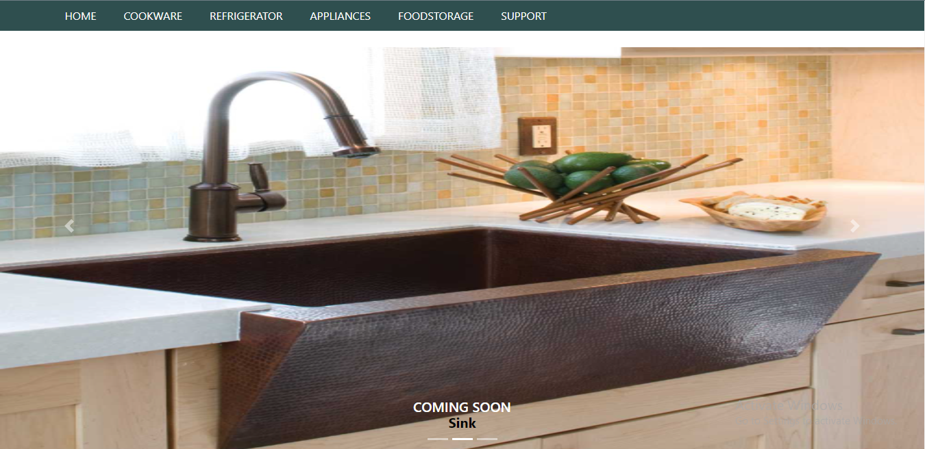

HOME

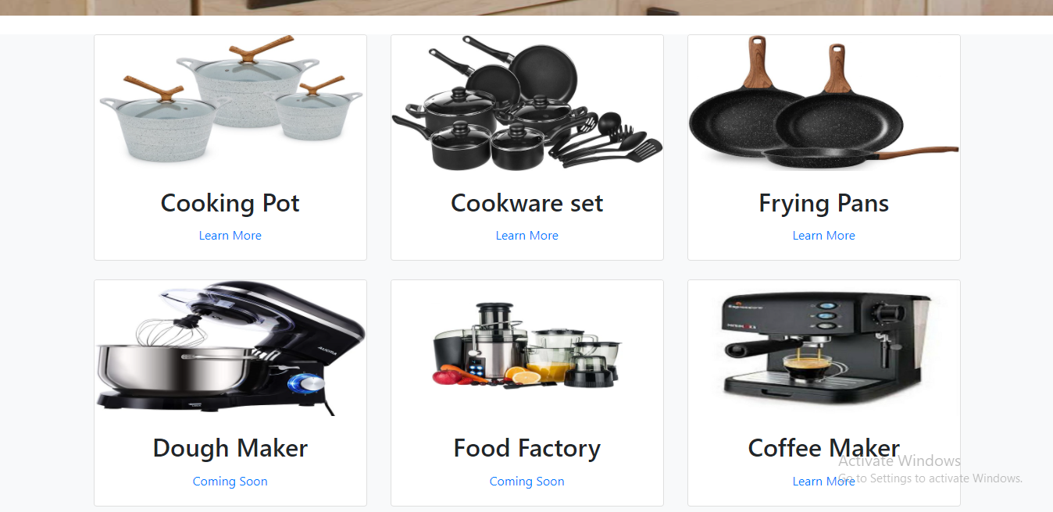

HOME

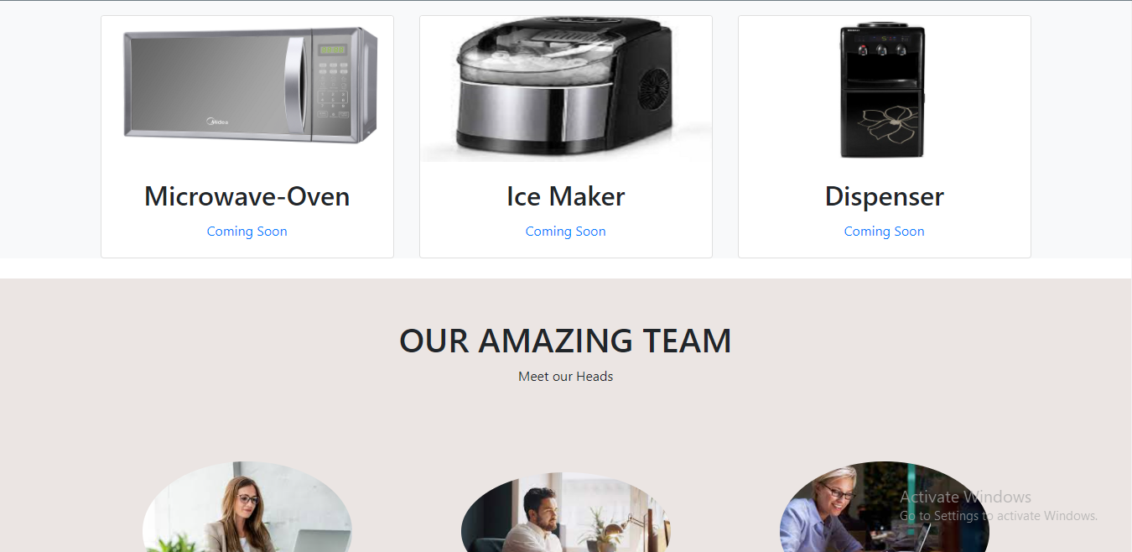

*+

HOME



HOME

HOME

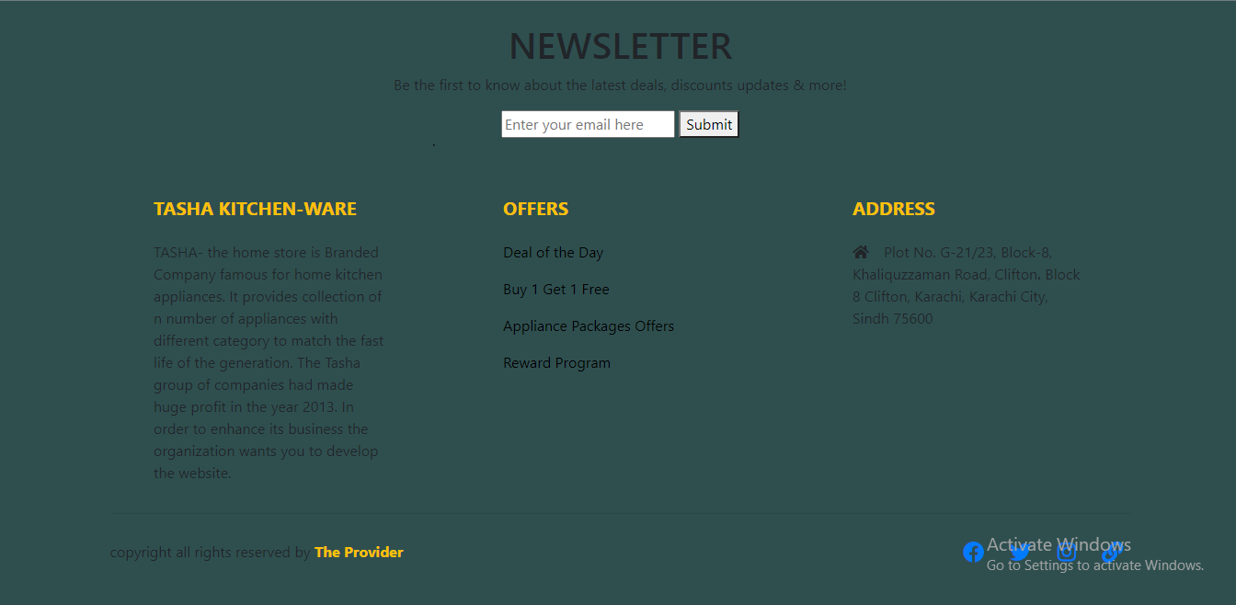

HOME CODING

<!doctype html>

<html>

<head>

<meta charset="utf-8">

<title>Untitled Document</title>

<!--CSS LINK -->

<link rel="stylesheet" type="text/css" href="CSS/Tasha.css"/>

<!-- Latest compiled and minified CSS START-->

<link rel="stylesheet" href="https://maxcdn.bootstrapcdn.com/bootstrap/4.5.2/css/bootstrap.min.css">

<!-- Latest compiled and minified CSS END-->

<!-- jQuery library START -->

<script src="https://ajax.googleapis.com/ajax/libs/jquery/3.5.1/jquery.min.js"></script>

<!-- jQuery library END-->

<!-- Popper JS START-->

<script src="https://cdnjs.cloudflare.com/ajax/libs/popper.js/1.16.0/umd/popper.min.js"></script>

<!-- Popper JS END -->

<!-- Latest compiled JavaScript START-->

<script src="https://maxcdn.bootstrapcdn.com/bootstrap/4.5.2/js/bootstrap.min.js"></script>

<!-- Latest compiled JavaScript -->

<!--Meta Link START-->

<meta name="viewport" content="width=device-width, initial-scale=1">

<!--Meta Link END-->

<!--FONT AWESOME CDN LINK-->

<link rel="stylesheet" href="https://pro.fontawesome.com/releases/v5.10.0/css/all.css" integrity="sha384-AYmEC3Yw5cVb3ZcuHtOA93w35dYTsvhLPVnYs9eStHfGJvOvKxVfELGroGkvsg+p" crossorigin="anonymous"/>

<!--FONT AWESOME CDN LINK-->

</head>

<body>

**<!--NAVIGATION BAR STARTS-->**

<header>

<ul>

<li><a href="#">HOME</a>

</li>

<li><a href="#">COOKWARE</a>

<ul>

<li><a href="links/Cooking Pot.html">Cooking Pots</a></li>

<li><a href="links/Frying Pans.html">Frying Pans</a></li>

<li><a href="links/Cookware-Sets.html">Cookware Sets</a></li>

<li><a href="links/Egg Poached.html">Egg Poachers</a></li>

<li><a href="links/grill pans.html">Grill Pans</a></li>

<li><a href="links/steamer.html">Steamers</a></li>

</ul>

</li>

<li><a href="#">REFRIGERATOR</a>

<ul>

<li><a href="links/Refrigerators.html">Refrigerators</a></li>

<li><a href="links/Freezers.html">Freezers</a></li>

</ul>

</li>

<li><a href="#">APPLIANCES</a>

<ul>

<li><a href="links/Blenders.html">Blenders</a></li>

<li><a href="links/Bread-Maker.html">Bread Makers</a></li>

<li><a href="links/Coffee-Maker.html">Coffee Makers</a></li>

<li><a href="links/Icecream-Sorbet-Maker.html">Ice-Cream and Sorbet Makers</a></li>

<li><a href="links/Kettles.html">Kettles</a></li>

<li><a href="links/Food-Chopper.html">Food Choppers</a></li>

<li><a href="links/Toaster.html">Toasters</a></li>

</ul>

</li>

<li><a href="#">FOODSTORAGE</a>

<ul>

<li><a href="links/Flask.html">Flask</a></li>

<li><a href="links/Spice-Jars.html">Spice Jars</a></li>

<li><a href="links/Storage-Bags.html">Storage Bags</a></li>

<li><a href="links/Lunch-Boxes.html">Lunch Boxes</a></li>

<li><a href="links/Storage-Containers.html">Storage Containers</a></li>

</ul>

</li>

<li><a href="#">SUPPORT</a>

<ul>

<li><a href="links/Expert Tips.html">Expert Tips</a></li>

<li><a href="links/Register-Complain.html">Register Complain</a></li>

<li><a href="links/Feedback-Form.html">Feed Back</a></li>

<li><a href="links/Contact Us.html">Contact Us</a></li>

</ul>

</li>

</ul>

</header>

**<!--NAVIGATION BAR ENDS-->**

<br/>

**<!--SLIDER STARTS-->**

<div id="carouselExampleCaptions" class="carousel slide " data-ride="carousel">

<ol class="carousel-indicators">

<li data-target="#carouselExampleCaptions" data-slide-to="0" class="active" style="color: black;"></li>

<li data-target="#carouselExampleCaptions" data-slide-to="1" style="color: black;"></li>

<li data-target="#carouselExampleCaptions" data-slide-to="2" style="color: black;"></li>

</ol>

<div class="carousel-inner">

<div class="carousel-item active" style="background-color: burlywood;">

<img src="Images/7.png" style="width:1200px; height:600px;" class="d-block w-100" alt="...">

<div class="carousel-caption d-none d-md-block">

<h5 style=" font-weight: 50%; margin-bottom: -4px">COMING SOON</h5>

<p style="font-weight: 50%; color: black; font-weight: bold;font-size: 20px; margin-bottom: -3px">Counter-Top Stove</p>

</div>

</div>

<div class="carousel-item">

<img src="Images/13.jpg" style="width:700px; height:600px;" class="d-block w-100" alt="...">

<div class="carousel-caption d-none d-md-block">

<h5 style=" font-weight: 50%; margin-bottom: -4px">COMING SOON</h5>

<p style="font-weight: 50%; color: black; font-weight: bold; font-size: 20px; margin-bottom: -3px">Sink</p>

</div>

</div>

<div class="carousel-item" >

<img src="Images/12.jpg" style="width:800px; height:600px;" class="d-block w-100" alt="...">

<div class="carousel-caption d-none d-md-block">

<h5 style="color: black; font-weight: 50%; margin-bottom: -4px">COMING SOON</h5>

<p style="font-weight: 50%; color: black; font-weight: bold; font-size: 20px;margin-bottom: -3px;">Microwave Oven</p>

</div>

</div>

</div>

</div>

<a class="carousel-control-prev" href="#carouselExampleCaptions" role="button" data-slide="prev">

<span class="carousel-control-prev-icon" aria-hidden="true"></span>

<span class="sr-only">Previous</span>

</a>

<a class="carousel-control-next" href="#carouselExampleCaptions" role="button" data-slide="next">

<span class="carousel-control-next-icon" aria-hidden="true"></span>

<span class="sr-only">Next</span>

</a>

</div>

<br/>

**<!--SLIDER ENDS-->**

**<!—IMAGES STARTS-->**

<section class="portfolio bg-light">

<div class="container text-center">

<div class="row">

<!--FIRST IMAGE-->

<div class="col-lg-4 col-md-4 col-sm-12 col-10 d-block m-auto">

<div class="card">

<img src="Images/14.jpg" class="card-img img-fluid"/>

<div class="card-body">

<h2 class="card-title">Cooking Pot</h2>

<p class="card-text"><a href="links/Cooking Pot.html">Learn More</a></p>

</div>

</div>

</div>

<!--SECOND IMAGE-->

<div class="col-lg-4 col-md-4 col-sm-12 col-10 d-block m-auto">

<div class="card">

<img src="Images/24.jpg" class="card-img img-fluid"/>

<div class="card-body">

<h2 class="card-title">Cookware set</h2>

<p class="card-text"><a href="links/Cookware-Sets.html">Learn More</a></p>

</div>

</div>

</div>

<!--THIRD IMAGE-->

<div class="col-lg-4 col-md-4 col-sm-12 col-10 d-block m-auto">

<div class="card">

<img src="Images/16.jpg" class="card-img img-fluid"/>

<div class="card-body">

<h2 class="card-title">Frying Pans</h2>

<p class="card-text"><a href="links/Frying Pans.html">Learn More</a></p>

</div>

</div>

</div>

</div>

<br/>

<!--SECOND ROW-->

<div class="row">

<!--FIRST IMAGE-->

<div class="col-lg-4 col-md-4 col-sm-12 col-10 d-block m-auto">

<div class="card">

<img src="Images/1.jpg" class="card-img img-fluid"/>

<div class="card-body">

<h2 class="card-title">Dough Maker</h2>

<p class="card-text"><a href="#">Coming Soon</a></p>

</div>

</div>

</div>

<!--SECOND IMAGE-->

<div class="col-lg-4 col-md-4 col-sm-12 col-10 d-block m-auto">

<div class="card">

<img src="Images/19.png" class="card-img img-fluid"/>

<div class="card-body">

<h2 class="card-title">Food Factory</h2>

<p class="card-text"><a href="#">Coming Soon</a></p>

</div>

</div>

</div>

<!--THIRD IMAGE-->

<div class="col-lg-4 col-md-4 col-sm-12 col-10 d-block m-auto">

<div class="card">

<img src="Images/20.jpeg" class="card-img img-fluid"/>

<div class="card-body">

<h2 class="card-title">Coffee Maker</h2>

<p class="card-text"><a href="links/Coffee-Maker.html">Learn More</a></p>

</div>

</div>

</div>

</div>

<br/>

<!--THIRD ROW-->

<div class="row">

<!--FIRST IMAGE-->

<div class="col-lg-4 col-md-4 col-sm-12 col-10 d-block m-auto">

<div class="card">

<img src="Images/8.png" class="card-img img-fluid"/>

<div class="card-body">

<h2 class="card-title">Microwave-Oven</h2>

<p class="card-text"><a href="#">Coming Soon</a></p>

</div>

</div>

</div>

<!--SECOND IMAGE-->

<div class="col-lg-4 col-md-4 col-sm-12 col-10 d-block m-auto">

<div class="card">

<img src="Images/22.jpg" class="card-img img-fluid"/>

<div class="card-body">

<h2 class="card-title">Ice Maker</h2>

<p class="card-text"><a href="#">Coming Soon</a></p>

</div>

</div>

</div>

<!--THIRD IMAGE-->

<div class="col-lg-4 col-md-4 col-sm-12 col-10 d-block m-auto">

<div class="card">

<img src="Images/23.jpg" class="card-img img-fluid"/>

<div class="card-body">

<h2 class="card-title">Dispenser</h2>

<p class="card-text"><a href="#">Coming Soon</a></p>

</div>

</div>

</div>

</div>

</div>

</section>

**<!--IMAGES ENDS-->**

<br/>

**<!--OUR TEAM STARTS-->**

<section class="ourteam" style="background-color: #EBE5E3; ">

<br>

<br>

<div class="container text-center">

<h1>OUR AMAZING TEAM</h1>

<p>Meet our Heads</p><br>

<div class="row teamsetting" style="margin-top: 50px;">

<!--FIRST IMAGE-->

<div class="col-lg-4 col-md-4 col-sm-12 col-10 d-block m-auto">

<figure class="figure">

<img src="Images/2.jpg" class="figure-img img-fluid rounded-circle" height="250px" width="250px">

<figcaption>

<h4>Kay Garland</h4>

<p class="figure-caption">CEO</p>

</figcaption>

</figure>

</div>

<!--SECOND IMAGE-->

<div class="col-lg-4 col-md-4 col-sm-12 col-10 d-block m-auto">

<figure class="figure">

<img src="Images/3.jpg" class="figure-img img-fluid rounded-circle" height="250px" width="250px">

<figcaption>

<h4>Musa Khan</h4>

<p class="figure-caption">Executive Head</p>

</figcaption>

</figure>

</div>

<!--THIRD IMAGE-->

<div class="col-lg-4 col-md-4 col-sm-12 col-10 d-block m-auto">

<figure class="figure">

<img src="Images/4.jpg" class="figure-img img-fluid rounded-circle" height="250px" width="250px">

<figcaption>

<h4>Rachel Robinson</h4>

<p class="figure-caption">Head</p>

</figcaption>

</figure>

</div>

<!--FOURTH IMAGE-->

<div class="col-lg-4 col-md-4 col-sm-12 col-10 d-block m-auto">

<figure class="figure">

<img src="Images/7.jpg" class="figure-img img-fluid rounded-circle" height="250px" width="250px">

<figcaption>

<h4>Hailey Cruise</h4>

<p class="figure-caption">Senior Manager</p>

</figcaption>

</figure>

</div>

<!--FIFTH IMAGE-->

<div class="col-lg-4 col-md-4 col-sm-12 col-10 d-block m-auto">

<figure class="figure">

<img src="Images/5.jpg" class="figure-img img-fluid rounded-circle" height="250px" width="250px">

<figcaption>

<h4>James Charles</h4>

<p class="figure-caption">Junior Manager</p>

</figcaption>

</figure>

</div>

<!--SIXTH IMAGE-->

<div class="col-lg-4 col-md-4 col-sm-12 col-10 d-block m-auto">

<figure class="figure">

<img src="Images/6.jpg" class="figure-img img-fluid rounded-circle" height="250px" width="250px">

<figcaption>

<h4>Team</h4>

<p class="figure-caption">Workers</p>

</figcaption>

</figure>

</div>

</div>

</div><br>

<br>

<br>

<br>

</section>

**<!--OUR TEAM ENDS-->**

**<!-- FOOTER STARTS -->**

<footer class=" text-black pt-5 pb-4 page-footer" style="background-color: darkslategray;">

<div class="text-center">

<h1 >NEWSLETTER</h1>

<p>Be the first to know about the latest deals, discounts updates & more!</p>

<input type="email" name="email" placeholder="Enter your email here"/>

<button type="submit" onClick="onclick" > Submit </button>

</div>

<br><br>

<div class=" container text-center text-md-left ">

<div class="row text-center text-md-left ">

<div class="col-md-3 col-lg-3 col-xl-3 mx-auto mt-3">

<h5 class="text-uppercase mb-4 font-weight-bold text-warning">TASHA Kitchen-Ware</h5>

<p>TASHA- the home store is Branded Company famous for home kitchen appliances. It provides collection of n number of appliances with different category to match the fast life of the generation. The Tasha group of companies had made huge profit in the year 2013. In order to enhance its business the organization wants you to develop the website.</p>

</div>

<div class="col-md-3 col-lg-3 col-xl-3 mx-auto mt-3" >

<h5 class="text-uppercase mb-4 font-weight-bold text-warning">OFFERS</h5>

<p><a href="#" class="text-black" style="text-decoration: none; color:black; ">Deal of the Day</a></p>

<p><a href="#" class="text-black" style="text-decoration: none;color:black;">Buy 1 Get 1 Free</a></p>

<p><a href="#" class="text-black" style="text-decoration: none;color:black;">Appliance Packages Offers</a></p>

<p ><a href="#" class="text-black" style="text-decoration: none; color:black;">Reward Program</a></p>

</div>

<div class="col-md-4 col-lg-3 col-xl-3 mx-auto mt-3">

<h5 class="text-uppercase mb-4 font-weight-bold text-warning">ADDRESS</h5>

<p>

<i class="fas fa-home mr-3"></i>Plot No. G-21/23, Block-8, Khaliquzzaman Road, Clifton، Block 8 Clifton, Karachi, Karachi City, Sindh 75600

</p>

</div>

</div>

<hr class="mb-4">

<div class="row align-items-center">

<div class="col-md-7 col-lg-8">

<p>copyright all rights reserved by <a href="#" style="text-decoration: none"><strong class="text-warning">The Provider</strong></a></p></div>

<div class="col-md-5 col-lg-4">

<div class="text-center text-md-right">

<ul class="list-unstyled list-inline">

<li class="list-inline-item">

<a href="#" class="btn-floating btn-sm text-black" style="font-size:23px;"><i class="fab fa-facebook"></i></a></li>

<li class="list-inline-item">

<a href="#" class="btn-floating btn-sm text-black" style="font-size:23px;"><i class="fab fa-twitter"></i></a></li>

<li class="list-inline-item">

<a href="#" class="btn-floating btn-sm text-black" style="font-size:23px;"><i class="fab fa-instagram"></i></a></li>

<li class="list-inline-item">

<a href="#" class="btn-floating btn-sm text-black" style="font-size:23px;"><i class="fas fa-link"></i></a></li>

</ul>

</div>

</div>

</div>

</div>

</footer>

**<!--FOOTER ENDS-->**

**<!--BOOTSTRAP JS LINK-->**

<script src="js/bootstrap.js"></script>

<script src="js/bootstrap.min.js"></script>

</body>

</html>

COOKING POTS

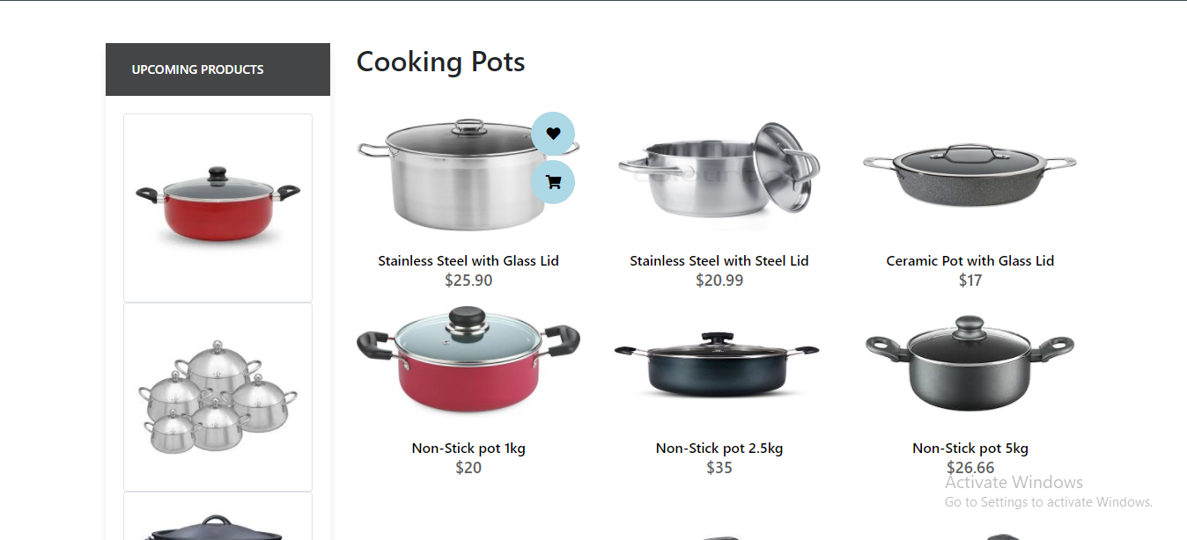

COOKING POTS

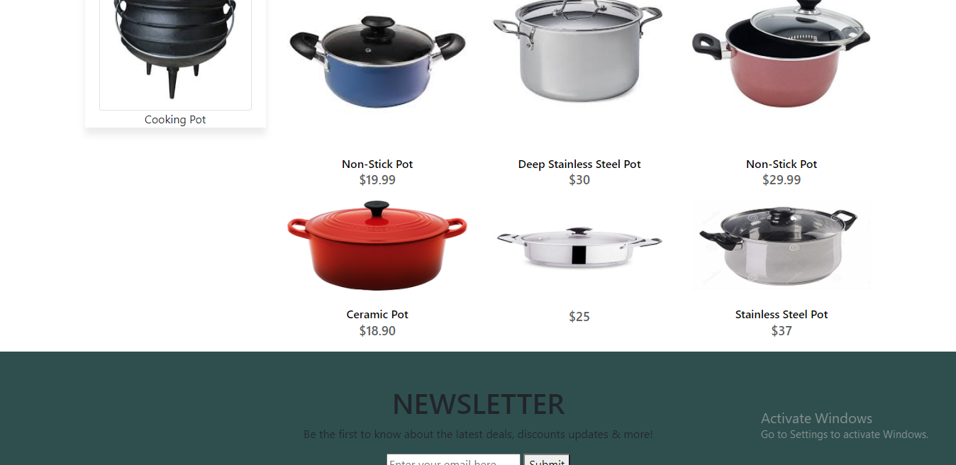

COOKING POTS



<!doctype html>

COOKING POTS CODING

<html>

<head>

<meta charset="utf-8">

<title>Untitled Document</title>

<!--CSS LINK -->

<link rel="stylesheet" type="text/css" href="../CSS/Tasha.css"/>

<link rel="stylesheet" type="text/css" href="../bootstraps/css/bootstrap.min.css"/>

<link rel="stylesheet" type="text/css" href="../bootstraps/css/bootstrap.css"/>

<link rel="stylesheet" type="text/css" href="../CSS/Links.css"/>

<!-- Latest compiled and minified CSS START-->

<link rel="stylesheet" href="https://maxcdn.bootstrapcdn.com/bootstrap/4.5.2/css/bootstrap.min.css">

<!-- Latest compiled and minified CSS END-->

<!-- jQuery library START -->

<script src="https://ajax.googleapis.com/ajax/libs/jquery/3.5.1/jquery.min.js"></script>

<!-- jQuery library END-->

<!-- Popper JS START-->

<script src="https://cdnjs.cloudflare.com/ajax/libs/popper.js/1.16.0/umd/popper.min.js"></script>

<!-- Popper JS END -->

<!-- Latest compiled JavaScript START-->

<script src="https://maxcdn.bootstrapcdn.com/bootstrap/4.5.2/js/bootstrap.min.js"></script>

<!-- Latest compiled JavaScript -->

<!--Meta Link START-->

<meta name="viewport" content="width=device-width, initial-scale=1">

<!--Meta Link END-->

<!--FONT AWESOME CDN LINK-->

<link rel="stylesheet" href="https://pro.fontawesome.com/releases/v5.10.0/css/all.css" integrity="sha384-AYmEC3Yw5cVb3ZcuHtOA93w35dYTsvhLPVnYs9eStHfGJvOvKxVfELGroGkvsg+p" crossorigin="anonymous"/>

<!--FONT AWESOME CDN LINK-->

<link rel="stylesheet" href="https://cdn.jsdelivr.net/npm/bootstrap-icons@1.6.0/font/bootstrap-icons.css" integrity="sha384-7ynz3n3tAGNUYFZD3cWe5PDcE36xj85vyFkawcF6tIwxvIecqKvfwLiaFdizhPpN" crossorigin="anonymous">

<link href="https://fonts.googleapis.com/css2?family=Open+Sans:wght@400;700&family=Poppins:wght@100;200;300;400&display=swap" rel="stylesheet">

</head>

<body>

<header>

<ul>

<li><a href="../Tasha.html">HOME</a>

</li>

<header>

<ul>

<li><a href="../Tasha.html">HOME</a>

</li>

<li><a href="#">COOKWARE</a>

<ul>

<li><a href="Cooking Pot.html">Cooking Pots</a></li>

<li><a href="Frying Pans.html">Frying Pans</a></li>

<li><a href="Cookware-Sets.html">Cookware Sets</a></li>

<li><a href="Egg Poached.html">Egg Poachers</a></li>

<li><a href="Grill-Pans.html">Grill Pans</a></li>

<li><a href="Steamer.html">Steamers</a></li>

</ul>

</li>

<li><a href="#">REFRIGERATOR</a>

<ul>

<li><a href="Refrigerators.html">Refrigerators</a></li>

<li><a href="Freezers.html">Freezers</a></li>

</ul>

</li>

<li><a href="#">APPLIANCES</a>

<ul>

<li><a href="Blenders.html">Blenders</a></li>

<li><a href="Bread-Maker.html">Bread Makers</a></li>

<li><a href="Coffee-Maker.html">Coffee Makers</a></li>

<li><a href="Icecream-Sorbet-Maker.html">Ice-Cream and Sorbet Makers</a></li>

<li><a href="Kettles.html">Kettles</a></li>

<li><a href="Food-Chopper.html">Food Choppers</a></li>

<li><a href="Toaster.html">Toasters</a></li>

</ul>

</li>

<li><a href="#">FOODSTORAGE</a>

<ul>

<li><a href="Flask.html">Flask</a></li>

<li><a href="Spice-Jars.html">Spice Jars</a></li>

<li><a href="Storage-Bags.html">Storage Bags</a></li>

<li><a href="Lunch-Boxes.html">Lunch Boxes</a></li>

<li><a href="Storage-Containers.html">Storage Containers</a></li>

</ul>

</li>

<li><a href="#">SUPPORT</a>

<ul>

<li><a href="Expert Tips.html">Expert Tips</a></li>

<li><a href="Register-Complain.html">Register Complain</a></li>

<li><a href="Feedback-Form.html">Feed Back</a></li>

<li><a href="Contact Us.html">Contact Us</a></li>

</ul>

</li>

</ul>

</header>

<!--NAVIGATION BAR ENDS-->

</header>

<!--NAVIGATION BAR ENDS-->

<!--SIDE NAVIGATOR STARTS-->

<section class="category">

<div class="container">

<div class="row">

<div class="col-lg-3">

<aside class="side-area product-side side-shadow mt-5">

<div class="side-title">

<h3>UpComing Products</h3>

</div>

<div class="side-content" style="margin: 20px;" >

<img src="../Images/230.jpg" class="img-thumbnail" alt="...">

<img src="../Images/231.jpg" class="img-thumbnail" alt="...">

<img src="../Images/232.jpg" class="img-thumbnail" alt="...">

<p style="text-align: center;">Cooking Pot </p>

</div>

</aside>

</div>

<!--SIDE NAVIGATOR ENDS-->

<!--COOKING POT STARTS-->

<div class="col-lg-9">

<div class="row">

<div class="col-lg-12">

<div class="product-top d-flex justify-content-between align-items-center" >

<div class="product-sec product-item ">

<h2 class="my-5">Cooking Pots</h2>

</div>

</div>

</div>

<div class="col-lg-4 col-sm-6">

<div class="product-cate">

<div>

<img src="../Images/31.jpg" alt="" />

<div class="product-icon">

<ul>

<li><a href=""><i class="fa fa-heart" aria-hidden="true"></i></a></li>

<li><a href="Checkout-Form.html"><i class="fa fa-shopping-cart" aria-hidden="true"></i></a></li>

</ul>

</div>

<!---->

<div class="product-des">

<h5>Stainless Steel with Glass Lid</h5>

<p>$25.90</p>

</div>

</div>

</div>

</div>

<!---->

<div class="col-lg-4 col-sm-6">

<div class="product-cate">

<div>

<img src="../Images/32.jpg" alt="pot" />

<div class="product-icon">

<ul>

<li><a href=""><i class="fa fa-heart" aria-hidden="true"></i></a></li>

<li><a href="Checkout-Form.html"><i class="fa fa-shopping-cart" aria-hidden="true"></i></a></li>

</ul>

</div>

<!---->

<div class="product-des">

<h5>Stainless Steel with Steel Lid</h5>

<p>$20.99</p>

</div>

</div>

</div>

</div>

<!---->

<div class="col-lg-4 col-sm-6">

<div class="product-cate">

<div>

<img src="../Images/33.jpg" alt="pot"/>

<div class="product-icon">

<ul>

<li><a href=""><i class="fa fa-heart" aria-hidden="true"></i></a></li>

<li><a href="Checkout-Form.html"><i class="fa fa-shopping-cart" aria-hidden="true"></i></a></li>

</ul>

</div>

<!---->

<div class="product-des">

<h5>Ceramic Pot with Glass Lid</h5>

<p>$17</p>

</div>

</div>

</div>

</div>

<!---->

<div class="col-lg-4 col-sm-6">

<div class="product-cate">

<div>

<img src="../Images/34.jpeg" alt="pot" class="img-fluid"/>

<div class="product-icon">

<ul>

<li><a href=""><i class="fa fa-heart" aria-hidden="true"></i></a></li>

<li><a href="Checkout-Form.html"><i class="fa fa-shopping-cart" aria-hidden="true"></i></a></li>

</ul>

</div>

<!---->

<div class="product-des">

<h5>Non-Stick pot 1kg</h5>

<p>$20</p>

</div>

</div>

</div>

</div>

<!---->

<div class="col-lg-4 col-sm-6">

<div class="product-cate">

<div>

<img src="../Images/35.jpg" alt="pot" />

<div class="product-icon">

<ul>

<li><a href=""><i class="fa fa-heart" aria-hidden="true"></i></a></li>

<li><a href="Checkout-Form.html"><i class="fa fa-shopping-cart" aria-hidden="true"></i></a></li>

</ul>

</div>

<!---->

<div class="product-des">

<h5>Non-Stick pot 2.5kg</h5>

<p>$35</p>

</div>

</div>

</div>

</div>

<!---->

<div class="col-lg-4 col-sm-6">

<div class="product-cate">

<div>

<img src="../Images/38.jpg" alt=""/>

<div class="product-icon">

<ul>

<li><a href=""><i class="fa fa-heart" aria-hidden="true"></i></a></li>

<li><a href="Checkout-Form.html"><i class="fa fa-shopping-cart" aria-hidden="true"></i></a></li>

</ul>

</div>

<!---->

<div class="product-des">

<h5>Non-Stick pot 5kg</h5>

<p>$26.66</p>

</div>

</div>

</div>

</div>

<!---->

<div class="col-lg-4 col-sm-6">

<div class="product-cate">

<div>

<img src="../Images/37.jpg" alt="pot" />

<div class="product-icon">

<ul>

<li><a href=""><i class="fa fa-heart" aria-hidden="true"></i></a></li>

<li><a href="Checkout-Form.html"><i class="fa fa-shopping-cart" aria-hidden="true"></i></a></li>

</ul>

</div>

<!---->

<div class="product-des">

<h5>Non-Stick Pot</h5>

<p>$19.99</p>

</div>

</div>

</div>

</div>

<!---->

<div class="col-lg-4 col-sm-6">

<div class="product-cate">

<div>

<img src="../Images/36.jpg" alt="pot"/>

<div class="product-icon">

<ul>

<li><a href=""><i class="fa fa-heart" aria-hidden="true"></i></a></li>

<li><a href="Checkout-Form.html"><i class="fa fa-shopping-cart" aria-hidden="true"></i></a></li>

</ul>

</div>

<!---->

<div class="product-des">

<h5>Deep Stainless Steel Pot</h5>

<p>$30</p>

</div>

</div>

</div>

</div>

<!---->

<div class="col-lg-4 col-sm-6">

<div class="product-cate">

<div>

<img src="../Images/39.jpg" alt="pot"/>

<div class="product-icon">

<ul>

<li><a href=""><i class="fa fa-heart" aria-hidden="true"></i></a></li>

<li><a href="Checkout-Form.html"><i class="fa fa-shopping-cart" aria-hidden="true"></i></a></li>

</ul>

</div>

<!---->

<div class="product-des">

<h5>Non-Stick Pot</h5>

<p>$29.99</p>

</div>

</div>

</div>

</div>

<!---->

<div class="col-lg-4 col-sm-6">

<div class="product-cate">

<div>

<img src="../Images/40.png" alt=""/>

<div class="product-icon">

<ul>

<li><a href=""><i class="fa fa-heart" aria-hidden="true"></i></a></li>

<li><a href="Checkout-Form.html"><i class="fa fa-shopping-cart" aria-hidden="true"></i></a></li>

</ul>

</div>

<!---->

<div class="product-des">

<h5>Ceramic Pot</h5>

<p>$18.90</p>

</div>

</div>

</div>

</div>

<!---->

<div class="col-lg-4 col-sm-6">

<div class="product-cate">

<div>

<img src="../Images/41.jpg" alt="pot" />

<div class="product-icon">

<ul>

<li><a href=""><i class="fa fa-heart" aria-hidden="true"></i></a></li>

<li><a href="Checkout-Form.html"><i class="fa fa-shopping-cart" aria-hidden="true"></i></a></li>

</ul>

</div>

<!---->

<div class="product-des">

<h5></h5>

<p>$25</p>

</div>

</div>

</div>

</div>

<!---->

<div class="col-lg-4 col-sm-6">

<div class="product-cate">

<div>

<img src="../Images/42.jpg" alt="pot"/>

<div class="product-icon">

<ul>

<li><a href=""><i class="fa fa-heart" aria-hidden="true"></i></a></li>

<li><a href="Checkout-Form.html"><i class="fa fa-shopping-cart" aria-hidden="true"></i></a></li>

</ul>

</div>

<!---->

<div class="product-des">

<h5>Stainless Steel Pot</h5>

<p>$37</p>

</div>

</div>

</div>

</div>

<!---->

</div>

</div>

</div>

</div>

</section>

<!--COOKING POT END-->

<!-- FOOTER STARTS -->

<footer class=" text-black pt-5 pb-4 page-footer" style="background-color: darkslategray;">

<div class="text-center">

<h1 >NEWSLETTER</h1>

<p>Be the first to know about the latest deals, discounts updates & more!</p>

<input type="email" name="email" placeholder="Enter your email here" />

<button type="submit" onClick="submit" > Submit </button>

</div>

<div class=" container text-center text-md-left ">

<div class="row text-center text-md-left ">

<div class="col-md-3 col-lg-3 col-xl-3 mx-auto mt-3">

<h5 class="text-uppercase mb-4 font-weight-bold text-warning">TASHA Kitchen-Ware</h5>

<p>TASHA- the home store is Branded Company famous for home kitchen appliances. It provides collection of n number of appliances with different category to match the fast life of the generation. The Tasha group of companies had made huge profit in the year 2013. In order to enhance its business the organization wants you to develop the website.</p>

</div>

<div class="col-md-3 col-lg-3 col-xl-3 mx-auto mt-3" >

<h5 class="text-uppercase mb-4 font-weight-bold text-warning">OFFERS</h5>

<p><a href="#" class="text-black" style="text-decoration: none; color:black; ">Deal of the Day</a></p>

<p><a href="#" class="text-black" style="text-decoration: none;color:black;">Buy 1 Get 1 Free</a></p>

<p><a href="#" class="text-black" style="text-decoration: none;color:black;">Appliance Packages Offers</a></p>

<p ><a href="#" class="text-black" style="text-decoration: none; color:black;">Reward Program</a></p>

</div>

<div class="col-md-4 col-lg-3 col-xl-3 mx-auto mt-3">

<h5 class="text-uppercase mb-4 font-weight-bold text-warning">ADDRESS</h5>

<p>

<i class="fas fa-home mr-3"></i>Plot No. G-21/23, Block-8, Khaliquzzaman Road, Clifton، Block 8 Clifton, Karachi, Karachi City, Sindh 75600

</p>

</div>

</div>

<hr class="mb-4">

<div class="row align-items-center">

<div class="col-md-7 col-lg-8">

<p>copyright all rights reserved by <a href="#" style="text-decoration: none"><strong class="text-warning">The Provider</strong></a></p></div>

<div class="col-md-5 col-lg-4">

<div class="text-center text-md-right">

<ul class="list-unstyled list-inline">

<li class="list-inline-item">

<a href="#" class="btn-floating btn-sm text-black" style="font-size:23px;"><i class="fab fa-facebook"></i></a></li>

<li class="list-inline-item">

<a href="#" class="btn-floating btn-sm text-black" style="font-size:23px;"><i class="fab fa-twitter"></i></a></li>

<li class="list-inline-item">

<a href="#" class="btn-floating btn-sm text-black" style="font-size:23px;"><i class="fab fa-instagram"></i></a></li>

<li class="list-inline-item">

<a href="#" class="btn-floating btn-sm text-black" style="font-size:23px;"><i class="fas fa-link"></i></a></li>

</ul>

</div>

</div>

</div>

</div>

</footer>

<!--FOOTER ENDS-->

</body>

</html>

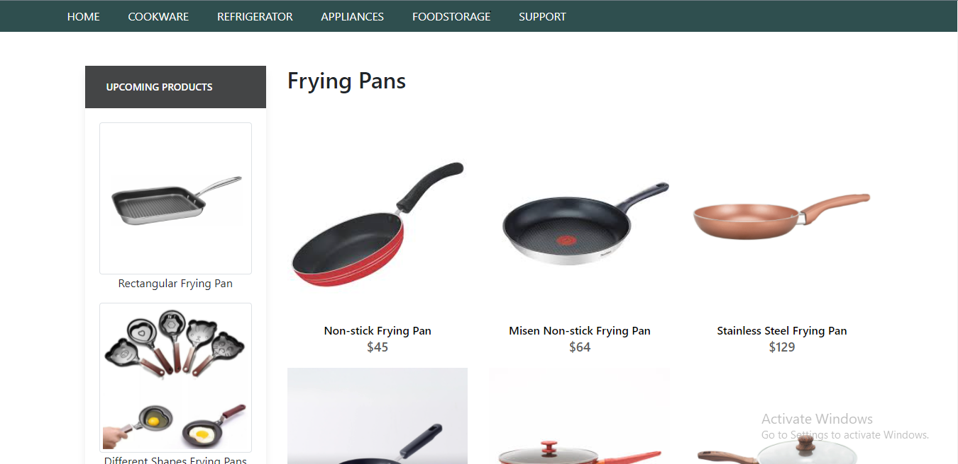

FRYING PANS

FRYING PANS

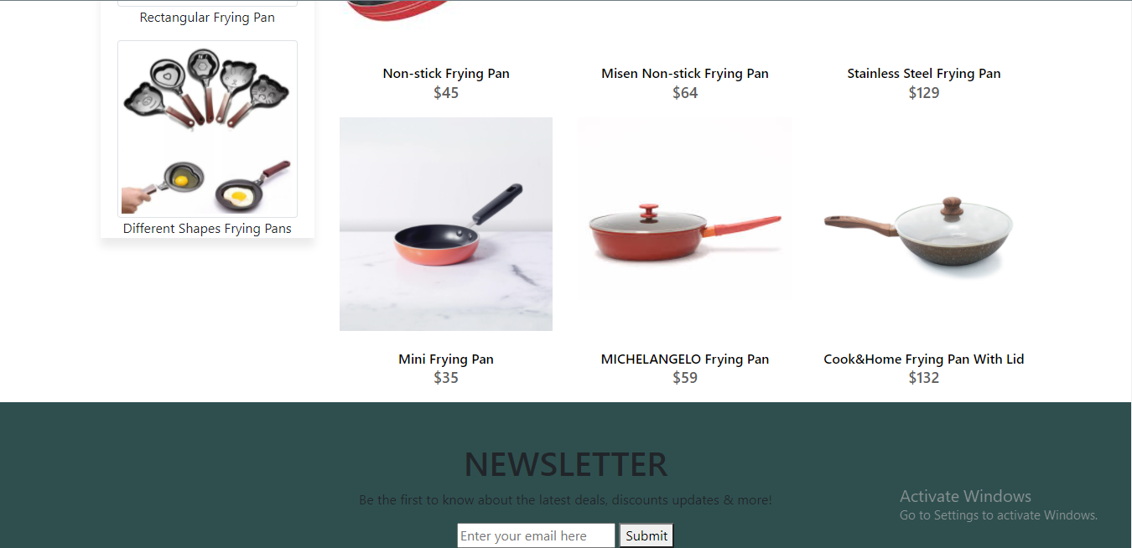

FRYING PANS



<!doctype html>

FRYING PANS CODING

<html>

<head>

<meta charset="utf-8">

<title>Untitled Document</title>

<link rel="stylesheet" type="text/css" href="../bootstraps/css/bootstrap.min.css"/>

<link rel="stylesheet" type="text/css" href="../bootstraps/css/bootstrap.css"/>

<link rel="stylesheet" type="text/css" href="../CSS/Tasha.css"/>

<!-- Latest compiled and minified CSS START-->

<link rel="stylesheet" href="https://maxcdn.bootstrapcdn.com/bootstrap/4.5.2/css/bootstrap.min.css">

<!-- Latest compiled and minified CSS END-->

<!-- jQuery library START -->

<script src="https://ajax.googleapis.com/ajax/libs/jquery/3.5.1/jquery.min.js"></script>

<!-- jQuery library END-->

<!-- Popper JS START-->

<script src="https://cdnjs.cloudflare.com/ajax/libs/popper.js/1.16.0/umd/popper.min.js"></script>

<!-- Popper JS END -->

<!-- Latest compiled JavaScript START-->

<script src="https://maxcdn.bootstrapcdn.com/bootstrap/4.5.2/js/bootstrap.min.js"></script>

<!-- Latest compiled JavaScript -->

<!--Meta Link START-->

<meta name="viewport" content="width=device-width, initial-scale=1">

<!--Meta Link END-->

<!--FONT AWESOME CDN LINK-->

<link rel="stylesheet" href="https://pro.fontawesome.com/releases/v5.10.0/css/all.css" integrity="sha384-AYmEC3Yw5cVb3ZcuHtOA93w35dYTsvhLPVnYs9eStHfGJvOvKxVfELGroGkvsg+p" crossorigin="anonymous"/>

<!--FONT AWESOME CDN LINK-->

<link rel="stylesheet" href="https://cdn.jsdelivr.net/npm/bootstrap-icons@1.6.0/font/bootstrap-icons.css" integrity="sha384-7ynz3n3tAGNUYFZD3cWe5PDcE36xj85vyFkawcF6tIwxvIecqKvfwLiaFdizhPpN" crossorigin="anonymous">

<link href="https://fonts.googleapis.com/css2?family=Open+Sans:wght@400;700&family=Poppins:wght@100;200;300;400&display=swap" rel="stylesheet">

</head>

<body>

<header>

<ul>

<li><a href="../Tasha.html">HOME</a>

</li>

<li><a href="#">COOKWARE</a>

<ul>

<li><a href="Cooking Pot.html">Cooking Pots</a></li>

<li><a href="Frying Pans.html">Frying Pans</a></li>

<li><a href="Cookware-Sets.html">Cookware Sets</a></li>

<li><a href="Egg Poached.html">Egg Poachers</a></li>

<li><a href="Grill-Pans.html">Grill Pans</a></li>

<li><a href="Steamer.html">Steamers</a></li>

</ul>

</li>

<li><a href="#">REFRIGERATOR</a>

<ul>

<li><a href="Refrigerators.html">Refrigerators</a></li>

<li><a href="Freezers.html">Freezers</a></li>

</ul>

</li>

<li><a href="#">APPLIANCES</a>

<ul>

<li><a href="Blenders.html">Blenders</a></li>

<li><a href="Bread-Maker.html">Bread Makers</a></li>

<li><a href="Coffee-Maker.html">Coffee Makers</a></li>

<li><a href="Icecream-Sorbet-Maker.html">Ice-Cream and Sorbet Makers</a></li>

<li><a href="Kettles.html">Kettles</a></li>

<li><a href="Food-Chopper.html">Food Choppers</a></li>

<li><a href="Toaster.html">Toasters</a></li>

</ul>

</li>

<li><a href="#">FOODSTORAGE</a>

<ul>

<li><a href="Flask.html">Flask</a></li>

<li><a href="Spice-Jars.html">Spice Jars</a></li>

<li><a href="Storage-Bags.html">Storage Bags</a></li>

<li><a href="Lunch-Boxes.html">Lunch Boxes</a></li>

<li><a href="Storage-Containers.html">Storage Containers</a></li>

</ul>

</li>

<li><a href="#">SUPPORT</a>

<ul>

<li><a href="Expert Tips.html">Expert Tips</a></li>

<li><a href="Register-Complain.html">Register Complain</a></li>

<li><a href="Feedback-Form.html">Feed Back</a></li>

<li><a href="Contact Us.html">Contact Us</a></li>

</ul>

</li>

</ul>

</header>

**<!--NAVIGATION BAR ENDS-->**

**<!--cooking pot start-->**

<section class="category">

<div class="container">

<div class="row">

<div class="col-lg-3">

<aside class="side-area product-side side-shadow mt-5">

<div class="side-title">

<h3>UpComing Products</h3>

</div>

<div class="side-content" style="margin: 20px;" >

<img src="../Images/203.png" class="img-thumbnail" alt="...">

<p style="text-align: center;">Rectangular Frying Pan </p>

<img src="../Images/200.jpg" class="img-thumbnail" alt="...">

<p style="text-align: center;">Different Shapes Frying Pans </p>

</div>

</aside>

</div>

<div class="col-lg-9">

<div class="row">

<div class="col-lg-12">

<div class="product-top d-flex justify-content-between align-items-center" >

<div class="product-sec product-item ">

<h2 class="my-5">Frying Pans</h2>

</div>

</div>

</div>

<div class="col-lg-4 col-sm-6">

<div class="product-cate">

<div>

<img src="../Images/207.jpg" alt="" />

<div class="product-icon">

<ul>

<li><a href=""><i class="fa fa-heart" aria-hidden="true"></i></a></li>

<li><a href="Checkout-Form.html"><i class="fa fa-shopping-cart" aria-hidden="true"></i></a></li>

</ul>

</div>

<!---->

<div class="product-des">

<h5>Non-stick Frying Pan</h5>

<p>$45</p>

</div>

</div>

</div>

</div>

<!---->

<div class="col-lg-4 col-sm-6">

<div class="product-cate">

<div>

<img src="../Images/206.jpg" alt="pot"/>

<div class="product-icon">

<ul>

<li><a href=""><i class="fa fa-heart" aria-hidden="true"></i></a></li>

<li><a href="Checkout-Form.html"><i class="fa fa-shopping-cart" aria-hidden="true"></i></a></li>

</ul>

</div>

<!---->

<div class="product-des">

<h5>Misen Non-stick Frying Pan</h5>

<p>$64</p>

</div>

</div>

</div>

</div>

<!---->

<div class="col-lg-4 col-sm-6">

<div class="product-cate">

<div>

<img src="../Images/201.jpg" alt="pot" class="img-fluid"/>

<div class="product-icon">

<ul>

<li><a href=""><i class="fa fa-heart" aria-hidden="true"></i></a></li>

<li><a href="Checkout-Form.html"><i class="fa fa-shopping-cart" aria-hidden="true"></i></a></li>

</ul>

</div>

<!---->

<div class="product-des">

<h5>Stainless Steel Frying Pan </h5>

<p>$129</p>

</div>

</div>

</div>

</div>

<!---->

<div class="col-lg-4 col-sm-6">

<div class="product-cate">

<div>

<img src="../Images/208.jpg" alt="pot" />

<div class="product-icon">

<ul>

<li><a href=""><i class="fa fa-heart" aria-hidden="true"></i></a></li>

<li><a href="Checkout-Form.html"><i class="fa fa-shopping-cart" aria-hidden="true"></i></a></li>

</ul>

</div>

<!---->

<div class="product-des">

<h5>Mini Frying Pan</h5>

<p>$35</p>

</div>

</div>

</div>

</div>

<!---->

<div class="col-lg-4 col-sm-6">

<div class="product-cate">

<div>

<img src="../Images/205.jpg" alt=""/>

<div class="product-icon">

<ul>

<li><a href=""><i class="fa fa-heart" aria-hidden="true"></i></a></li>

<li><a href="Checkout-Form.html"><i class="fa fa-shopping-cart" aria-hidden="true"></i></a></li>

</ul>

</div>

<!---->

<div class="product-des">

<h5>MICHELANGELO Frying Pan </h5>

<p>$59</p>

</div>

</div>

</div>

</div>

<!---->

<div class="col-lg-4 col-sm-6">

<div class="product-cate">

<div>

<img src="../Images/204.jpg" alt="pot" />

<div class="product-icon">

<ul>

<li><a href=""><i class="fa fa-heart" aria-hidden="true"></i></a></li>

<li><a href="Checkout-Form.html"><i class="fa fa-shopping-cart" aria-hidden="true"></i></a></li>

</ul>

</div>

<!---->

<div class="product-des">

<h5>Cook&Home Frying Pan With Lid </h5>

<p>$132</p>

</div>

</div>

</div>

</div>

<!---->

</div>

</div>

</div>

</div>

</section>

**<!--cooking pot end-->**

**<!-- FOOTER STARTS -->**

<footer class=" text-black pt-5 pb-4 page-footer" style="background-color: darkslategray;">

<div class="text-center">

<h1 >NEWSLETTER</h1>

<p>Be the first to know about the latest deals, discounts updates & more!</p>

<input type="email" name="email" placeholder="Enter your email here"/>

<button type="submit" onClick="onclick" > Submit </button>

</div>

<br><br>

<div class=" container text-center text-md-left ">

<div class="row text-center text-md-left ">

<div class="col-md-3 col-lg-3 col-xl-3 mx-auto mt-3">

<h5 class="text-uppercase mb-4 font-weight-bold text-warning">TASHA Kitchen-Ware</h5>

<p>TASHA- the home store is Branded Company famous for home kitchen appliances. It provides collection of n number of appliances with different category to match the fast life of the generation. The Tasha group of companies had made huge profit in the year 2013. In order to enhance its business the organization wants you to develop the website.</p>

</div>

<div class="col-md-3 col-lg-3 col-xl-3 mx-auto mt-3" >

<h5 class="text-uppercase mb-4 font-weight-bold text-warning">OFFERS</h5>

<p><a href="#" class="text-black" style="text-decoration: none; color:black; ">Deal of the Day</a></p>

<p><a href="#" class="text-black" style="text-decoration: none;color:black;">Buy 1 Get 1 Free</a></p>

<p><a href="#" class="text-black" style="text-decoration: none;color:black;">Appliance Packages Offers</a></p>

<p ><a href="#" class="text-black" style="text-decoration: none; color:black;">Reward Program</a></p>

</div>

<div class="col-md-4 col-lg-3 col-xl-3 mx-auto mt-3">

<h5 class="text-uppercase mb-4 font-weight-bold text-warning">ADDRESS</h5>

<p>

<i class="fas fa-home mr-3"></i>Plot No. G-21/23, Block-8, Khaliquzzaman Road, Clifton، Block 8 Clifton, Karachi, Karachi City, Sindh 75600

</p>

</div>

</div>

<hr class="mb-4">

<div class="row align-items-center">

<div class="col-md-7 col-lg-8">

<p>copyright all rights reserved by <a href="#" style="text-decoration: none"><strong class="text-warning">The Provider</strong></a></p></div>

<div class="col-md-5 col-lg-4">

<div class="text-center text-md-right">

<ul class="list-unstyled list-inline">

<li class="list-inline-item">

<a href="#" class="btn-floating btn-sm text-black" style="font-size:23px;"><i class="fab fa-facebook"></i></a></li>

<li class="list-inline-item">

<a href="#" class="btn-floating btn-sm text-black" style="font-size:23px;"><i class="fab fa-twitter"></i></a></li>

<li class="list-inline-item">

<a href="#" class="btn-floating btn-sm text-black" style="font-size:23px;"><i class="fab fa-instagram"></i></a></li>

<li class="list-inline-item">

<a href="#" class="btn-floating btn-sm text-black" style="font-size:23px;"><i class="fas fa-link"></i></a></li>

</ul>

</div>

</div>

</div>

</div>

</footer>

**<!--FOOTER ENDS-->**

</body>

</html>

COOKWARE SETS

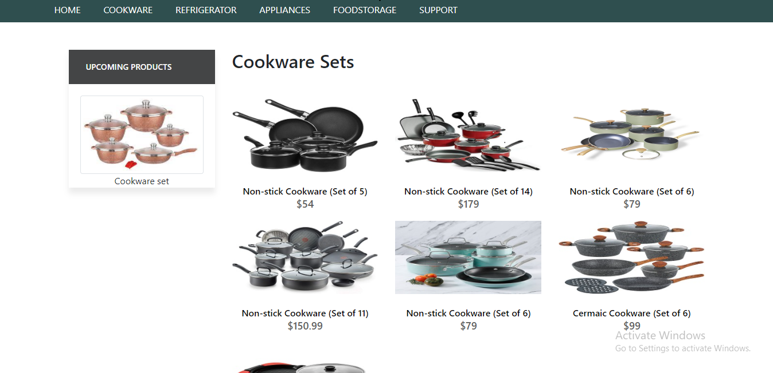

COOKWARE SETS

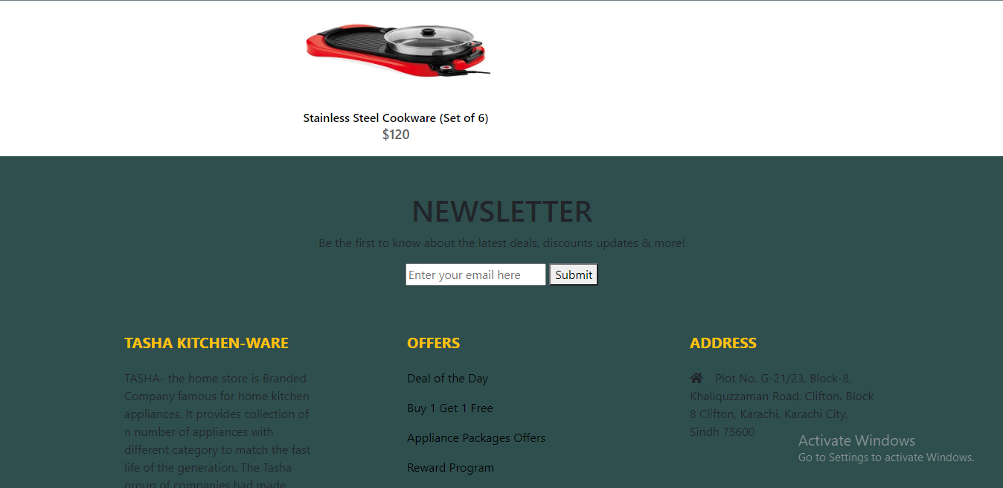

COOKWARE SETS



!doctype html>

COOKWARE SETS CODING

<html>

<head>

<meta charset="utf-8">

<title>Untitled Document</title>

<!--CSS LINK -->

<link rel="stylesheet" type="text/css" href="../CSS/Tasha.css"/>

<link rel="stylesheet" type="text/css" href="../bootstraps/css/bootstrap.min.css"/>

<link rel="stylesheet" type="text/css" href="../bootstraps/css/bootstrap.css"/>

<link rel="stylesheet" type="text/css" href="../CSS/Links.css"/>

<!-- Latest compiled and minified CSS START-->

<link rel="stylesheet" href="https://maxcdn.bootstrapcdn.com/bootstrap/4.5.2/css/bootstrap.min.css">

<!-- Latest compiled and minified CSS END-->

<!-- jQuery library START -->

<script src="https://ajax.googleapis.com/ajax/libs/jquery/3.5.1/jquery.min.js"></script>

<!-- jQuery library END-->

<!-- Popper JS START-->

<script src="https://cdnjs.cloudflare.com/ajax/libs/popper.js/1.16.0/umd/popper.min.js"></script>

<!-- Popper JS END -->

<!-- Latest compiled JavaScript START-->

<script src="https://maxcdn.bootstrapcdn.com/bootstrap/4.5.2/js/bootstrap.min.js"></script>

<!-- Latest compiled JavaScript -->

<!--Meta Link START-->

<meta name="viewport" content="width=device-width, initial-scale=1">

<!--Meta Link END-->

<!--FONT AWESOME CDN LINK-->

<link rel="stylesheet" href="https://pro.fontawesome.com/releases/v5.10.0/css/all.css" integrity="sha384-AYmEC3Yw5cVb3ZcuHtOA93w35dYTsvhLPVnYs9eStHfGJvOvKxVfELGroGkvsg+p" crossorigin="anonymous"/>

<!--FONT AWESOME CDN LINK-->

<link rel="stylesheet" href="https://cdn.jsdelivr.net/npm/bootstrap-icons@1.6.0/font/bootstrap-icons.css" integrity="sha384-7ynz3n3tAGNUYFZD3cWe5PDcE36xj85vyFkawcF6tIwxvIecqKvfwLiaFdizhPpN" crossorigin="anonymous">

<link href="https://fonts.googleapis.com/css2?family=Open+Sans:wght@400;700&family=Poppins:wght@100;200;300;400&display=swap" rel="stylesheet">

</head>

<body>

<header>

<ul>

<li><a href="../Tasha.html">HOME</a>

</li>

<li><a href="#">COOKWARE</a>

<ul>

<li><a href="Cooking Pot.html">Cooking Pots</a></li>

<li><a href="Frying Pans.html">Frying Pans</a></li>

<li><a href="Cookware-Sets.html">Cookware Sets</a></li>

<li><a href="Egg Poached.html">Egg Poachers</a></li>

<li><a href="Grill-Pans.html">Grill Pans</a></li>

<li><a href="Steamer.html">Steamers</a></li>

</ul>

</li>

<li><a href="#">REFRIGERATOR</a>

<ul>

<li><a href="Refrigerators.html">Refrigerators</a></li>

<li><a href="Freezers.html">Freezers</a></li>

</ul>

</li>

<li><a href="#">APPLIANCES</a>

<ul>

<li><a href="Blenders.html">Blenders</a></li>

<li><a href="Bread-Maker.html">Bread Makers</a></li>

<li><a href="Coffee-Maker.html">Coffee Makers</a></li>

<li><a href="Icecream-Sorbet-Maker.html">Ice-Cream and Sorbet Makers</a></li>

<li><a href="Kettles.html">Kettles</a></li>

<li><a href="Food-Chopper.html">Food Choppers</a></li>

<li><a href="Toaster.html">Toasters</a></li>

</ul>

</li>

<li><a href="#">FOODSTORAGE</a>

<ul>

<li><a href="Flask.html">Flask</a></li>

<li><a href="Spice-Jars.html">Spice Jars</a></li>

<li><a href="Storage-Bags.html">Storage Bags</a></li>

<li><a href="Lunch-Boxes.html">Lunch Boxes</a></li>

<li><a href="Storage-Containers.html">Storage Containers</a></li>

</ul>

</li>

<li><a href="#">SUPPORT</a>

<ul>

<li><a href="Expert Tips.html">Expert Tips</a></li>

<li><a href="Register-Complain.html">Register Complain</a></li>

<li><a href="Feedback-Form.html">Feed Back</a></li>

<li><a href="Contact Us.html">Contact Us</a></li>

</ul>

</li>

</ul>

</header>

<!--NAVIGATION BAR ENDS-->

<!--SIDE NAVIGATOR STARTS-->

<section class="category">

<div class="container">

<div class="row">

<div class="col-lg-3">

<aside class="side-area product-side side-shadow mt-5">

<div class="side-title">

<h3>UpComing Products</h3>

</div>

<div class="side-content" style="margin: 20px;" >

<img src="../Images/233.jpg" class="img-thumbnail" alt="...">

<p style="text-align: center;">Cookware set</p>

</div>

</aside>

</div>

<!--SIDE NAVIGATOR ENDS-->

<!--COOKING POT STARTS-->

<div class="col-lg-9">

<div class="row">

<div class="col-lg-12">

<div class="product-top d-flex justify-content-between align-items-center" >

<div class="product-sec product-item ">

<h2 class="my-5">Cookware Sets</h2>

</div>

</div>

</div>

<div class="col-lg-4 col-sm-6">

<div class="product-cate">

<div>

<img src="../Images/43.jpg" alt="" />

<div class="product-icon">

<ul>

<li><a href=""><i class="fa fa-heart" aria-hidden="true"></i></a></li>

<li><a href="Checkout-Form.html"><i class="fa fa-shopping-cart" aria-hidden="true"></i></a></li>

</ul>

</div>

<!---->

<div class="product-des">

<h5>Non-stick Cookware (Set of 5)</h5>

<p>$54</p>

</div>

</div>

</div>

</div>

<!---->

<div class="col-lg-4 col-sm-6">

<div class="product-cate">

<div>

<img src="../Images/44.jpg" alt="pot" />

<div class="product-icon">

<ul>

<li><a href=""><i class="fa fa-heart" aria-hidden="true"></i></a></li>

<li><a href="Checkout-Form.html"><i class="fa fa-shopping-cart" aria-hidden="true"></i></a></li>

</ul>

</div>

<!---->

<div class="product-des">

<h5>Non-stick Cookware (Set of 14)</h5>

<p>$179</p>

</div>

</div>

</div>

</div>

<!---->

<div class="col-lg-4 col-sm-6">

<div class="product-cate">

<div>

<img src="../Images/45.png" alt="pot"/>

<div class="product-icon">

<ul>

<li><a href=""><i class="fa fa-heart" aria-hidden="true"></i></a></li>

<li><a href="Checkout-Form.html"><i class="fa fa-shopping-cart" aria-hidden="true"></i></a></li>

</ul>

</div>

<!---->

<div class="product-des">

<h5>Non-stick Cookware (Set of 6)</h5>

<p>$79</p>

</div>

</div>

</div>

</div>

<!---->

<div class="col-lg-4 col-sm-6">

<div class="product-cate">

<div>

<img src="../Images/46.jpg" alt="pot" class="img-fluid"/>

<div class="product-icon">

<ul>

<li><a href=""><i class="fa fa-heart" aria-hidden="true"></i></a></li>

<li><a href="Checkout-Form.html"><i class="fa fa-shopping-cart" aria-hidden="true"></i></a></li>

</ul>

</div>

<!---->

<div class="product-des">

<h5>Non-stick Cookware (Set of 11)</h5>

<p>$150.99</p>

</div>

</div>

</div>

</div>

<!---->

<div class="col-lg-4 col-sm-6">

<div class="product-cate">

<div>

<img src="../Images/47.jpg" alt="pot" />

<div class="product-icon">

<ul>

<li><a href=""><i class="fa fa-heart" aria-hidden="true"></i></a></li>

<li><a href="Checkout-Form.html"><i class="fa fa-shopping-cart" aria-hidden="true"></i></a></li>

</ul>

</div>

<!---->

<div class="product-des">

<h5>Non-stick Cookware (Set of 6)</h5>

<p>$79</p>

</div>

</div>

</div>

</div>

<!---->

<div class="col-lg-4 col-sm-6">

<div class="product-cate">

<div>

<img src="../Images/48.jpg" alt=""/>

<div class="product-icon">

<ul>

<li><a href=""><i class="fa fa-heart" aria-hidden="true"></i></a></li>

<li><a href="Checkout-Form.html"><i class="fa fa-shopping-cart" aria-hidden="true"></i></a></li>

</ul>

</div>

<!---->

<div class="product-des">

<h5>Cermaic Cookware (Set of 6)</h5>

<p>$99</p>

</div>

</div>

</div>

</div>

<!---->

<div class="col-lg-4 col-sm-6">

<div class="product-cate">

<div>

<img src="../Images/88.jpg" alt="pot" />

<div class="product-icon">

<ul>

<li><a href=""><i class="fa fa-heart" aria-hidden="true"></i></a></li>

<li><a href="Checkout-Form.html"><i class="fa fa-shopping-cart" aria-hidden="true"></i></a></li>

</ul>

</div>

<!---->

<div class="product-des">

<h5>Stainless Steel Cookware (Set of 6)</h5>

<p>$120</p>

</div>

</div>

</div>

</div>

<!---->

</div>

</div>

</div>

</div>

</section>

<!--COOKING POT END-->

<!-- FOOTER STARTS -->

<footer class=" text-black pt-5 pb-4 page-footer" style="background-color: darkslategray;">

<div class="text-center">

<h1 >NEWSLETTER</h1>

<p>Be the first to know about the latest deals, discounts updates & more!</p>

<input type="email" name="email" placeholder="Enter your email here"/>

<button type="submit" onClick="onclick" > Submit </button>

</div>

<br><br>

<div class=" container text-center text-md-left ">

<div class="row text-center text-md-left ">

<div class="col-md-3 col-lg-3 col-xl-3 mx-auto mt-3">

<h5 class="text-uppercase mb-4 font-weight-bold text-warning">TASHA Kitchen-Ware</h5>

<p>TASHA- the home store is Branded Company famous for home kitchen appliances. It provides collection of n number of appliances with different category to match the fast life of the generation. The Tasha group of companies had made huge profit in the year 2013. In order to enhance its business the organization wants you to develop the website.</p>

</div>

<div class="col-md-3 col-lg-3 col-xl-3 mx-auto mt-3" >

<h5 class="text-uppercase mb-4 font-weight-bold text-warning">OFFERS</h5>

<p><a href="#" class="text-black" style="text-decoration: none; color:black; ">Deal of the Day</a></p>

<p><a href="#" class="text-black" style="text-decoration: none;color:black;">Buy 1 Get 1 Free</a></p>

<p><a href="#" class="text-black" style="text-decoration: none;color:black;">Appliance Packages Offers</a></p>

<p ><a href="#" class="text-black" style="text-decoration: none; color:black;">Reward Program</a></p>

</div>

<div class="col-md-4 col-lg-3 col-xl-3 mx-auto mt-3">

<h5 class="text-uppercase mb-4 font-weight-bold text-warning">ADDRESS</h5>

<p>

<i class="fas fa-home mr-3"></i>Plot No. G-21/23, Block-8, Khaliquzzaman Road, Clifton، Block 8 Clifton, Karachi, Karachi City, Sindh 75600

</p

</div>

</div>

<hr class="mb-4">

<div class="row align-items-center">

<div class="col-md-7 col-lg-8">

<p>copyright all rights reserved by <a href="#" style="text-decoration: none"><strong class="text-warning">The Provider</strong></a></p></div>

<div class="col-md-5 col-lg-4">

<div class="text-center text-md-right">

<ul class="list-unstyled list-inline">

<li class="list-inline-item">

<a href="#" class="btn-floating btn-sm text-black" style="font-size:23px;"><i class="fab fa-facebook"></i></a></li>

<li class="list-inline-item">

<a href="#" class="btn-floating btn-sm text-black" style="font-size:23px;"><i class="fab fa-twitter"></i></a></li>

<li class="list-inline-item">

<a href="#" class="btn-floating btn-sm text-black" style="font-size:23px;"><i class="fab fa-instagram"></i></a></li>

<li class="list-inline-item">

<a href="#" class="btn-floating btn-sm text-black" style="font-size:23px;"><i class="fas fa-link"></i></a></li>

</ul>

</div>

</div>

</div>

</div>

</footer>

<!--FOOTER ENDS-->

</body>

</html>

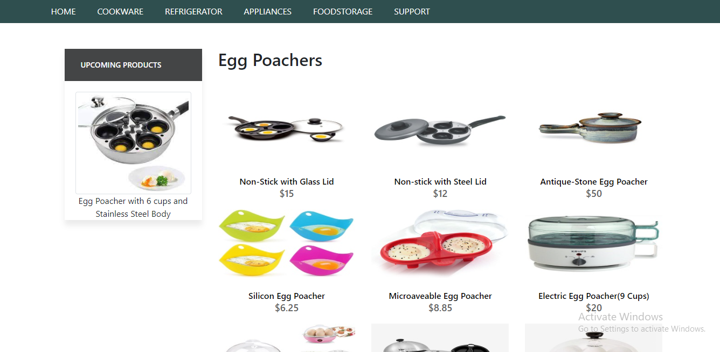

EGG POACHERS

EGG POACHERS

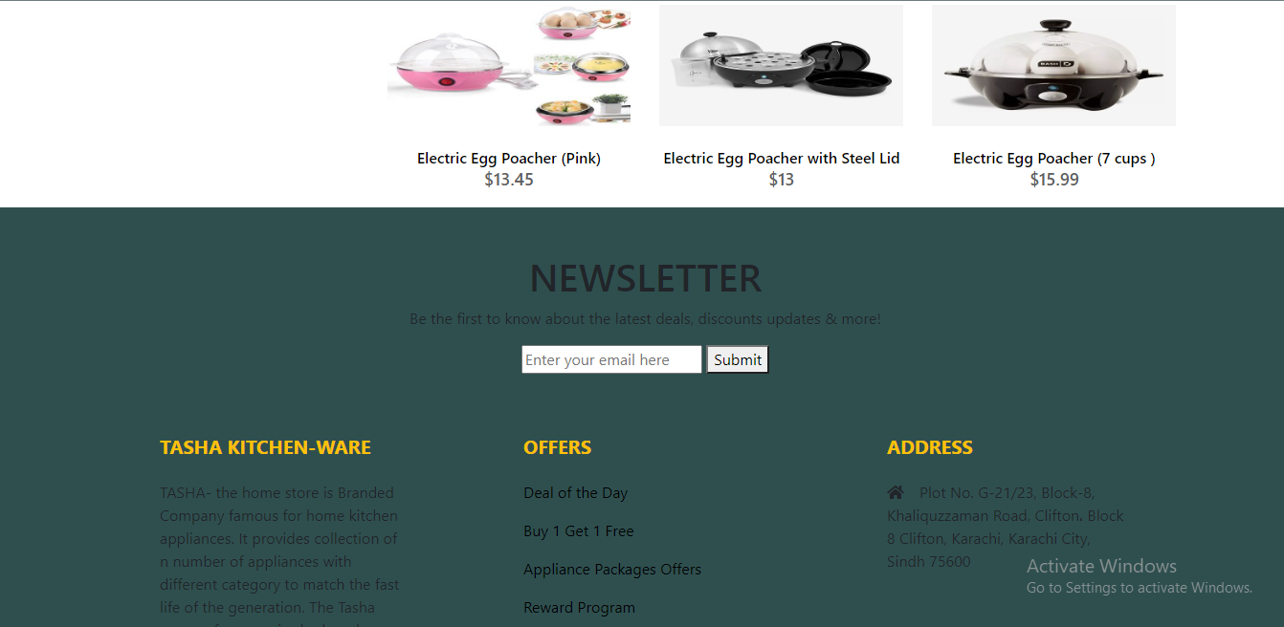

EGG POACHER



<!doctype html>

EGG POACHER CODING

<html>

<head>

<meta charset="utf-8">

<title>Untitled Document</title>

<!--CSS LINK -->

<link rel="stylesheet" type="text/css" href="../CSS/Tasha.css"/>

<link rel="stylesheet" type="text/css" href="../bootstraps/css/bootstrap.min.css"/>

<link rel="stylesheet" type="text/css" href="../bootstraps/css/bootstrap.css"/>

<link rel="stylesheet" type="text/css" href="../CSS/Links.css"/>

<!-- Latest compiled and minified CSS START-->

<link rel="stylesheet" href="https://maxcdn.bootstrapcdn.com/bootstrap/4.5.2/css/bootstrap.min.css">

<!-- Latest compiled and minified CSS END-->

<!-- jQuery library START -->

<script src="https://ajax.googleapis.com/ajax/libs/jquery/3.5.1/jquery.min.js"></script>

<!-- jQuery library END-->

<!-- Popper JS START-->

<script src="https://cdnjs.cloudflare.com/ajax/libs/popper.js/1.16.0/umd/popper.min.js"></script>

<!-- Popper JS END -->

<!-- Latest compiled JavaScript START-->

<script src="https://maxcdn.bootstrapcdn.com/bootstrap/4.5.2/js/bootstrap.min.js"></script>

<!-- Latest compiled JavaScript -->

<!--Meta Link START-->

<meta name="viewport" content="width=device-width, initial-scale=1">

<!--Meta Link END-->

<!--FONT AWESOME CDN LINK-->

<link rel="stylesheet" href="https://pro.fontawesome.com/releases/v5.10.0/css/all.css" integrity="sha384-AYmEC3Yw5cVb3ZcuHtOA93w35dYTsvhLPVnYs9eStHfGJvOvKxVfELGroGkvsg+p" crossorigin="anonymous"/>

<!--FONT AWESOME CDN LINK-->

<link rel="stylesheet" href="https://cdn.jsdelivr.net/npm/bootstrap-icons@1.6.0/font/bootstrap-icons.css" integrity="sha384-7ynz3n3tAGNUYFZD3cWe5PDcE36xj85vyFkawcF6tIwxvIecqKvfwLiaFdizhPpN" crossorigin="anonymous">

<link href="https://fonts.googleapis.com/css2?family=Open+Sans:wght@400;700&family=Poppins:wght@100;200;300;400&display=swap" rel="stylesheet">

</head>

<body>

<header>

<ul>

<li><a href="../Tasha.html">HOME</a>

</li>

<li><a href="#">COOKWARE</a>

<ul>

<li><a href="Cooking Pot.html">Cooking Pots</a></li>

<li><a href="Frying Pans.html">Frying Pans</a></li>

<li><a href="Cookware-Sets.html">Cookware Sets</a></li>

<li><a href="Egg Poached.html">Egg Poachers</a></li>

<li><a href="Grill-Pans.html">Grill Pans</a></li>

<li><a href="Steamer.html">Steamers</a></li>

</ul>

</li>

<li><a href="#">REFRIGERATOR</a>

<ul>

<li><a href="Refrigerators.html">Refrigerators</a></li>

<li><a href="Freezers.html">Freezers</a></li>

</ul>

</li>

<li><a href="#">APPLIANCES</a>

<ul>

<li><a href="Blenders.html">Blenders</a></li>

<li><a href="Bread-Maker.html">Bread Makers</a></li>

<li><a href="Coffee-Maker.html">Coffee Makers</a></li>

<li><a href="Icecream-Sorbet-Maker.html">Ice-Cream and Sorbet Makers</a></li>

<li><a href="Kettles.html">Kettles</a></li>

<li><a href="Food-Chopper.html">Food Choppers</a></li>

<li><a href="Toaster.html">Toasters</a></li>

</ul>

</li>

<li><a href="#">FOODSTORAGE</a>

<ul>

<li><a href="Flask.html">Flask</a></li>

<li><a href="Spice-Jars.html">Spice Jars</a></li>

<li><a href="Storage-Bags.html">Storage Bags</a></li>

<li><a href="Lunch-Boxes.html">Lunch Boxes</a></li>

<li><a href="Storage-Containers.html">Storage Containers</a></li>

</ul>

</li>

<li><a href="#">SUPPORT</a>

<ul>

<li><a href="Expert Tips.html">Expert Tips</a></li>

<li><a href="Register-Complain.html">Register Complain</a></li>

<li><a href="Feedback-Form.html">Feed Back</a></li>

<li><a href="Contact Us.html">Contact Us</a></li>

</ul>

</li>

</ul>

</header>

<!--NAVIGATION BAR ENDS-->

<!--SIDE NAVIGATOR STARTS-->

<section class="category">

<div class="container">

<div class="row">

<div class="col-lg-3">

<aside class="side-area product-side side-shadow mt-5">

<div class="side-title">

<h3>UpComing Products</h3>

</div>

<div class="side-content" style="margin: 20px;" >

<img src="../Images/234.jpg" class="img-thumbnail" alt="...">

<p style="text-align: center;">Egg Poacher with 6 cups and Stainless Steel Body </p>

</div>

</aside>

</div>

<!--SIDE NAVIGATOR ENDS-->

<!--COOKING POT STARTS-->

<div class="col-lg-9">

<div class="row">

<div class="col-lg-12">

<div class="product-top d-flex justify-content-between align-items-center" >

<div class="product-sec product-item ">

<h2 class="my-5">Egg Poachers</h2>

</div>

</div>

</div>

<div class="col-lg-4 col-sm-6">

<div class="product-cate">

<div>

<img src="../Images/73.jpg" alt="" />

<div class="product-icon">

<ul>

<li><a href=""><i class="fa fa-heart" aria-hidden="true"></i></a></li>

<li><a href="Checkout-Form.html"><i class="fa fa-shopping-cart" aria-hidden="true"></i></a></li>

</ul>

</div>

<!---->

<div class="product-des">

<h5>Non-Stick with Glass Lid</h5>

<p>$15</p>

</div>

</div>

</div>

</div>

<!---->

<div class="col-lg-4 col-sm-6">

<div class="product-cate">

<div>

<img src="../Images/74.jpg" alt="pot" />

<div class="product-icon">

<ul>

<li><a href=""><i class="fa fa-heart" aria-hidden="true"></i></a></li>

<li><a href="Checkout-Form.html"><i class="fa fa-shopping-cart" aria-hidden="true"></i></a></li>

</ul>

</div>

<!---->

<div class="product-des">

<h5>Non-stick with Steel Lid</h5>

<p>$12</p>

</div>

</div>

</div>

</div>

<!---->

<div class="col-lg-4 col-sm-6">

<div class="product-cate">

<div>

<img src="../Images/75.jpg" alt="pot"/>

<div class="product-icon">

<ul>

<li><a href=""><i class="fa fa-heart" aria-hidden="true"></i></a></li>

<li><a href="Checkout-Form.html"><i class="fa fa-shopping-cart" aria-hidden="true"></i></a></li>

</ul>

</div>

<!---->

<div class="product-des">

<h5>Antique-Stone Egg Poacher </h5>

<p>$50</p>

</div>

</div>

</div>

</div>

<!---->

<div class="col-lg-4 col-sm-6">

<div class="product-cate">

<div>

<img src="../Images/76.jpeg" alt="pot" class="img-fluid"/>

<div class="product-icon">

<ul>

<li><a href=""><i class="fa fa-heart" aria-hidden="true"></i></a></li>

<li><a href="Checkout-Form.html"><i class="fa fa-shopping-cart" aria-hidden="true"></i></a></li>

</ul>

</div>

<!---->

<div class="product-des">

<h5>Silicon Egg Poacher</h5>

<p>$6.25</p>

</div>

</div>

</div>

</div>

<!---->

<div class="col-lg-4 col-sm-6">

<div class="product-cate">

<div>

<img src="../Images/77.jpg" alt="pot" />

<div class="product-icon">

<ul>

<li><a href=""><i class="fa fa-heart" aria-hidden="true"></i></a></li>

<li><a href="Checkout-Form.html"><i class="fa fa-shopping-cart" aria-hidden="true"></i></a></li>

</ul>

</div>

<!---->

<div class="product-des">

<h5>Microaveable Egg Poacher</h5>

<p>$8.85</p>

</div>

</div>

</div>

</div>

<!---->

<div class="col-lg-4 col-sm-6">

<div class="product-cate">

<div>

<img src="../Images/78.jpg" alt=""/>

<div class="product-icon">

<ul>

<li><a href=""><i class="fa fa-heart" aria-hidden="true"></i></a></li>

<li><a href="Checkout-Form.html"><i class="fa fa-shopping-cart" aria-hidden="true"></i></a></li>

</ul>

</div>

<!---->

<div class="product-des">

<h5>Electric Egg Poacher(9 Cups)</h5>

<p>$20</p>

</div>

</div>

</div>

</div>

<!---->

<div class="col-lg-4 col-sm-6">

<div class="product-cate">

<div>

<img src="../Images/79.jpeg" alt="pot" />

<div class="product-icon">

<ul>

<li><a href=""><i class="fa fa-heart" aria-hidden="true"></i></a></li>

<li><a href="Checkout-Form.html"><i class="fa fa-shopping-cart" aria-hidden="true"></i></a></li>

</ul>

</div>

<!---->

<div class="product-des">

<h5>Electric Egg Poacher (Pink)</h5>

<p>$13.45</p>

</div>

</div>

</div>

</div>

<!---->

<div class="col-lg-4 col-sm-6">

<div class="product-cate">

<div>

<img src="../Images/80.jpg" alt="pot" />

<div class="product-icon">

<ul>

<li><a href=""><i class="fa fa-heart" aria-hidden="true"></i></a></li>

<li><a href="Checkout-Form.html"><i class="fa fa-shopping-cart" aria-hidden="true"></i></a></li>

</ul>

</div>

<!---->

<div class="product-des">

<h5>Electric Egg Poacher with Steel Lid </h5>

<p>$13 </p>

</div>

</div>

</div>

</div>

<!---->

<div class="col-lg-4 col-sm-6">

<div class="product-cate">

<div>

<img src="../Images/81.jpg" alt="pot" />

<div class="product-icon">

<ul>

<li><a href=""><i class="fa fa-heart" aria-hidden="true"></i></a></li>

<li><a href="Checkout-Form.html"><i class="fa fa-shopping-cart" aria-hidden="true"></i></a></li>

</ul>

</div>

<!---->

<div class="product-des">

<h5>Electric Egg Poacher (7 cups )</h5>

<p>$15.99</p>

</div>

</div>

</div>

</div>

</div>

</div>

</div>

</div>

</section>

<!--COOKING POT END-->

<!-- FOOTER STARTS -->

<footer class=" text-black pt-5 pb-4 page-footer" style="background-color: darkslategray;">

<div class="text-center">

<h1 >NEWSLETTER</h1>

<p>Be the first to know about the latest deals, discounts updates & more!</p>

<input type="email" name="email" placeholder="Enter your email here"/>

<button type="submit" onClick="onclick" > Submit </button>

</div>

<br><br>

<div class=" container text-center text-md-left ">

<div class="row text-center text-md-left ">

<div class="col-md-3 col-lg-3 col-xl-3 mx-auto mt-3">

<h5 class="text-uppercase mb-4 font-weight-bold text-warning">TASHA Kitchen-Ware</h5>

<p>TASHA- the home store is Branded Company famous for home kitchen appliances. It provides collection of n number of appliances with different category to match the fast life of the generation. The Tasha group of companies had made huge profit in the year 2013. In order to enhance its business the organization wants you to develop the website.</p>

</div>

<div class="col-md-3 col-lg-3 col-xl-3 mx-auto mt-3" >

<h5 class="text-uppercase mb-4 font-weight-bold text-warning">OFFERS</h5>

<p><a href="#" class="text-black" style="text-decoration: none; color:black; ">Deal of the Day</a></p>

<p><a href="#" class="text-black" style="text-decoration: none;color:black;">Buy 1 Get 1 Free</a></p>

<p><a href="#" class="text-black" style="text-decoration: none;color:black;">Appliance Packages Offers</a></p>

<p ><a href="#" class="text-black" style="text-decoration: none; color:black;">Reward Program</a></p>

</div>

<div class="col-md-4 col-lg-3 col-xl-3 mx-auto mt-3">

<h5 class="text-uppercase mb-4 font-weight-bold text-warning">ADDRESS</h5>

<p>

<i class="fas fa-home mr-3"></i>Plot No. G-21/23, Block-8, Khaliquzzaman Road, Clifton، Block 8 Clifton, Karachi, Karachi City, Sindh 75600

</p>

</div>

</div>

<hr class="mb-4">

<div class="row align-items-center">

<div class="col-md-7 col-lg-8">

<p>copyright all rights reserved by <a href="#" style="text-decoration: none"><strong class="text-warning">The Provider</strong></a></p></div>

<div class="col-md-5 col-lg-4">

<div class="text-center text-md-right">

<ul class="list-unstyled list-inline">

<li class="list-inline-item">

<a href="#" class="btn-floating btn-sm text-black" style="font-size:23px;"><i class="fab fa-facebook"></i></a></li>

<li class="list-inline-item">

<a href="#" class="btn-floating btn-sm text-black" style="font-size:23px;"><i class="fab fa-twitter"></i></a></li>

<li class="list-inline-item">

<a href="#" class="btn-floating btn-sm text-black" style="font-size:23px;"><i class="fab fa-instagram"></i></a></li>

<li class="list-inline-item">

<a href="#" class="btn-floating btn-sm text-black" style="font-size:23px;"><i class="fas fa-link"></i></a></li>

</ul>

</div>

</div>

</div>

</div>

</footer>

<!--FOOTER ENDS-->

</body>

</html>

GRILL PANS

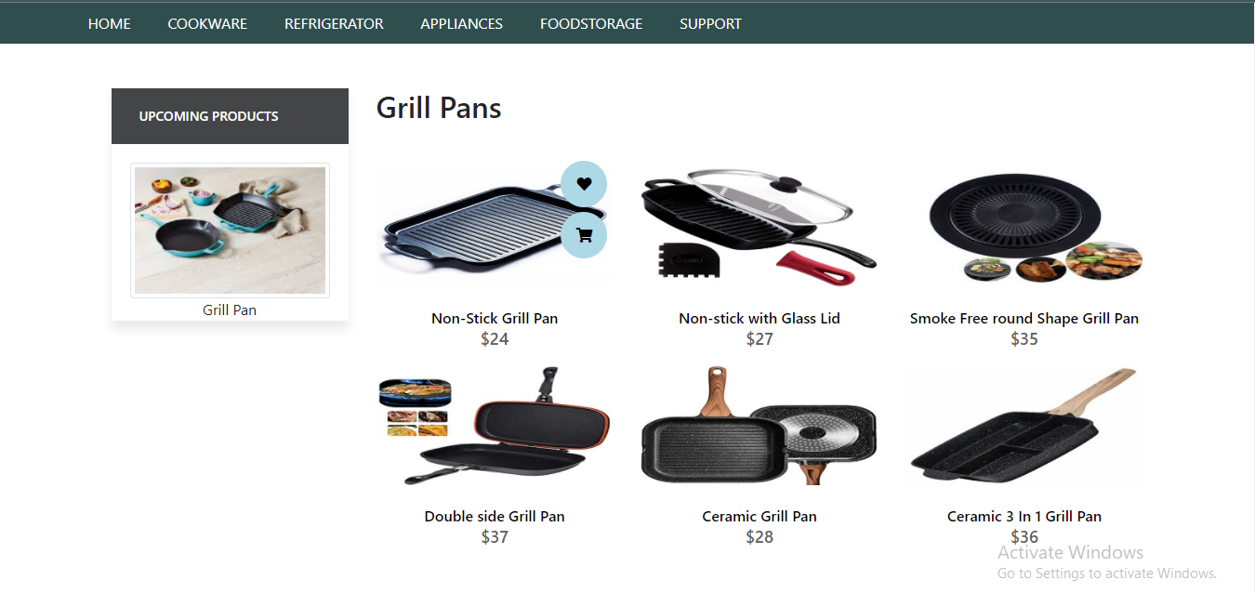

GRILL PANS

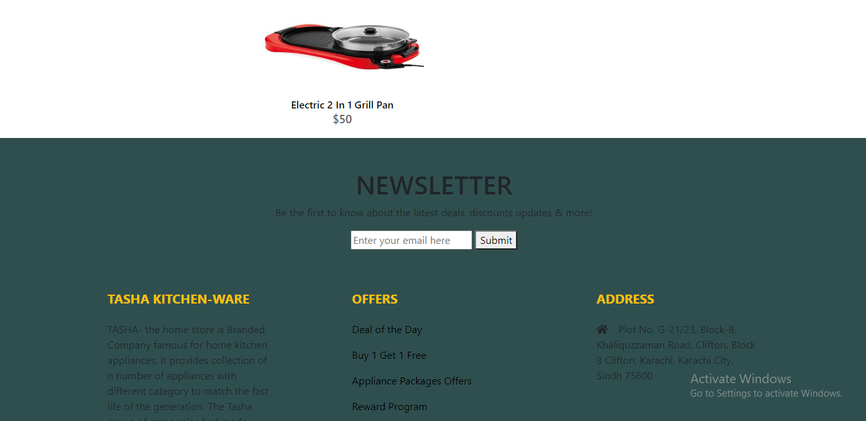

<!doctype html>

GRILL PANS CODING

<html>

<head>

<meta charset="utf-8">

<title>Untitled Document</title>

<!--CSS LINK -->

<link rel="stylesheet" type="text/css" href="../CSS/Tasha.css"/>

<link rel="stylesheet" type="text/css" href="../bootstraps/css/bootstrap.min.css"/>

<link rel="stylesheet" type="text/css" href="../bootstraps/css/bootstrap.css"/>

<link rel="stylesheet" type="text/css" href="../CSS/Links.css"/>

<!-- Latest compiled and minified CSS START-->

<link rel="stylesheet" href="https://maxcdn.bootstrapcdn.com/bootstrap/4.5.2/css/bootstrap.min.css">

<!-- Latest compiled and minified CSS END-->

<!-- jQuery library START -->

<script src="https://ajax.googleapis.com/ajax/libs/jquery/3.5.1/jquery.min.js"></script>

<!-- jQuery library END-->

<!-- Popper JS START-->

<script src="https://cdnjs.cloudflare.com/ajax/libs/popper.js/1.16.0/umd/popper.min.js"></script>

<!-- Popper JS END -->

<!-- Latest compiled JavaScript START-->

<script src="https://maxcdn.bootstrapcdn.com/bootstrap/4.5.2/js/bootstrap.min.js"></script>

<!-- Latest compiled JavaScript -->

<!--Meta Link START-->

<meta name="viewport" content="width=device-width, initial-scale=1">

<!--Meta Link END-->

<!--FONT AWESOME CDN LINK-->

<link rel="stylesheet" href="https://pro.fontawesome.com/releases/v5.10.0/css/all.css" integrity="sha384-AYmEC3Yw5cVb3ZcuHtOA93w35dYTsvhLPVnYs9eStHfGJvOvKxVfELGroGkvsg+p" crossorigin="anonymous"/>

<!--FONT AWESOME CDN LINK-->

<link rel="stylesheet" href="https://cdn.jsdelivr.net/npm/bootstrap-icons@1.6.0/font/bootstrap-icons.css" integrity="sha384-7ynz3n3tAGNUYFZD3cWe5PDcE36xj85vyFkawcF6tIwxvIecqKvfwLiaFdizhPpN" crossorigin="anonymous">

<link href="https://fonts.googleapis.com/css2?family=Open+Sans:wght@400;700&family=Poppins:wght@100;200;300;400&display=swap" rel="stylesheet">

</head>

<body>

<header>

<ul>

<li><a href="../Tasha.html">HOME</a>

</li>

<li><a href="#">COOKWARE</a>

<ul>

<li><a href="Cooking Pot.html">Cooking Pots</a></li>

<li><a href="Frying Pans.html">Frying Pans</a></li>

<li><a href="Cookware-Sets.html">Cookware Sets</a></li>

<li><a href="Egg Poached.html">Egg Poachers</a></li>

<li><a href="Grill-Pans.html">Grill Pans</a></li>

<li><a href="Steamer.html">Steamers</a></li>

</ul>

</li>

<li><a href="#">REFRIGERATOR</a>

<ul>

<li><a href="Refrigerators.html">Refrigerators</a></li>

<li><a href="Freezers.html">Freezers</a></li>

</ul>

</li>

<li><a href="#">APPLIANCES</a>

<ul>

<li><a href="Blenders.html">Blenders</a></li>

<li><a href="Bread-Maker.html">Bread Makers</a></li>

<li><a href="Coffee-Maker.html">Coffee Makers</a></li>

<li><a href="Icecream-Sorbet-Maker.html">Ice-Cream and Sorbet Makers</a></li>

<li><a href="Kettles.html">Kettles</a></li>

<li><a href="Food-Chopper.html">Food Choppers</a></li>

<li><a href="Toaster.html">Toasters</a></li>

</ul>

</li>

<li><a href="#">FOODSTORAGE</a>

<ul>

<li><a href="Flask.html">Flask</a></li>

<li><a href="Spice-Jars.html">Spice Jars</a></li>

<li><a href="Storage-Bags.html">Storage Bags</a></li>

<li><a href="Lunch-Boxes.html">Lunch Boxes</a></li>

<li><a href="Storage-Containers.html">Storage Containers</a></li>

</ul>

</li>

<li><a href="#">SUPPORT</a>

<ul>

<li><a href="Expert Tips.html">Expert Tips</a></li>

<li><a href="Register-Complain.html">Register Complain</a></li>

<li><a href="Feedback-Form.html">Feed Back</a></li>

<li><a href="Contact Us.html">Contact Us</a></li>

</ul>

</li>

</ul>

</header>

<!--NAVIGATION BAR ENDS-->

<!--NAVIGATION BAR ENDS-->

<!--SIDE NAVIGATOR STARTS-->

<section class="category">

<div class="container">

<div class="row">

<div class="col-lg-3">

<aside class="side-area product-side side-shadow mt-5">

<div class="side-title">

<h3>UpComing Products</h3>

</div>

<div class="side-content" style="margin: 20px;" >

<img src="../Images/222.jpg" class="img-thumbnail" alt="...">

<p style="text-align: center;">Grill Pan </p>

</div>

</aside>

</div>

<!--SIDE NAVIGATOR ENDS-->

<!--COOKING POT STARTS-->

<div class="col-lg-9">

<div class="row">

<div class="col-lg-12">

<div class="product-top d-flex justify-content-between align-items-center" >

<div class="product-sec product-item ">

<h2 class="my-5">Grill Pans </h2>

</div>

</div>

</div>

<div class="col-lg-4 col-sm-6">

<div class="product-cate">

<div>

<img src="../Images/82.jpg"="" />

<div class="product-icon">

<ul>

<li><a href=""><i class="fa fa-heart" aria-hidden="true"></i></a></li>

<li><a href="Checkout-Form.html"><i class="fa fa-shopping-cart" aria-hidden="true"></i></a></li>

</ul>

</div>

<!---->

<div class="product-des">

<h5>Non-Stick Grill Pan</h5>

<p>$24</p>

</div>

</div>

</div>

</div>

<!---->

<div class="col-lg-4 col-sm-6">

<div class="product-cate">

<div>

<img src="../Images/83.jpg" alt="pot" />

<div class="product-icon">

<ul>

<li><a href=""><i class="fa fa-heart" aria-hidden="true"></i></a></li>

<li><a href="Checkout-Form.html"><i class="fa fa-shopping-cart" aria-hidden="true"></i></a></li>

</ul>

</div>

<!---->

<div class="product-des">

<h5>Non-stick with Glass Lid</h5>

<p>$27</p>

</div>

</div>

</div>

</div>

<!---->

<div class="col-lg-4 col-sm-6">

<div class="product-cate">

<div>

<img src="../Images/84.jpeg" alt="pot"/>

<div class="product-icon">

<ul>

<li><a href=""><i class="fa fa-heart" aria-hidden="true"></i></a></li>

<li><a href="Checkout-Form.html"><i class="fa fa-shopping-cart" aria-hidden="true"></i></a></li>

</ul>

</div>

<!---->

<div class="product-des">

<h5>Smoke Free round Shape Grill Pan </h5>

<p>$35</p>

</div>

</div>

</div>

</div>

<!---->

<div class="col-lg-4 col-sm-6">

<div class="product-cate">

<div>

<img src="../Images/85.jpg" alt="pot" class="img-fluid"/>

<div class="product-icon">

<ul>

<li><a href=""><i class="fa fa-heart" aria-hidden="true"></i></a></li>

<li><a href="Checkout-Form.html"><i class="fa fa-shopping-cart" aria-hidden="true"></i></a></li>

</ul>

</div>

<!---->

<div class="product-des">

<h5>Double side Grill Pan</h5>

<p>$37</p>

</div>

</div>

</div>

</div>

<!---->

<div class="col-lg-4 col-sm-6">

<div class="product-cate">

<div>

<img src="../Images/86.jpg" alt="pot" />

<div class="product-icon">

<ul>

<li><a href=""><i class="fa fa-heart" aria-hidden="true"></i></a></li>

<li><a href="Checkout-Form.html"><i class="fa fa-shopping-cart" aria-hidden="true"></i></a></li>

</ul>

</div>

<!---->

<div class="product-des">

<h5>Ceramic Grill Pan</h5>

<p>$28</p>

</div>

</div>

</div>

</div>

<!---->

<div class="col-lg-4 col-sm-6">

<div class="product-cate">

<div>

<img src="../Images/87.jpg" alt=""/>

<div class="product-icon">

<ul>

<li><a href=""><i class="fa fa-heart" aria-hidden="true"></i></a></li>

<li><a href="Checkout-Form.html"><i class="fa fa-shopping-cart" aria-hidden="true"></i></a></li>

</ul>

</div>

<!---->

<div class="product-des">

<h5>Ceramic 3 In 1 Grill Pan</h5>

<p>$36</p>

</div>

</div>

</div>

</div>

<!---->

<div class="col-lg-4 col-sm-6">

<div class="product-cate">

<div>

<img src="../Images/88.jpg" alt="pot" />

<div class="product-icon">

<ul>

<li><a href=""><i class="fa fa-heart" aria-hidden="true"></i></a></li>

<li><a href="Checkout-Form.html"><i class="fa fa-shopping-cart" aria-hidden="true"></i></a></li>

</ul>

</div>

<!---->

<div class="product-des">

<h5>Electric 2 In 1 Grill Pan</h5>

<p>$50</p>

</div>

</div>

</div>

</div>

<!---->

</div>

</div>

</div>

</div>

</section>

<!--COOKING POT END-->

<!-- FOOTER STARTS -->

<footer class=" text-black pt-5 pb-4 page-footer" style="background-color: darkslategray;">

<div class="text-center">

<h1 >NEWSLETTER</h1>

<p>Be the first to know about the latest deals, discounts updates & more!</p>

<input type="email" name="email" placeholder="Enter your email here"/>

<button type="submit" onClick="onclick" > Submit </button>

</div>

<br><br>

<div class=" container text-center text-md-left ">

<div class="row text-center text-md-left ">

<div class="col-md-3 col-lg-3 col-xl-3 mx-auto mt-3">

<h5 class="text-uppercase mb-4 font-weight-bold text-warning">TASHA Kitchen-Ware</h5>

<p>TASHA- the home store is Branded Company famous for home kitchen appliances. It provides collection of n number of appliances with different category to match the fast life of the generation. The Tasha group of companies had made huge profit in the year 2013. In order to enhance its business the organization wants you to develop the website.</p>

</div>

<div class="col-md-3 col-lg-3 col-xl-3 mx-auto mt-3" >

<h5 class="text-uppercase mb-4 font-weight-bold text-warning">OFFERS</h5>

<p><a href="#" class="text-black" style="text-decoration: none; color:black; ">Deal of the Day</a></p>

<p><a href="#" class="text-black" style="text-decoration: none;color:black;">Buy 1 Get 1 Free</a></p>

<p><a href="#" class="text-black" style="text-decoration: none;color:black;">Appliance Packages Offers</a></p>

<p ><a href="#" class="text-black" style="text-decoration: none; color:black;">Reward Program</a></p>

</div>

<div class="col-md-4 col-lg-3 col-xl-3 mx-auto mt-3">

<h5 class="text-uppercase mb-4 font-weight-bold text-warning">ADDRESS</h5>

<p>

<i class="fas fa-home mr-3"></i>Plot No. G-21/23, Block-8, Khaliquzzaman Road, Clifton، Block 8 Clifton, Karachi, Karachi City, Sindh 75600

</p>

</div>

</div>

<hr class="mb-4">

<div class="row align-items-center">

<div class="col-md-7 col-lg-8">

<p>copyright all rights reserved by <a href="#" style="text-decoration: none"><strong class="text-warning">The Provider</strong></a></p></div>

<div class="col-md-5 col-lg-4">

<div class="text-center text-md-right">

<ul class="list-unstyled list-inline">

<li class="list-inline-item">

<a href="#" class="btn-floating btn-sm text-black" style="font-size:23px;"><i class="fab fa-facebook"></i></a></li>

<li class="list-inline-item">

<a href="#" class="btn-floating btn-sm text-black" style="font-size:23px;"><i class="fab fa-twitter"></i></a></li>

<li class="list-inline-item">

<a href="#" class="btn-floating btn-sm text-black" style="font-size:23px;"><i class="fab fa-instagram"></i></a></li>

<li class="list-inline-item">

<a href="#" class="btn-floating btn-sm text-black" style="font-size:23px;"><i class="fas fa-link"></i></a></li>

</ul>

</div>

</div>

</div>

</div>

</footer>

<!--FOOTER ENDS-->

</body>

</html> 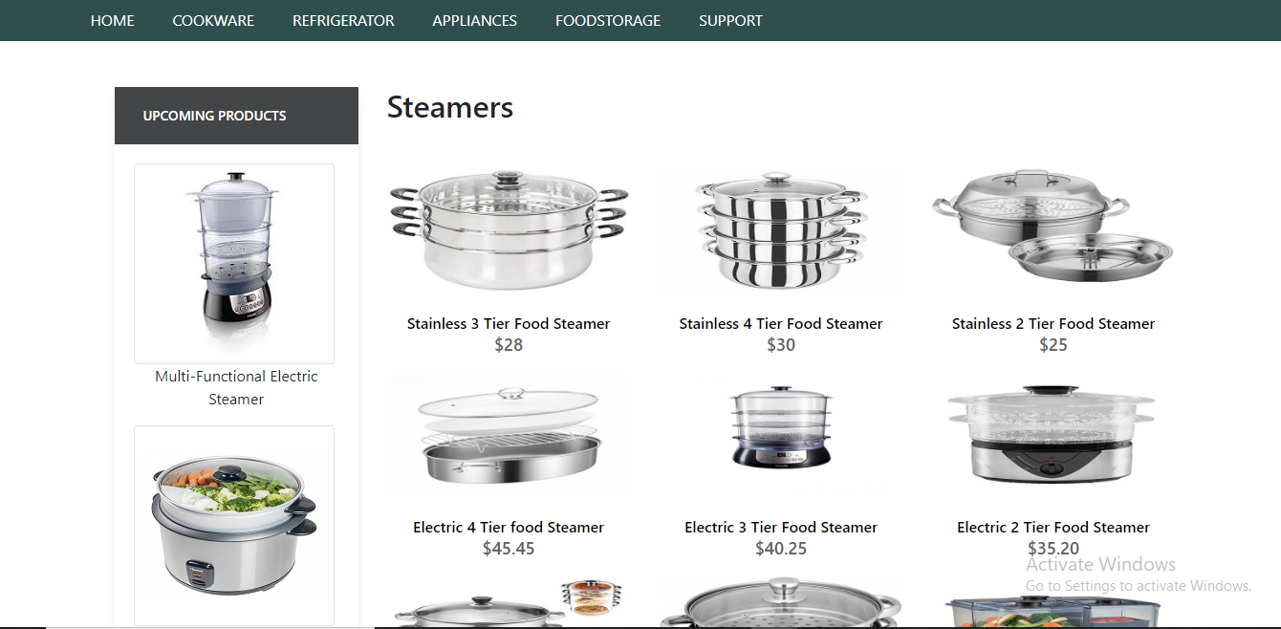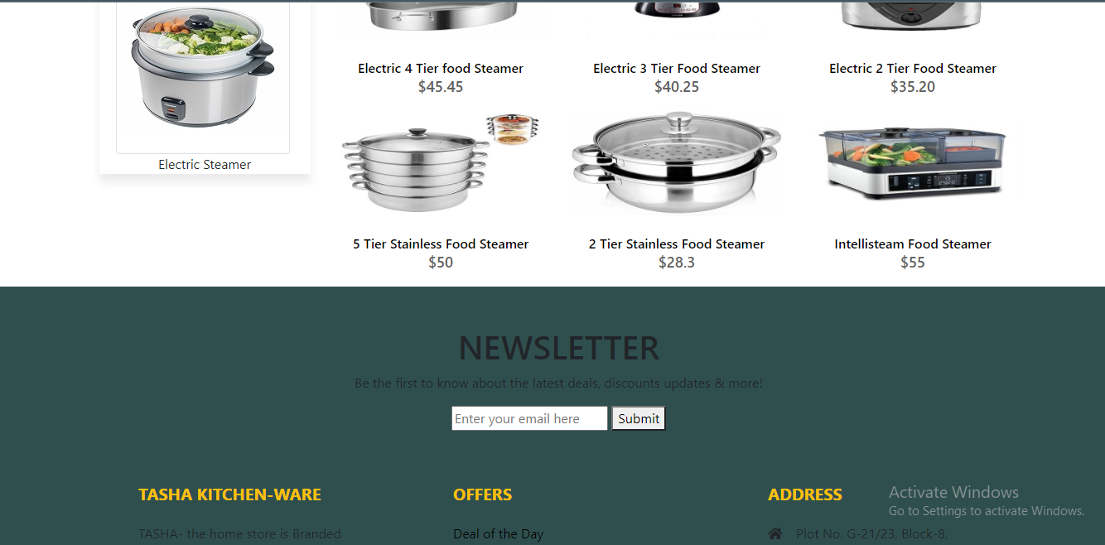

STEAMERS

STEAMERS

<!doctype html>

STEAMERS CODING

<html>

<head>

<meta charset="utf-8">

<title>Untitled Document</title>

<!--CSS LINK -->

<link rel="stylesheet" type="text/css" href="../CSS/Tasha.css"/>

<link rel="stylesheet" type="text/css" href="../bootstraps/css/bootstrap.min.css"/>

<link rel="stylesheet" type="text/css" href="../bootstraps/css/bootstrap.css"/>

<link rel="stylesheet" type="text/css" href="../CSS/Links.css"/>

<!-- Latest compiled and minified CSS START-->

<link rel="stylesheet" href="https://maxcdn.bootstrapcdn.com/bootstrap/4.5.2/css/bootstrap.min.css">

<!-- Latest compiled and minified CSS END-->

<!-- jQuery library START -->

<script src="https://ajax.googleapis.com/ajax/libs/jquery/3.5.1/jquery.min.js"></script>

<!-- jQuery library END-->

<!-- Popper JS START-->

<script src="https://cdnjs.cloudflare.com/ajax/libs/popper.js/1.16.0/umd/popper.min.js"></script>

<!-- Popper JS END -->

<!-- Latest compiled JavaScript START-->

<script src="https://maxcdn.bootstrapcdn.com/bootstrap/4.5.2/js/bootstrap.min.js"></script>

<!-- Latest compiled JavaScript -->

<!--Meta Link START-->

<meta name="viewport" content="width=device-width, initial-scale=1">

<!--Meta Link END-->

<!--FONT AWESOME CDN LINK-->

<link rel="stylesheet" href="https://pro.fontawesome.com/releases/v5.10.0/css/all.css" integrity="sha384-AYmEC3Yw5cVb3ZcuHtOA93w35dYTsvhLPVnYs9eStHfGJvOvKxVfELGroGkvsg+p" crossorigin="anonymous"/>

<!--FONT AWESOME CDN LINK-->

<link rel="stylesheet" href="https://cdn.jsdelivr.net/npm/bootstrap-icons@1.6.0/font/bootstrap-icons.css" integrity="sha384-7ynz3n3tAGNUYFZD3cWe5PDcE36xj85vyFkawcF6tIwxvIecqKvfwLiaFdizhPpN" crossorigin="anonymous">

<link href="https://fonts.googleapis.com/css2?family=Open+Sans:wght@400;700&family=Poppins:wght@100;200;300;400&display=swap" rel="stylesheet">

</head>

<body>

<header>

<ul>

<li><a href="../Tasha.html">HOME</a>

</li>

<li><a href="#">COOKWARE</a>

<ul>

<li><a href="Cooking Pot.html">Cooking Pots</a></li>

<li><a href="Frying Pans.html">Frying Pans</a></li>

<li><a href="Cookware-Sets.html">Cookware Sets</a></li>

<li><a href="Egg Poached.html">Egg Poachers</a></li>

<li><a href="Grill-Pans.html">Grill Pans</a></li>

<li><a href="Steamer.html">Steamers</a></li>

</ul>

</li>

<li><a href="#">REFRIGERATOR</a>

<ul>

<li><a href="Refrigerators.html">Refrigerators</a></li>

<li><a href="Freezers.html">Freezers</a></li>

</ul>

</li>

<li><a href="#">APPLIANCES</a>

<ul>

<li><a href="Blenders.html">Blenders</a></li>

<li><a href="Bread-Maker.html">Bread Makers</a></li>

<li><a href="Coffee-Maker.html">Coffee Makers</a></li>

<li><a href="Icecream-Sorbet-Maker.html">Ice-Cream and Sorbet Makers</a></li>

<li><a href="Kettles.html">Kettles</a></li>

<li><a href="Food-Chopper.html">Food Choppers</a></li>

<li><a href="Toaster.html">Toasters</a></li>

</ul>

</li>

<li><a href="#">FOODSTORAGE</a>

<ul>

<li><a href="Flask.html">Flask</a></li>

<li><a href="Spice-Jars.html">Spice Jars</a></li>

<li><a href="Storage-Bags.html">Storage Bags</a></li>

<li><a href="Lunch-Boxes.html">Lunch Boxes</a></li>

<li><a href="Storage-Containers.html">Storage Containers</a></li>

</ul>

</li>

<li><a href="#">SUPPORT</a>

<ul>

<li><a href="Expert Tips.html">Expert Tips</a></li>

<li><a href="Register-Complain.html">Register Complain</a></li>

<li><a href="Feedback-Form.html">Feed Back</a></li>

<li><a href="Contact Us.html">Contact Us</a></li>

</ul>

</li>

</ul>

</header>

<!--NAVIGATION BAR ENDS-->

<!--SIDE NAVIGATOR STARTS-->

<section class="category">

<div class="container">

<div class="row">

<div class="col-lg-3">

<aside class="side-area product-side side-shadow mt-5">

<div class="side-title">

<h3>UpComing Products</h3>

</div>

<div class="side-content" style="margin: 20px;" >

<img src="../Images/193.jpg" class="img-thumbnail" alt="...">

<p style="text-align: center;">Multi-Functional Electric Steamer </p>

<img src="../Images/194.jpg" class="img-thumbnail" alt="...">

<p style="text-align: center;">Electric Steamer</p>

</div>

</aside>

</div>

<!--SIDE NAVIGATOR ENDS-->

<!--COOKING POT STARTS-->

<div class="col-lg-9">

<div class="row">

<div class="col-lg-12">

<div class="product-top d-flex justify-content-between align-items-center" >

<div class="product-sec product-item ">

<h2 class="my-5">Steamers</h2>

</div>

</div>

</div>

<div class="col-lg-4 col-sm-6">

<div class="product-cate">

<div>

<img src="../Images/89.jpg" alt="" />

<div class="product-icon">

<ul>

<li><a href=""><i class="fa fa-heart" aria-hidden="true"></i></a></li>

<li><a href="Checkout-Form.html"><i class="fa fa-shopping-cart" aria-hidden="true"></i></a></li>

</ul>

</div>

<!---->

<div class="product-des">

<h5>Stainless 3 Tier Food Steamer</h5>

<p>$28</p>

</div>

</div>

</div>

</div>

<!---->

<div class="col-lg-4 col-sm-6">

<div class="product-cate">

<div>

<img src="../Images/91.jpg" alt="pot" />

<div class="product-icon">

<ul>

<li><a href=""><i class="fa fa-heart" aria-hidden="true"></i></a></li>

<li><a href="Checkout-Form.html"><i class="fa fa-shopping-cart" aria-hidden="true"></i></a></li>

</ul>

</div>

<!---->

<div class="product-des">

<h5>Stainless 4 Tier Food Steamer </h5>

<p>$30</p>

</div>

</div>

</div>

</div>

<!---->

<div class="col-lg-4 col-sm-6">

<div class="product-cate">

<div>

<img src="../Images/92.jpg" alt="pot"/>

<div class="product-icon">

<ul>

<li><a href=""><i class="fa fa-heart" aria-hidden="true"></i></a></li>

<li><a href="Checkout-Form.html"><i class="fa fa-shopping-cart" aria-hidden="true"></i></a></li>

</ul>

</div>

<!---->

<div class="product-des">

<h5>Stainless 2 Tier Food Steamer </h5>

<p>$25</p>

</div>

</div>

</div>

</div>

<!---->

<div class="col-lg-4 col-sm-6">

<div class="product-cate">

<div>

<img src="../Images/93.jpg" alt="pot" class="img-fluid"/>

<div class="product-icon">

<ul>

<li><a href=""><i class="fa fa-heart" aria-hidden="true"></i></a></li>

<li><a href="Checkout-Form.html"><i class="fa fa-shopping-cart" aria-hidden="true"></i></a></li>

</ul>

</div>

<!---->

<div class="product-des">

<h5>Electric 4 Tier food Steamer </h5>

<p>$45.45</p>

</div>

</div>

</div>

</div>

<!---->

<div class="col-lg-4 col-sm-6">

<div class="product-cate">

<div>

<img src="../Images/94.jpg" alt="pot" />

<div class="product-icon">

<ul>

<li><a href=""><i class="fa fa-heart" aria-hidden="true"></i></a></li>

<li><a href="Checkout-Form.html"><i class="fa fa-shopping-cart" aria-hidden="true"></i></a></li>

</ul>

</div>

<!---->

<div class="product-des">

<h5>Electric 3 Tier Food Steamer</h5>

<p>$40.25</p>

</div>

</div>

</div>

</div>

<!---->

<div class="col-lg-4 col-sm-6">

<div class="product-cate">

<div>

<img src="../Images/95.jpeg" alt=""/>

<div class="product-icon">

<ul>

<li><a href=""><i class="fa fa-heart" aria-hidden="true"></i></a></li>

<li><a href="Checkout-Form.html"><i class="fa fa-shopping-cart" aria-hidden="true"></i></a></li>

</ul>

</div>

<!---->

<div class="product-des">

<h5>Electric 2 Tier Food Steamer</h5>

<p>$35.20</p>

</div>

</div>

</div>

</div>

<!---->

<div class="col-lg-4 col-sm-6">

<div class="product-cate">

<div>

<img src="../Images/96.jpeg" alt="pot" />

<div class="product-icon">

<ul>

<li><a href=""><i class="fa fa-heart" aria-hidden="true"></i></a></li>

<li><a href="Checkout-Form.html"><i class="fa fa-shopping-cart" aria-hidden="true"></i></a></li>

</ul>

</div>

<!---->

<div class="product-des">

<h5>5 Tier Stainless Food Steamer</h5>

<p>$50</p>

</div>

</div>

</div>

</div>

<!---->

<div class="col-lg-4 col-sm-6">

<div class="product-cate">

<div>

<img src="../Images/97.jpeg" alt="pot" />

<div class="product-icon">

<ul>

<li><a href=""><i class="fa fa-heart" aria-hidden="true"></i></a></li>

<li><a href="Checkout-Form.html"><i class="fa fa-shopping-cart" aria-hidden="true"></i></a></li>

</ul>

</div>

<!---->

<div class="product-des">

<h5>2 Tier Stainless Food Steamer </h5>

<p>$28.3 </p>

</div>

</div>

</div>

</div>

<!---->

<div class="col-lg-4 col-sm-6">

<div class="product-cate">

<div>

<img src="../Images/98.jpg" alt="pot" />

<div class="product-icon">

<ul>

<li><a href=""><i class="fa fa-heart" aria-hidden="true"></i></a></li>

<li><a href="Checkout-Form.html"><i class="fa fa-shopping-cart" aria-hidden="true"></i></a></li>

</ul>

</div>

<!---->

<div class="product-des">

<h5>Intellisteam Food Steamer</h5>

<p>$55</p>

</div>

</div>

</div>

</div>

</div>

</div>

</div>

</div>

</section>

<!--COOKING POT END-->

<!-- FOOTER STARTS -->

<footer class=" text-black pt-5 pb-4 page-footer" style="background-color: darkslategray;">

<div class="text-center">

<h1 >NEWSLETTER</h1>

<p>Be the first to know about the latest deals, discounts updates & more!</p>

<input type="email" name="email" placeholder="Enter your email here"/>

<button type="submit" onClick="onclick" > Submit </button>

</div>

<br><br>

<div class=" container text-center text-md-left ">

<div class="row text-center text-md-left ">

<div class="col-md-3 col-lg-3 col-xl-3 mx-auto mt-3">

<h5 class="text-uppercase mb-4 font-weight-bold text-warning">TASHA Kitchen-Ware</h5>

<p>TASHA- the home store is Branded Company famous for home kitchen appliances. It provides collection of n number of appliances with different category to match the fast life of the generation. The Tasha group of companies had made huge profit in the year 2013. In order to enhance its business the organization wants you to develop the website.</p>

</div>

<div class="col-md-3 col-lg-3 col-xl-3 mx-auto mt-3" >

<h5 class="text-uppercase mb-4 font-weight-bold text-warning">OFFERS</h5>

<p><a href="#" class="text-black" style="text-decoration: none; color:black; ">Deal of the Day</a></p>

<p><a href="#" class="text-black" style="text-decoration: none;color:black;">Buy 1 Get 1 Free</a></p>

<p><a href="#" class="text-black" style="text-decoration: none;color:black;">Appliance Packages Offers</a></p>

<p ><a href="#" class="text-black" style="text-decoration: none; color:black;">Reward Program</a></p>

</div>

<div class="col-md-4 col-lg-3 col-xl-3 mx-auto mt-3">

<h5 class="text-uppercase mb-4 font-weight-bold text-warning">ADDRESS</h5>

<p>

<i class="fas fa-home mr-3"></i>Plot No. G-21/23, Block-8, Khaliquzzaman Road, Clifton، Block 8 Clifton, Karachi, Karachi City, Sindh 75600

</p>

</div>

</div>

<hr class="mb-4">

<div class="row align-items-center">

<div class="col-md-7 col-lg-8">

<p>copyright all rights reserved by <a href="#" style="text-decoration: none"><strong class="text-warning">The Provider</strong></a></p></div>

<div class="col-md-5 col-lg-4">

<div class="text-center text-md-right">

<ul class="list-unstyled list-inline">

<li class="list-inline-item">

<a href="#" class="btn-floating btn-sm text-black" style="font-size:23px;"><i class="fab fa-facebook"></i></a></li>

<li class="list-inline-item">

<a href="#" class="btn-floating btn-sm text-black" style="font-size:23px;"><i class="fab fa-twitter"></i></a></li>

<li class="list-inline-item">

<a href="#" class="btn-floating btn-sm text-black" style="font-size:23px;"><i class="fab fa-instagram"></i></a></li>

<li class="list-inline-item">

<a href="#" class="btn-floating btn-sm text-black" style="font-size:23px;"><i class="fas fa-link"></i></a></li>

</ul>

</div>

</div>

</div>

</div>

</footer>

<!--FOOTER ENDS-->

</body>

</html>

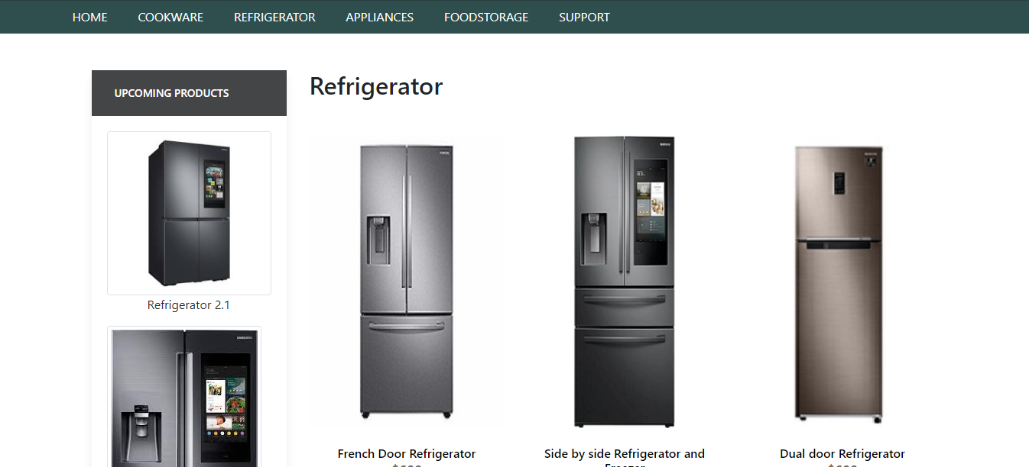

REFRIGERATOR

REFRIGERATOR

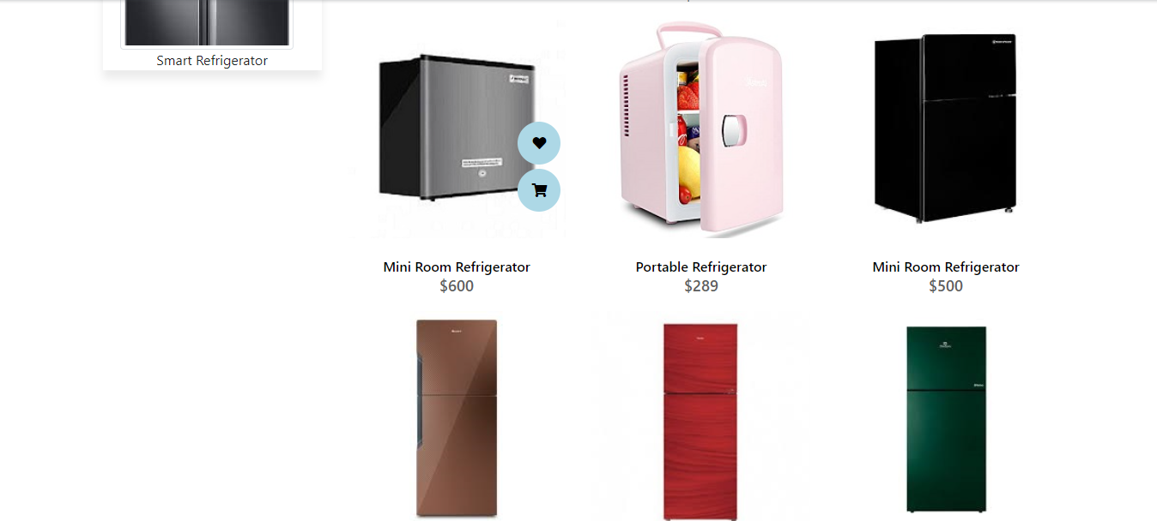

REFRIGERATOR

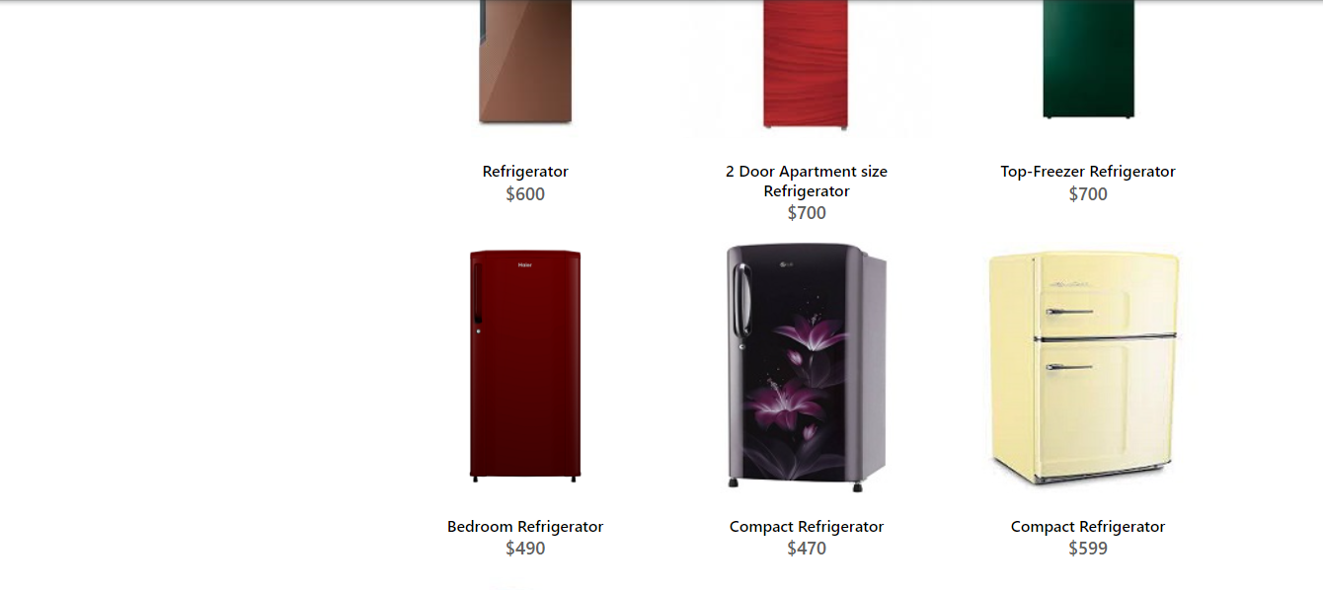

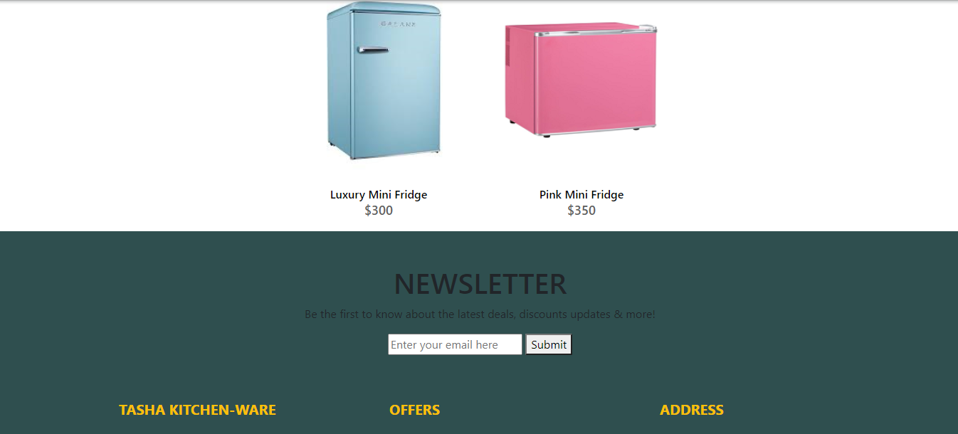

REFRIGERATOR

<!doctype html>

REFRIGERATOR CODING

<html>

<head>

<meta charset="utf-8">

<title>Untitled Document</title>

<!--CSS LINK -->

<link rel="stylesheet" type="text/css" href="../CSS/Tasha.css"/>

<link rel="stylesheet" type="text/css" href="../bootstraps/css/bootstrap.min.css"/>

<link rel="stylesheet" type="text/css" href="../bootstraps/css/bootstrap.css"/>

<link rel="stylesheet" type="text/css" href="../CSS/Links.css"/>

<!-- Latest compiled and minified CSS START-->

<link rel="stylesheet" href="https://maxcdn.bootstrapcdn.com/bootstrap/4.5.2/css/bootstrap.min.css">

<!-- Latest compiled and minified CSS END-->

<!-- jQuery library START -->

<script src="https://ajax.googleapis.com/ajax/libs/jquery/3.5.1/jquery.min.js"></script>

<!-- jQuery library END-->

<!-- Popper JS START-->

<script src="https://cdnjs.cloudflare.com/ajax/libs/popper.js/1.16.0/umd/popper.min.js"></script>

<!-- Popper JS END -->

<!-- Latest compiled JavaScript START-->

<script src="https://maxcdn.bootstrapcdn.com/bootstrap/4.5.2/js/bootstrap.min.js"></script>

<!-- Latest compiled JavaScript -->

<!--Meta Link START-->

<meta name="viewport" content="width=device-width, initial-scale=1">

<!--Meta Link END-->

<!--FONT AWESOME CDN LINK-->

<link rel="stylesheet" href="https://pro.fontawesome.com/releases/v5.10.0/css/all.css" integrity="sha384-AYmEC3Yw5cVb3ZcuHtOA93w35dYTsvhLPVnYs9eStHfGJvOvKxVfELGroGkvsg+p" crossorigin="anonymous"/>

<!--FONT AWESOME CDN LINK-->

<link rel="stylesheet" href="https://cdn.jsdelivr.net/npm/bootstrap-icons@1.6.0/font/bootstrap-icons.css" integrity="sha384-7ynz3n3tAGNUYFZD3cWe5PDcE36xj85vyFkawcF6tIwxvIecqKvfwLiaFdizhPpN" crossorigin="anonymous">

<link href="https://fonts.googleapis.com/css2?family=Open+Sans:wght@400;700&family=Poppins:wght@100;200;300;400&display=swap" rel="stylesheet">

</head>

<body>

<header>

<ul>

<li><a href="../Tasha.html">HOME</a>

</li>

<li><a href="#">COOKWARE</a>

<ul>

<li><a href="Cooking Pot.html">Cooking Pots</a></li>

<li><a href="Frying Pans.html">Frying Pans</a></li>

<li><a href="Cookware-Sets.html">Cookware Sets</a></li>

<li><a href="Egg Poached.html">Egg Poachers</a></li>

<li><a href="Grill-Pans.html">Grill Pans</a></li>

<li><a href="Steamer.html">Steamers</a></li>

</ul>

</li>

<li><a href="#">REFRIGERATOR</a>

<ul>

<li><a href="Refrigerators.html">Refrigerators</a></li>

<li><a href="Freezers.html">Freezers</a></li>

</ul>

</li>

<li><a href="#">APPLIANCES</a>

<ul>

<li><a href="Blenders.html">Blenders</a></li>

<li><a href="Bread-Maker.html">Bread Makers</a></li>

<li><a href="Coffee-Maker.html">Coffee Makers</a></li>

<li><a href="Icecream-Sorbet-Maker.html">Ice-Cream and Sorbet Makers</a></li>

<li><a href="Kettles.html">Kettles</a></li>

<li><a href="Food-Chopper.html">Food Choppers</a></li>

<li><a href="Toaster.html">Toasters</a></li>

</ul>

</li>

<li><a href="#">FOODSTORAGE</a>

<ul>

<li><a href="Flask.html">Flask</a></li>

<li><a href="Spice-Jars.html">Spice Jars</a></li>

<li><a href="Storage-Bags.html">Storage Bags</a></li>

<li><a href="Lunch-Boxes.html">Lunch Boxes</a></li>

<li><a href="Storage-Containers.html">Storage Containers</a></li>

</ul>

</li>

<li><a href="#">SUPPORT</a>

<ul>

<li><a href="Expert Tips.html">Expert Tips</a></li>

<li><a href="Register-Complain.html">Register Complain</a></li>

<li><a href="Feedback-Form.html">Feed Back</a></li>

<li><a href="Contact Us.html">Contact Us</a></li>

</ul>

</li>

</ul>

</header>

<!--NAVIGATION BAR ENDS-->

<!—**REFRIGERATOR START** 🡪

<section class="category">

<div class="container">

<div class="row">

<div class="col-lg-3">

<aside class="side-area product-side side-shadow mt-5">

<div class="side-title">

<h3>UpComing Products</h3>

</div>

<div class="side-content" style="margin: 20px;" >

<img src="../Images/195.jpg" class="img-thumbnail" alt="...">

<p style="text-align: center;">Refrigerator 2.1 </p>

<img src="../Images/196.jpg" class="img-thumbnail" alt="...">

<p style="text-align: center;">Smart Refrigerator</p>

</div>

</aside>

</div>

<!--SIDE NAVIGATOR ENDS-->

<!--COOKING POT STARTS-->

<div class="col-lg-9">

<div class="row">

<div class="col-lg-12">

<div class="product-top d-flex justify-content-between align-items-center" >

<div class="product-sec product-item ">

<h2 class="my-5">Refrigerator</h2>

</div>

</div>

</div>

<div class="col-lg-4 col-sm-6">

<div class="product-cate">

<div>

<img src="../Images/55.jpg" alt="" />

<div class="product-icon">

<ul>

<li><a href=""><i class="fa fa-heart" aria-hidden="true"></i></a></li>

<li><a href="Checkout-Form.html"><i class="fa fa-shopping-cart" aria-hidden="true"></i></a></li>

</ul>

</div>

<!---->

<div class="product-des">

<h5>French Door Refrigerator</h5>

<p>$600</p>

</div>

</div>

</div>

</div>

<!---->

<div class="col-lg-4 col-sm-6">

<div class="product-cate">

<div>

<img src="../Images/56.png" alt="pot" />

<div class="product-icon">

<ul>

<li><a href=""><i class="fa fa-heart" aria-hidden="true"></i></a></li>

<li><a href="Checkout-Form.html"><i class="fa fa-shopping-cart" aria-hidden="true"></i></a></li>

</ul>

</div>

<!---->

<div class="product-des">

<h5>Side by side Refrigerator and Freezer</h5>

<p>$799</p>

</div>

</div>

</div>

</div>

<!---->

<div class="col-lg-4 col-sm-6">

<div class="product-cate">

<div>

<img src="../Images/67.jpg" alt="pot"/>

<div class="product-icon">

<ul>

<li><a href=""><i class="fa fa-heart" aria-hidden="true"></i></a></li>

<li><a href="Checkout-Form.html"><i class="fa fa-shopping-cart" aria-hidden="true"></i></a></li>

</ul>

</div>

<!---->

<div class="product-des">

<h5>Dual door Refrigerator</h5>

<p>$600</p>

</div>

</div>

</div>

</div>

<!---->

<div class="col-lg-4 col-sm-6">

<div class="product-cate">

<div>

<img src="../Images/57.jpg" alt="pot" class="img-fluid"/>

<div class="product-icon">

<ul>

<li><a href=""><i class="fa fa-heart" aria-hidden="true"></i></a></li>

<li><a href="Checkout-Form.html"><i class="fa fa-shopping-cart" aria-hidden="true"></i></a></li>

</ul>

</div>

<!---->

<div class="product-des">

<h5>Mini Room Refrigerator</h5>

<p>$600</p>

</div>

</div>

</div>

</div>

<!---->

<div class="col-lg-4 col-sm-6">

<div class="product-cate">

<div>

<img src="../Images/58.jpg" alt="pot" />

<div class="product-icon">

<ul>

<li><a href=""><i class="fa fa-heart" aria-hidden="true"></i></a></li>

<li><a href="Checkout-Form.html"><i class="fa fa-shopping-cart" aria-hidden="true"></i></a></li>

</ul>

</div>

<!---->

<div class="product-des">

<h5>Portable Refrigerator</h5>

<p>$289</p>

</div>

</div>

</div>

</div>

<!---->

<div class="col-lg-4 col-sm-6">

<div class="product-cate">

<div>

<img src="../Images/59.jpg" alt=""/>

<div class="product-icon">

<ul>

<li><a href=""><i class="fa fa-heart" aria-hidden="true"></i></a></li>

<li><a href="Checkout-Form.html"><i class="fa fa-shopping-cart" aria-hidden="true"></i></a></li>

</ul>

</div>

<!---->

<div class="product-des">

<h5>Mini Room Refrigerator</h5>

<p>$500</p>

</div>

</div>

</div>

</div>

<!---->

<div class="col-lg-4 col-sm-6">

<div class="product-cate">

<div>

<img src="../Images/62.jpg" alt="pot" />

<div class="product-icon">

<ul>

<li><a href=""><i class="fa fa-heart" aria-hidden="true"></i></a></li>

<li><a href="Checkout-Form.html"><i class="fa fa-shopping-cart" aria-hidden="true"></i></a></li>

</ul>

</div>

<!---->

<div class="product-des">

<h5>Refrigerator</h5>

<p>$600</p>

</div>

</div>

</div>

</div>

<!---->

<div class="col-lg-4 col-sm-6">

<div class="product-cate">

<div>

<img src="../Images/63.jpg" alt="pot"/>

<div class="product-icon">

<ul>

<li><a href=""><i class="fa fa-heart" aria-hidden="true"></i></a></li>

<li><a href="Checkout-Form.html"><i class="fa fa-shopping-cart" aria-hidden="true"></i></a></li>

</ul>

</div>

<!---->

<div class="product-des">

<h5>2 Door Apartment size Refrigerator</h5>

<p>$700</p>

</div>

</div>

</div>

</div>

<!---->

<div class="col-lg-4 col-sm-6">

<div class="product-cate">

<div>

<img src="../Images/64.jpg" alt="pot"/>

<div class="product-icon">

<ul>

<li><a href=""><i class="fa fa-heart" aria-hidden="true"></i></a></li>

<li><a href="Checkout-Form.html"><i class="fa fa-shopping-cart" aria-hidden="true"></i></a></li>

</ul>

</div>

<!---->

<div class="product-des">

<h5>Top-Freezer Refrigerator</h5>

<p>$700</p>

</div>

</div>

</div>

</div>

<!---->

<div class="col-lg-4 col-sm-6">

<div class="product-cate">

<div>

<img src="../Images/65.jpg" alt=""/>

<div class="product-icon">

<ul>

<li><a href=""><i class="fa fa-heart" aria-hidden="true"></i></a></li>

<li><a href="Checkout-Form.html"><i class="fa fa-shopping-cart" aria-hidden="true"></i></a></li>

</ul>

</div>

<!---->

<div class="product-des">

<h5>Bedroom Refrigerator</h5>

<p>$490</p>

</div>

</div>

</div>

</div>

<!---->

<div class="col-lg-4 col-sm-6">

<div class="product-cate">

<div>

<img src="../Images/66.jpg" alt="pot" />

<div class="product-icon">

<ul>

<li><a href=""><i class="fa fa-heart" aria-hidden="true"></i></a></li>

<li><a href="Checkout-Form.html"><i class="fa fa-shopping-cart" aria-hidden="true"></i></a></li>

</ul>

</div>

<!---->

<div class="product-des">

<h5>Compact Refrigerator</h5>

<p>$470</p>

</div>

</div>

</div>

</div>

<!---->

<div class="col-lg-4 col-sm-6">

<div class="product-cate">

<div>

<img src="../Images/68.jpg" alt="pot"/>

<div class="product-icon">

<ul>

<li><a href=""><i class="fa fa-heart" aria-hidden="true"></i></a></li>

<li><a href="Checkout-Form.html"><i class="fa fa-shopping-cart" aria-hidden="true"></i></a></li>

</ul>

</div>

<!---->

<div class="product-des">

<h5>Compact Refrigerator</h5>

<p>$599</p>

</div>

</div>

</div>

</div>

<!---->

<div class="col-lg-4 col-sm-6">

<div class="product-cate">

<div>

<img src="../Images/60.jpg" alt="pot"/>

<div class="product-icon">

<ul>

<li><a href=""><i class="fa fa-heart" aria-hidden="true"></i></a></li>

<li><a href="Checkout-Form.html"><i class="fa fa-shopping-cart" aria-hidden="true"></i></a></li>

</ul>

</div>

<!---->

<div class="product-des">

<h5>Luxury Mini Fridge</h5>

<p>$300</p>

</div>

</div>

</div>

</div>

<!---->

<div class="col-lg-4 col-sm-6">

<div class="product-cate">

<div>

<img src="../Images/61.jpg" alt="pot"/>

<div class="product-icon">

<ul>

<li><a href=""><i class="fa fa-heart" aria-hidden="true"></i></a></li>

<li><a href="Checkout-Form.html"><i class="fa fa-shopping-cart" aria-hidden="true"></i></a></li>

</ul>

</div>

<!---->

<div class="product-des">

<h5>Pink Mini Fridge</h5>

<p>$350</p>

</div>

</div>

</div>

</div>

<!---->

</div>

</div>

</div>

</div>

</section>

**<!--REFRIGERATOR END-->**

**<!-- FOOTER STARTS -->**

<footer class=" text-black pt-5 pb-4 page-footer" style="background-color: darkslategray;">

<div class="text-center">

<h1 >NEWSLETTER</h1>

<p>Be the first to know about the latest deals, discounts updates & more!</p>

<input type="email" name="email" placeholder="Enter your email here"/>

<button type="submit" onClick="onclick" > Submit </button>

</div>

<br><br>

<div class=" container text-center text-md-left ">

<div class="row text-center text-md-left ">

<div class="col-md-3 col-lg-3 col-xl-3 mx-auto mt-3">

<h5 class="text-uppercase mb-4 font-weight-bold text-warning">TASHA Kitchen-Ware</h5>

<p>TASHA- the home store is Branded Company famous for home kitchen appliances. It provides collection of n number of appliances with different category to match the fast life of the generation. The Tasha group of companies had made huge profit in the year 2013. In order to enhance its business the organization wants you to develop the website.</p>

</div>

<div class="col-md-3 col-lg-3 col-xl-3 mx-auto mt-3" >

<h5 class="text-uppercase mb-4 font-weight-bold text-warning">OFFERS</h5>

<p><a href="#" class="text-black" style="text-decoration: none; color:black; ">Deal of the Day</a></p>

<p><a href="#" class="text-black" style="text-decoration: none;color:black;">Buy 1 Get 1 Free</a></p>

<p><a href="#" class="text-black" style="text-decoration: none;color:black;">Appliance Packages Offers</a></p>

<p ><a href="#" class="text-black" style="text-decoration: none; color:black;">Reward Program</a></p>

</div>

<div class="col-md-4 col-lg-3 col-xl-3 mx-auto mt-3">

<h5 class="text-uppercase mb-4 font-weight-bold text-warning">ADDRESS</h5>

<p>

<i class="fas fa-home mr-3"></i>Plot No. G-21/23, Block-8, Khaliquzzaman Road, Clifton، Block 8 Clifton, Karachi, Karachi City, Sindh 75600

</p>

</div>

</div>

<hr class="mb-4">

<div class="row align-items-center">

<div class="col-md-7 col-lg-8">

<p>copyright all rights reserved by <a href="#" style="text-decoration: none"><strong class="text-warning">The Provider</strong></a></p></div>

<div class="col-md-5 col-lg-4">

<div class="text-center text-md-right">

<ul class="list-unstyled list-inline">

<li class="list-inline-item">

<a href="#" class="btn-floating btn-sm text-black" style="font-size:23px;"><i class="fab fa-facebook"></i></a></li>

<li class="list-inline-item">

<a href="#" class="btn-floating btn-sm text-black" style="font-size:23px;"><i class="fab fa-twitter"></i></a></li>

<li class="list-inline-item">

<a href="#" class="btn-floating btn-sm text-black" style="font-size:23px;"><i class="fab fa-instagram"></i></a></li>

<li class="list-inline-item">

<a href="#" class="btn-floating btn-sm text-black" style="font-size:23px;"><i class="fas fa-link"></i></a></li>

</ul>

</div>

</div>

</div>

</div>

</footer>

**<!--FOOTER ENDS-->**

</body>

</html>

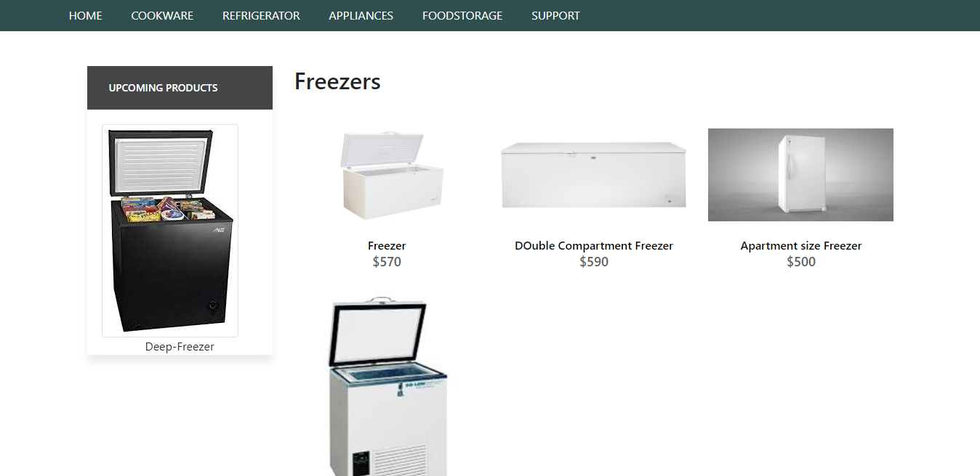

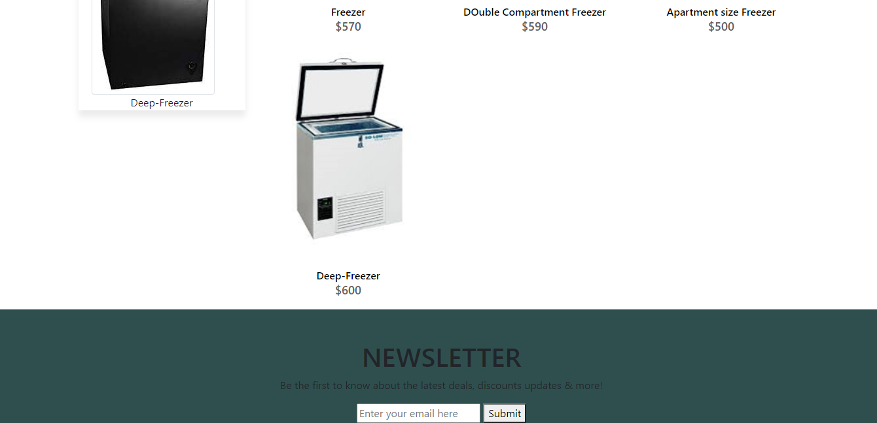

<!doctype html>

<html>

<head>

<meta charset="utf-8">

<title>Untitled Document</title>

<!--CSS LINK -->

<link rel="stylesheet" type="text/css" href="../CSS/Tasha.css"/>

<link rel="stylesheet" type="text/css" href="../bootstraps/css/bootstrap.min.css"/>

<link rel="stylesheet" type="text/css" href="../bootstraps/css/bootstrap.css"/>

<link rel="stylesheet" type="text/css" href="../CSS/Links.css"/>

<!-- Latest compiled and minified CSS START-->

<link rel="stylesheet" href="https://maxcdn.bootstrapcdn.com/bootstrap/4.5.2/css/bootstrap.min.css">

<!-- Latest compiled and minified CSS END-->

<!-- jQuery library START -->

<script src="https://ajax.googleapis.com/ajax/libs/jquery/3.5.1/jquery.min.js"></script>

<!-- jQuery library END-->

<!-- Popper JS START-->

<script src="https://cdnjs.cloudflare.com/ajax/libs/popper.js/1.16.0/umd/popper.min.js"></script>

<!-- Popper JS END -->

<!-- Latest compiled JavaScript START-->

<script src="https://maxcdn.bootstrapcdn.com/bootstrap/4.5.2/js/bootstrap.min.js"></script>

<!-- Latest compiled JavaScript -->

<!--Meta Link START-->

<meta name="viewport" content="width=device-width, initial-scale=1">

<!--Meta Link END-->

<!--FONT AWESOME CDN LINK-->

<link rel="stylesheet" href="https://pro.fontawesome.com/releases/v5.10.0/css/all.css" integrity="sha384-AYmEC3Yw5cVb3ZcuHtOA93w35dYTsvhLPVnYs9eStHfGJvOvKxVfELGroGkvsg+p" crossorigin="anonymous"/>

<!--FONT AWESOME CDN LINK-->

<link rel="stylesheet" href="https://cdn.jsdelivr.net/npm/bootstrap-icons@1.6.0/font/bootstrap-icons.css" integrity="sha384-7ynz3n3tAGNUYFZD3cWe5PDcE36xj85vyFkawcF6tIwxvIecqKvfwLiaFdizhPpN" crossorigin="anonymous">

<link href="https://fonts.googleapis.com/css2?family=Open+Sans:wght@400;700&family=Poppins:wght@100;200;300;400&display=swap" rel="stylesheet">

</head>

<body>

<header>

<ul>

<li><a href="../Tasha.html">HOME</a>

</li>

<li><a href="#">COOKWARE</a>

<ul>

<li><a href="Cooking Pot.html">Cooking Pots</a></li>

<li><a href="Frying Pans.html">Frying Pans</a></li>

<li><a href="Cookware-Sets.html">Cookware Sets</a></li>

<li><a href="Egg Poached.html">Egg Poachers</a></li>

<li><a href="Grill-Pans.html">Grill Pans</a></li>

<li><a href="Steamer.html">Steamers</a></li>

</ul>

</li>

<li><a href="#">REFRIGERATOR</a>

<ul>

<li><a href="Refrigerators.html">Refrigerators</a></li>

<li><a href="Freezers.html">Freezers</a></li>

</ul>

</li>

<li><a href="#">APPLIANCES</a>

<ul>

<li><a href="Blenders.html">Blenders</a></li>

<li><a href="Bread-Maker.html">Bread Makers</a></li>

<li><a href="Coffee-Maker.html">Coffee Makers</a></li>

<li><a href="Icecream-Sorbet-Maker.html">Ice-Cream and Sorbet Makers</a></li>

<li><a href="Kettles.html">Kettles</a></li>

<li><a href="Food-Chopper.html">Food Choppers</a></li>

<li><a href="Toaster.html">Toasters</a></li>

</ul>

</li>

<li><a href="#">FOODSTORAGE</a>

<ul>

<li><a href="Flask.html">Flask</a></li>

<li><a href="Spice-Jars.html">Spice Jars</a></li>

<li><a href="Storage-Bags.html">Storage Bags</a></li>

<li><a href="Lunch-Boxes.html">Lunch Boxes</a></li>

<li><a href="Storage-Containers.html">Storage Containers</a></li>

</ul>

</li>

<li><a href="#">SUPPORT</a>

<ul>

<li><a href="Expert Tips.html">Expert Tips</a></li>

<li><a href="Register-Complain.html">Register Complain</a></li>

<li><a href="Feedback-Form.html">Feed Back</a></li>

<li><a href="Contact Us.html">Contact Us</a></li>

</ul>

</li>

</ul>

</header>

<!--NAVIGATION BAR ENDS-->

<!--NAVIGATION BAR ENDS-->

<!--SIDE NAVIGATOR STARTS-->

<section class="category">

<div class="container">

<div class="row">

<div class="col-lg-3">

<aside class="side-area product-side side-shadow mt-5">

<div class="side-title">

<h3>UpComing Products</h3>

</div>

<div class="side-content" style="margin: 20px;" >

<img src="../Images/224.jpg" class="img-thumbnail" alt="...">

<p style="text-align: center;">Deep-Freezer </p>

</div>

</aside>

</div>

<!--SIDE NAVIGATOR ENDS-->

<!--COOKING POT STARTS-->

<div class="col-lg-9">

<div class="row">

<div class="col-lg-12">

<div class="product-top d-flex justify-content-between align-items-center" >

<div class="product-sec product-item ">

<h2 class="my-5">Freezers</h2>

</div>

</div>

</div>

<div class="col-lg-4 col-sm-6">

<div class="product-cate">

<div>

<img src="../Images/69.webp" alt="" />

<div class="product-icon">

<ul>

<li><a href=""><i class="fa fa-heart" aria-hidden="true"></i></a></li>

<li><a href="Checkout-Form.html"><i class="fa fa-shopping-cart" aria-hidden="true"></i></a></li>

</ul>

</div>

<!---->

<div class="product-des">

<h5>Freezer</h5>

<p>$570</p>

</div>

</div>

</div>

</div>

<!---->

<div class="col-lg-4 col-sm-6">

<div class="product-cate">

<div>

<img src="../Images/71.jpg" alt="pot" />

<div class="product-icon">

<ul>

<li><a href=""><i class="fa fa-heart" aria-hidden="true"></i></a></li>

<li><a href="Checkout-Form.html"><i class="fa fa-shopping-cart" aria-hidden="true"></i></a></li>

</ul>

</div>

<!---->

<div class="product-des">

<h5>DOuble Compartment Freezer</h5>

<p>$590</p>

</div>

</div>

</div>

</div>

<!---->

<div class="col-lg-4 col-sm-6">

<div class="product-cate">

<div>

<img src="../Images/72.jpg" alt="pot"/>

<div class="product-icon">

<ul>

<li><a href=""><i class="fa fa-heart" aria-hidden="true"></i></a></li>

<li><a href="Checkout-Form.html"><i class="fa fa-shopping-cart" aria-hidden="true"></i></a></li>

</ul>

</div>

<!---->

<div class="product-des">

<h5>Apartment size Freezer</h5>

<p>$500</p>

</div>

</div>

</div>

</div>

<!---->

<!---->

<!---->

<div class="col-lg-4 col-sm-6">

<div class="product-cate">

<div>

<img src="../Images/70.jpg" alt=""/>

<div class="product-icon">

<ul>

<li><a href=""><i class="fa fa-heart" aria-hidden="true"></i></a></li>

<li><a href="Checkout-Form.html"><i class="fa fa-shopping-cart" aria-hidden="true"></i></a></li>

</ul>

</div>

<!---->

<div class="product-des">

<h5>Deep-Freezer</h5>

<p>$600</p>

</div>

</div>

</div>

</div>

<!---->

</div>

</div>

</div>

</div>

</section>

<!--FREEZER END-->

<!-- FOOTER STARTS -->

<footer class=" text-black pt-5 pb-4 page-footer" style="background-color: darkslategray;">

<div class="text-center">

<h1 >NEWSLETTER</h1>

<p>Be the first to know about the latest deals, discounts updates & more!</p>

<input type="email" name="email" placeholder="Enter your email here"/>

<button type="submit" onClick="onclick" > Submit </button>

</div>

<br><br>

<div class=" container text-center text-md-left ">

<div class="row text-center text-md-left ">

<div class="col-md-3 col-lg-3 col-xl-3 mx-auto mt-3">

<h5 class="text-uppercase mb-4 font-weight-bold text-warning">TASHA Kitchen-Ware</h5>

<p>TASHA- the home store is Branded Company famous for home kitchen appliances. It provides collection of n number of appliances with different category to match the fast life of the generation. The Tasha group of companies had made huge profit in the year 2013. In order to enhance its business the organization wants you to develop the website.</p>

</div>

<div class="col-md-3 col-lg-3 col-xl-3 mx-auto mt-3" >

<h5 class="text-uppercase mb-4 font-weight-bold text-warning">OFFERS</h5>

<p><a href="#" class="text-black" style="text-decoration: none; color:black; ">Deal of the Day</a></p>

<p><a href="#" class="text-black" style="text-decoration: none;color:black;">Buy 1 Get 1 Free</a></p>

<p><a href="#" class="text-black" style="text-decoration: none;color:black;">Appliance Packages Offers</a></p>

<p ><a href="#" class="text-black" style="text-decoration: none; color:black;">Reward Program</a></p>

</div>

<div class="col-md-4 col-lg-3 col-xl-3 mx-auto mt-3">

<h5 class="text-uppercase mb-4 font-weight-bold text-warning">ADDRESS</h5>

<p>

<i class="fas fa-home mr-3"></i>Plot No. G-21/23, Block-8, Khaliquzzaman Road, Clifton، Block 8 Clifton, Karachi, Karachi City, Sindh 75600

</p>

</div>

</div>

<hr class="mb-4">

<div class="row align-items-center">

<div class="col-md-7 col-lg-8">

<p>copyright all rights reserved by <a href="#" style="text-decoration: none"><strong class="text-warning">The Provider</strong></a></p></div>

<div class="col-md-5 col-lg-4">

<div class="text-center text-md-right">

<ul class="list-unstyled list-inline">

<li class="list-inline-item">

<a href="#" class="btn-floating btn-sm text-black" style="font-size:23px;"><i class="fab fa-facebook"></i></a></li>

<li class="list-inline-item">

<a href="#" class="btn-floating btn-sm text-black" style="font-size:23px;"><i class="fab fa-twitter"></i></a></li>

<li class="list-inline-item">

<a href="#" class="btn-floating btn-sm text-black" style="font-size:23px;"><i class="fab fa-instagram"></i></a></li>

<li class="list-inline-item">

<a href="#" class="btn-floating btn-sm text-black" style="font-size:23px;"><i class="fas fa-link"></i></a></li>

</ul>

</div>

</div>

</div>

</div>

</footer>

<!--FOOTER ENDS-->

</body>

</html>

Blenders

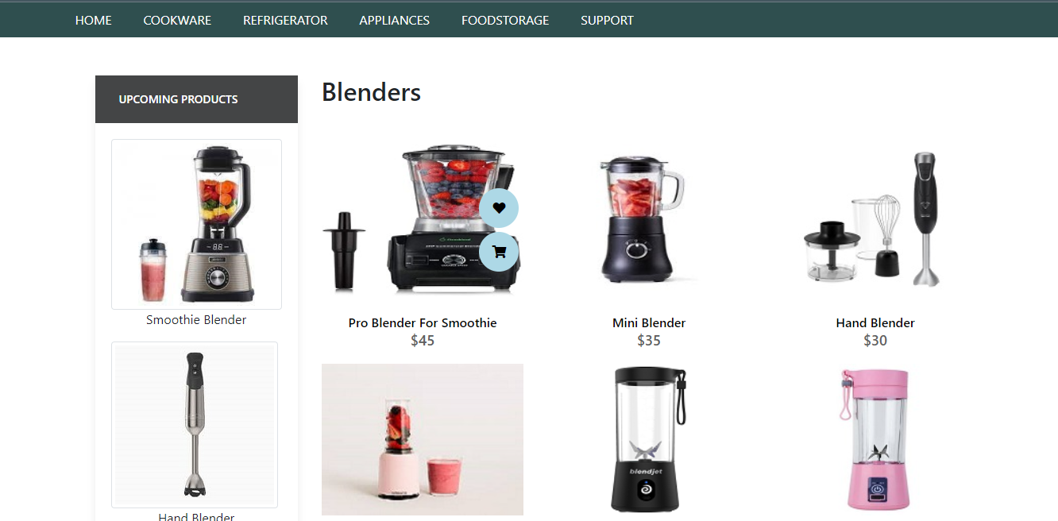

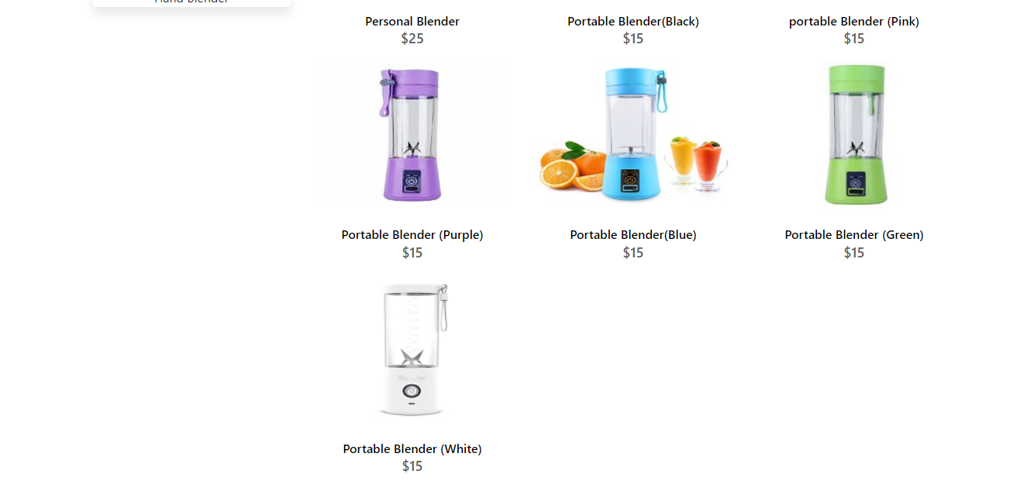

Blenders

Blenders



<!doctype html>

<html>

<head>

<meta charset="utf-8">

<title>Untitled Document</title>

<!--CSS LINK -->

<link rel="stylesheet" type="text/css" href="../CSS/Tasha.css"/>

<link rel="stylesheet" type="text/css" href="../bootstraps/css/bootstrap.min.css"/>

<link rel="stylesheet" type="text/css" href="../bootstraps/css/bootstrap.css"/>

<link rel="stylesheet" type="text/css" href="../CSS/Links.css"/>

<!-- Latest compiled and minified CSS START-->

<link rel="stylesheet" href="https://maxcdn.bootstrapcdn.com/bootstrap/4.5.2/css/bootstrap.min.css">

<!-- Latest compiled and minified CSS END-->

<!-- jQuery library START -->

<script src="https://ajax.googleapis.com/ajax/libs/jquery/3.5.1/jquery.min.js"></script>

<!-- jQuery library END-->

<!-- Popper JS START-->

<script src="https://cdnjs.cloudflare.com/ajax/libs/popper.js/1.16.0/umd/popper.min.js"></script>

<!-- Popper JS END -->

<!-- Latest compiled JavaScript START-->

<script src="https://maxcdn.bootstrapcdn.com/bootstrap/4.5.2/js/bootstrap.min.js"></script>

<!-- Latest compiled JavaScript -->

<!--Meta Link START-->

<meta name="viewport" content="width=device-width, initial-scale=1">

<!--Meta Link END-->

<!--FONT AWESOME CDN LINK-->

<link rel="stylesheet" href="https://pro.fontawesome.com/releases/v5.10.0/css/all.css" integrity="sha384-AYmEC3Yw5cVb3ZcuHtOA93w35dYTsvhLPVnYs9eStHfGJvOvKxVfELGroGkvsg+p" crossorigin="anonymous"/>

<!--FONT AWESOME CDN LINK-->

<link rel="stylesheet" href="https://cdn.jsdelivr.net/npm/bootstrap-icons@1.6.0/font/bootstrap-icons.css" integrity="sha384-7ynz3n3tAGNUYFZD3cWe5PDcE36xj85vyFkawcF6tIwxvIecqKvfwLiaFdizhPpN" crossorigin="anonymous">

<link href="https://fonts.googleapis.com/css2?family=Open+Sans:wght@400;700&family=Poppins:wght@100;200;300;400&display=swap" rel="stylesheet">

</head>

<body>

<header>

<ul>

<li><a href="../Tasha.html">HOME</a>

</li>

<li><a href="#">COOKWARE</a>

<ul>

<li><a href="Cooking Pot.html">Cooking Pots</a></li>

<li><a href="Frying Pans.html">Frying Pans</a></li>

<li><a href="Cookware-Sets.html">Cookware Sets</a></li>

<li><a href="Egg Poached.html">Egg Poachers</a></li>

<li><a href="Grill-Pans.html">Grill Pans</a></li>

<li><a href="Steamer.html">Steamers</a></li>

</ul>

</li>

<li><a href="#">REFRIGERATOR</a>

<ul>

<li><a href="Refrigerators.html">Refrigerators</a></li>

<li><a href="Freezers.html">Freezers</a></li>

</ul>

</li>

<li><a href="#">APPLIANCES</a>

<ul>

<li><a href="Blenders.html">Blenders</a></li>

<li><a href="Bread-Maker.html">Bread Makers</a></li>

<li><a href="Coffee-Maker.html">Coffee Makers</a></li>

<li><a href="Icecream-Sorbet-Maker.html">Ice-Cream and Sorbet Makers</a></li>

<li><a href="Kettles.html">Kettles</a></li>

<li><a href="Food-Chopper.html">Food Choppers</a></li>

<li><a href="Toaster.html">Toasters</a></li>

</ul>

</li>

<li><a href="#">FOODSTORAGE</a>

<ul>

<li><a href="Flask.html">Flask</a></li>

<li><a href="Spice-Jars.html">Spice Jars</a></li>

<li><a href="Storage-Bags.html">Storage Bags</a></li>

<li><a href="Lunch-Boxes.html">Lunch Boxes</a></li>

<li><a href="Storage-Containers.html">Storage Containers</a></li>

</ul>

</li>

<li><a href="#">SUPPORT</a>

<ul>

<li><a href="Expert Tips.html">Expert Tips</a></li>

<li><a href="Register-Complain.html">Register Complain</a></li>

<li><a href="Feedback-Form.html">Feed Back</a></li>

<li><a href="Contact Us.html">Contact Us</a></li>

</ul>

</li>

</ul>

</header>

<!--NAVIGATION BAR ENDS-->

<!--SIDE NAVIGATOR STARTS-->

<section class="category">

<div class="container">

<div class="row">

<div class="col-lg-3">

<aside class="side-area product-side side-shadow mt-5">

<div class="side-title">

<h3>UpComing Products</h3>

</div>

<div class="side-content" style="margin: 20px;" >

<img src="../Images/225.jpg" class="img-thumbnail" alt="...">

<p style="text-align: center;">Smoothie Blender </p>

<img src="../Images/226.jpg" class="img-thumbnail" alt="...">

<p style="text-align: center;">Hand Blender</p>

</div>

</aside>

</div>

<!--SIDE NAVIGATOR ENDS-->

<!--COOKING POT STARTS-->

<div class="col-lg-9">

<div class="row">

<div class="col-lg-12">

<div class="product-top d-flex justify-content-between align-items-center" >

<div class="product-sec product-item ">

<h2 class="my-5">Blenders</h2>

</div>

</div>

</div>

<div class="col-lg-4 col-sm-6">

<div class="product-cate">

<div>

<img src="../Images/109.jpg" alt="" />

<div class="product-icon">

<ul>

<li><a href=""><i class="fa fa-heart" aria-hidden="true"></i></a></li>

<li><a href="Checkout-Form.html"><i class="fa fa-shopping-cart" aria-hidden="true"></i></a></li>

</ul>

</div>

<!---->

<div class="product-des">

<h5>Pro Blender For Smoothie </h5>

<p>$45</p>

</div>

</div>

</div>

</div>

<!---->

<div class="col-lg-4 col-sm-6">

<div class="product-cate">

<div>

<img src="../Images/100.jpg" alt="pot" />

<div class="product-icon">

<ul>

<li><a href=""><i class="fa fa-heart" aria-hidden="true"></i></a></li>

<li><a href="Checkout-Form.html"><i class="fa fa-shopping-cart" aria-hidden="true"></i></a></li>

</ul>

</div>

<!---->

<div class="product-des">

<h5>Mini Blender </h5>

<p>$35</p>

</div>

</div>

</div>

</div>

<!---->

<div class="col-lg-4 col-sm-6">

<div class="product-cate">

<div>

<img src="../Images/107.jpg" alt="pot"/>

<div class="product-icon">

<ul>

<li><a href=""><i class="fa fa-heart" aria-hidden="true"></i></a></li>

<li><a href="Checkout-Form.html"><i class="fa fa-shopping-cart" aria-hidden="true"></i></a></li>

</ul>

</div>

<!---->

<div class="product-des">

<h5>Hand Blender </h5>

<p>$30</p>

</div>

</div>

</div>

</div>

<!---->

<div class="col-lg-4 col-sm-6">

<div class="product-cate">

<div>

<img src="../Images/99.jpg" alt="pot"/>

<div class="product-icon">

<ul>

<li><a href=""><i class="fa fa-heart" aria-hidden="true"></i></a></li>

<li><a href="Checkout-Form.html"><i class="fa fa-shopping-cart" aria-hidden="true"></i></a></li>

</ul>

</div>

<!---->

<div class="product-des">

<h5>Personal Blender </h5>

<p>$25</p>

</div>

</div>

</div>

</div>

<!---->

<div class="col-lg-4 col-sm-6">

<div class="product-cate">

<div>

<img src="../Images/108.png" alt="pot" />

<div class="product-icon">

<ul>

<li><a href=""><i class="fa fa-heart" aria-hidden="true"></i></a></li>

<li><a href="Checkout-Form.html"><i class="fa fa-shopping-cart" aria-hidden="true"></i></a></li>

</ul>

</div>

<!---->

<div class="product-des">

<h5>Portable Blender(Black)</h5>

<p>$15</p>

</div>

</div>

</div>

</div>

<!---->

<div class="col-lg-4 col-sm-6">

<div class="product-cate">

<div>

<img src="../Images/105.jpeg" alt=""/>

<div class="product-icon">

<ul>

<li><a href=""><i class="fa fa-heart" aria-hidden="true"></i></a></li>

<li><a href="Checkout-Form.html"><i class="fa fa-shopping-cart" aria-hidden="true"></i></a></li>

</ul>

</div>

<!---->

<div class="product-des">

<h5>portable Blender (Pink)</h5>

<p>$15</p>

</div>

</div>

</div>

</div>

<!---->

<div class="col-lg-4 col-sm-6">

<div class="product-cate">

<div>

<img src="../Images/106.jpg" alt="pot" />

<div class="product-icon">

<ul>

<li><a href=""><i class="fa fa-heart" aria-hidden="true"></i></a></li>

<li><a href="Checkout-Form.html"><i class="fa fa-shopping-cart" aria-hidden="true"></i></a></li>

</ul>

</div>

<!---->

<div class="product-des">

<h5>Portable Blender (Purple)</h5>

<p>$15</p>

</div>

</div>

</div>

</div>

<!---->

<div class="col-lg-4 col-sm-6">

<div class="product-cate">

<div>

<img src="../Images/102.jpeg" alt="pot" />

<div class="product-icon">

<ul>

<li><a href=""><i class="fa fa-heart" aria-hidden="true"></i></a></li>

<li><a href="Checkout-Form.html"><i class="fa fa-shopping-cart" aria-hidden="true"></i></a></li>

</ul>

</div>

<!---->

<div class="product-des">

<h5>Portable Blender(Blue) </h5>

<p>$15 </p>

</div>

</div>

</div>

</div>

<!---->

<div class="col-lg-4 col-sm-6">

<div class="product-cate">

<div>

<img src="../Images/110.jpg" alt="pot" />

<div class="product-icon">

<ul>

<li><a href=""><i class="fa fa-heart" aria-hidden="true"></i></a></li>

<li><a href="Checkout-Form.html"><i class="fa fa-shopping-cart" aria-hidden="true"></i></a></li>

</ul>

</div>

<!---->

<div class="product-des">

<h5>Portable Blender (Green)</h5>

<p>$15</p>

</div>

</div>

</div>

</div>

<!---->

<div class="col-lg-4 col-sm-6">

<div class="product-cate">

<div>

<img src="../Images/111.jpg" alt="pot" />

<div class="product-icon">

<ul>

<li><a href=""><i class="fa fa-heart" aria-hidden="true"></i></a></li>

<li><a href="Checkout-Form.html"><i class="fa fa-shopping-cart" aria-hidden="true"></i></a></li>

</ul>

</div>

<!---->

<div class="product-des">

<h5>Portable Blender (White)</h5>

<p>$15</p>

</div>

</div>

</div>

</div>

</div>

</div>

</div>

</div>

</section>

<!--COOKING POT END-->

<!-- FOOTER STARTS -->

<footer class=" text-black pt-5 pb-4 page-footer" style="background-color: darkslategray;">

<div class="text-center">

<h1 >NEWSLETTER</h1>

<p>Be the first to know about the latest deals, discounts updates & more!</p>

<input type="email" name="email" placeholder="Enter your email here"/>

<button type="submit" onClick="onclick" > Submit </button>

</div>

<br><br>

<div class=" container text-center text-md-left ">

<div class="row text-center text-md-left ">

<div class="col-md-3 col-lg-3 col-xl-3 mx-auto mt-3">

<h5 class="text-uppercase mb-4 font-weight-bold text-warning">TASHA Kitchen-Ware</h5>

<p>TASHA- the home store is Branded Company famous for home kitchen appliances. It provides collection of n number of appliances with different category to match the fast life of the generation. The Tasha group of companies had made huge profit in the year 2013. In order to enhance its business the organization wants you to develop the website.</p>

</div>

<div class="col-md-3 col-lg-3 col-xl-3 mx-auto mt-3" >

<h5 class="text-uppercase mb-4 font-weight-bold text-warning">OFFERS</h5>

<p><a href="#" class="text-black" style="text-decoration: none; color:black; ">Deal of the Day</a></p>

<p><a href="#" class="text-black" style="text-decoration: none;color:black;">Buy 1 Get 1 Free</a></p>

<p><a href="#" class="text-black" style="text-decoration: none;color:black;">Appliance Packages Offers</a></p>

<p ><a href="#" class="text-black" style="text-decoration: none; color:black;">Reward Program</a></p>

</div>

<div class="col-md-4 col-lg-3 col-xl-3 mx-auto mt-3">

<h5 class="text-uppercase mb-4 font-weight-bold text-warning">ADDRESS</h5>

<p>

<i class="fas fa-home mr-3"></i>Plot No. G-21/23, Block-8, Khaliquzzaman Road, Clifton، Block 8 Clifton, Karachi, Karachi City, Sindh 75600

</p>

</div>

</div>

<hr class="mb-4">

<div class="row align-items-center">

<div class="col-md-7 col-lg-8">

<p>copyright all rights reserved by <a href="#" style="text-decoration: none"><strong class="text-warning">The Provider</strong></a></p></div>

<div class="col-md-5 col-lg-4">

<div class="text-center text-md-right">

<ul class="list-unstyled list-inline">

<li class="list-inline-item">

<a href="#" class="btn-floating btn-sm text-black" style="font-size:23px;"><i class="fab fa-facebook"></i></a></li>

<li class="list-inline-item">

<a href="#" class="btn-floating btn-sm text-black" style="font-size:23px;"><i class="fab fa-twitter"></i></a></li>

<li class="list-inline-item">

<a href="#" class="btn-floating btn-sm text-black" style="font-size:23px;"><i class="fab fa-instagram"></i></a></li>

<li class="list-inline-item">

<a href="#" class="btn-floating btn-sm text-black" style="font-size:23px;"><i class="fas fa-link"></i></a></li>

</ul>

</div>

</div>

</div>

</div>

</footer>

<!--FOOTER ENDS-->

</body>

</html>

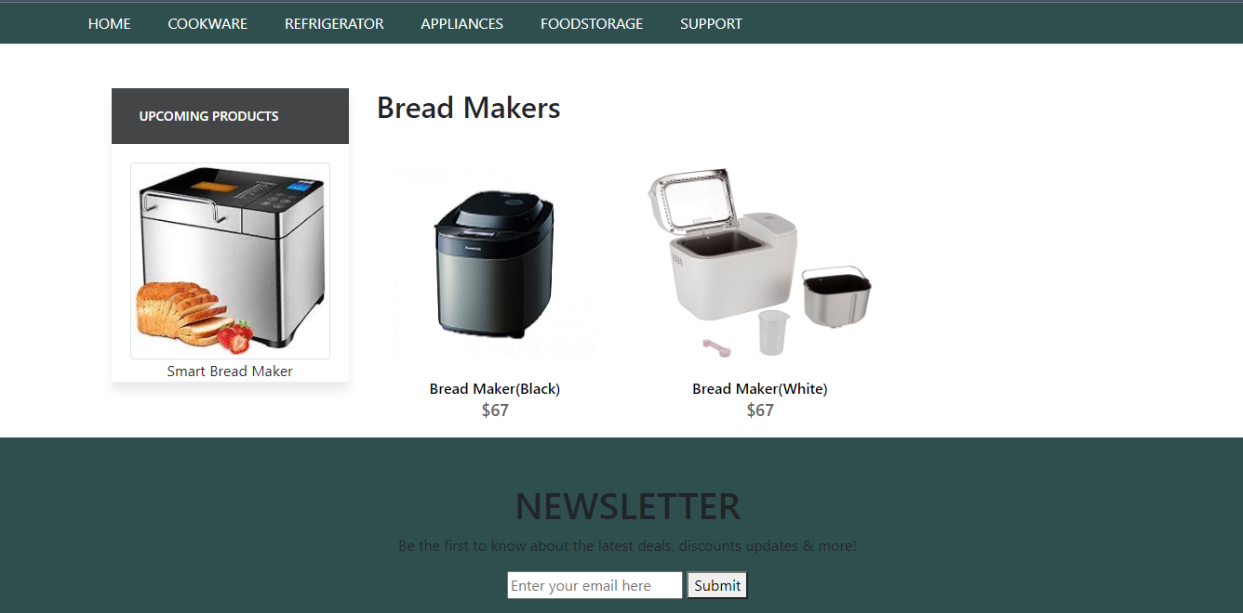

Bread Makers

<!doctype html>

Bread Makers Code

<html>

<head>

<meta charset="utf-8">

<title>Untitled Document</title>

<!--CSS LINK -->

<link rel="stylesheet" type="text/css" href="../CSS/Tasha.css"/>

<link rel="stylesheet" type="text/css" href="../bootstraps/css/bootstrap.min.css"/>

<link rel="stylesheet" type="text/css" href="../bootstraps/css/bootstrap.css"/>

<link rel="stylesheet" type="text/css" href="../CSS/Links.css"/>

<!-- Latest compiled and minified CSS START-->

<link rel="stylesheet" href="https://maxcdn.bootstrapcdn.com/bootstrap/4.5.2/css/bootstrap.min.css">

<!-- Latest compiled and minified CSS END-->

<!-- jQuery library START -->

<script src="https://ajax.googleapis.com/ajax/libs/jquery/3.5.1/jquery.min.js"></script>

<!-- jQuery library END-->

<!-- Popper JS START-->

<script src="https://cdnjs.cloudflare.com/ajax/libs/popper.js/1.16.0/umd/popper.min.js"></script>

<!-- Popper JS END -->

<!-- Latest compiled JavaScript START-->

<script src="https://maxcdn.bootstrapcdn.com/bootstrap/4.5.2/js/bootstrap.min.js"></script>

<!-- Latest compiled JavaScript -->

<!--Meta Link START-->

<meta name="viewport" content="width=device-width, initial-scale=1">

<!--Meta Link END-->

<!--FONT AWESOME CDN LINK-->

<link rel="stylesheet" href="https://pro.fontawesome.com/releases/v5.10.0/css/all.css" integrity="sha384-AYmEC3Yw5cVb3ZcuHtOA93w35dYTsvhLPVnYs9eStHfGJvOvKxVfELGroGkvsg+p" crossorigin="anonymous"/>

<!--FONT AWESOME CDN LINK-->

<link rel="stylesheet" href="https://cdn.jsdelivr.net/npm/bootstrap-icons@1.6.0/font/bootstrap-icons.css" integrity="sha384-7ynz3n3tAGNUYFZD3cWe5PDcE36xj85vyFkawcF6tIwxvIecqKvfwLiaFdizhPpN" crossorigin="anonymous">

<link href="https://fonts.googleapis.com/css2?family=Open+Sans:wght@400;700&family=Poppins:wght@100;200;300;400&display=swap" rel="stylesheet">

</head>

<body>

<header>

<ul>

<li><a href="../Tasha.html">HOME</a>

</li>

<li><a href="#">COOKWARE</a>

<ul>

<li><a href="Cooking Pot.html">Cooking Pots</a></li>

<li><a href="Frying Pans.html">Frying Pans</a></li>

<li><a href="Cookware-Sets.html">Cookware Sets</a></li>

<li><a href="Egg Poached.html">Egg Poachers</a></li>

<li><a href="Grill-Pans.html">Grill Pans</a></li>

<li><a href="Steamer.html">Steamers</a></li>

</ul>

</li>

<li><a href="#">REFRIGERATOR</a>

<ul>

<li><a href="Refrigerators.html">Refrigerators</a></li>

<li><a href="Freezers.html">Freezers</a></li>

</ul>

</li>

<li><a href="#">APPLIANCES</a>

<ul>

<li><a href="Blenders.html">Blenders</a></li>

<li><a href="Bread-Maker.html">Bread Makers</a></li>

<li><a href="Coffee-Maker.html">Coffee Makers</a></li>

<li><a href="Icecream-Sorbet-Maker.html">Ice-Cream and Sorbet Makers</a></li>

<li><a href="Kettles.html">Kettles</a></li>

<li><a href="Food-Chopper.html">Food Choppers</a></li>

<li><a href="Toaster.html">Toasters</a></li>

</ul>

</li>

<li><a href="#">FOODSTORAGE</a>

<ul>

<li><a href="Flask.html">Flask</a></li>

<li><a href="Spice-Jars.html">Spice Jars</a></li>

<li><a href="Storage-Bags.html">Storage Bags</a></li>

<li><a href="Lunch-Boxes.html">Lunch Boxes</a></li>

<li><a href="Storage-Containers.html">Storage Containers</a></li>

</ul>

</li>

<li><a href="#">SUPPORT</a>

<ul>

<li><a href="Expert Tips.html">Expert Tips</a></li>

<li><a href="Register-Complain.html">Register Complain</a></li>

<li><a href="Feedback-Form.html">Feed Back</a></li>

<li><a href="Contact Us.html">Contact Us</a></li>

</ul>

</li>

</ul>

</header>

<!--NAVIGATION BAR ENDS-->

<!--SIDE NAVIGATOR STARTS-->

<section class="category">

<div class="container">

<div class="row">

<div class="col-lg-3">

<aside class="side-area product-side side-shadow mt-5">

<div class="side-title">

<h3>UpComing Products</h3>

</div>

<div class="side-content" style="margin: 20px;" >

<img src="../Images/227.jpg" class="img-thumbnail" alt="...">

<p style="text-align: center;">Smart Bread Maker </p>

</div>

</aside>

</div>

<!--SIDE NAVIGATOR ENDS-->

<!--COOKING POT STARTS-->

<div class="col-lg-9">

<div class="row">

<div class="col-lg-12">

<div class="product-top d-flex justify-content-between align-items-center" >

<div class="product-sec product-item ">

<h2 class="my-5">Bread Makers</h2>

</div>

</div>

</div>

<div class="col-lg-4 col-sm-6">

<div class="product-cate">

<div>

<img src="../Images/112.jpg" alt="" />

<div class="product-icon">

<ul>

<li><a href=""><i class="fa fa-heart" aria-hidden="true"></i></a></li>

<li><a href="Checkout-Form.html"><i class="fa fa-shopping-cart" aria-hidden="true"></i></a></li>

</ul>

</div>

<!---->

<div class="product-des">

<h5>Bread Maker(Black) </h5>

<p>$67</p>

</div>

</div>

</div>

</div>

<!---->

<div class="col-lg-4 col-sm-6">

<div class="product-cate">

<div>

<img src="../Images/114.jpg" alt="pot" />

<div class="product-icon">

<ul>

<li><a href=""><i class="fa fa-heart" aria-hidden="true"></i></a></li>

<li><a href="Checkout-Form.html"><i class="fa fa-shopping-cart" aria-hidden="true"></i></a></li>

</ul>

</div>

<!---->

<div class="product-des">

<h5>Bread Maker(White) </h5>

<p>$67</p>

</div>

</div>

</div>

</div>

<!---->

</div>

</div>

</div>

</div>

</section>

<!--COOKING POT END-->

<!-- FOOTER STARTS -->

<footer class=" text-black pt-5 pb-4 page-footer" style="background-color: darkslategray;">

<div class="text-center">

<h1 >NEWSLETTER</h1>

<p>Be the first to know about the latest deals, discounts updates & more!</p>

<input type="email" name="email" placeholder="Enter your email here"/>

<button type="submit" onClick="onclick" > Submit </button>

</div>

<br><br>

<div class=" container text-center text-md-left ">

<div class="row text-center text-md-left ">

<div class="col-md-3 col-lg-3 col-xl-3 mx-auto mt-3">

<h5 class="text-uppercase mb-4 font-weight-bold text-warning">TASHA Kitchen-Ware</h5>

<p>TASHA- the home store is Branded Company famous for home kitchen appliances. It provides collection of n number of appliances with different category to match the fast life of the generation. The Tasha group of companies had made huge profit in the year 2013. In order to enhance its business the organization wants you to develop the website.</p>

</div>

<div class="col-md-3 col-lg-3 col-xl-3 mx-auto mt-3" >

<h5 class="text-uppercase mb-4 font-weight-bold text-warning">OFFERS</h5>

<p><a href="#" class="text-black" style="text-decoration: none; color:black; ">Deal of the Day</a></p>

<p><a href="#" class="text-black" style="text-decoration: none;color:black;">Buy 1 Get 1 Free</a></p>

<p><a href="#" class="text-black" style="text-decoration: none;color:black;">Appliance Packages Offers</a></p>

<p ><a href="#" class="text-black" style="text-decoration: none; color:black;">Reward Program</a></p>

</div>

<div class="col-md-4 col-lg-3 col-xl-3 mx-auto mt-3">

<h5 class="text-uppercase mb-4 font-weight-bold text-warning">ADDRESS</h5>

<p>

<i class="fas fa-home mr-3"></i>Plot No. G-21/23, Block-8, Khaliquzzaman Road, Clifton، Block 8 Clifton, Karachi, Karachi City, Sindh 75600

</p>

</div>

</div>

<hr class="mb-4">

<div class="row align-items-center">

<div class="col-md-7 col-lg-8">

<p>copyright all rights reserved by <a href="#" style="text-decoration: none"><strong class="text-warning">The Provider</strong></a></p></div>

<div class="col-md-5 col-lg-4">

<div class="text-center text-md-right">

<ul class="list-unstyled list-inline">

<li class="list-inline-item">

<a href="#" class="btn-floating btn-sm text-black" style="font-size:23px;"><i class="fab fa-facebook"></i></a></li>

<li class="list-inline-item">

<a href="#" class="btn-floating btn-sm text-black" style="font-size:23px;"><i class="fab fa-twitter"></i></a></li>

<li class="list-inline-item">

<a href="#" class="btn-floating btn-sm text-black" style="font-size:23px;"><i class="fab fa-instagram"></i></a></li>

<li class="list-inline-item">

<a href="#" class="btn-floating btn-sm text-black" style="font-size:23px;"><i class="fas fa-link"></i></a></li>

</ul>

</div>

</div>

</div>

</div>

</footer>

<!--FOOTER ENDS-->

</body>

</html>

Coffee Makers

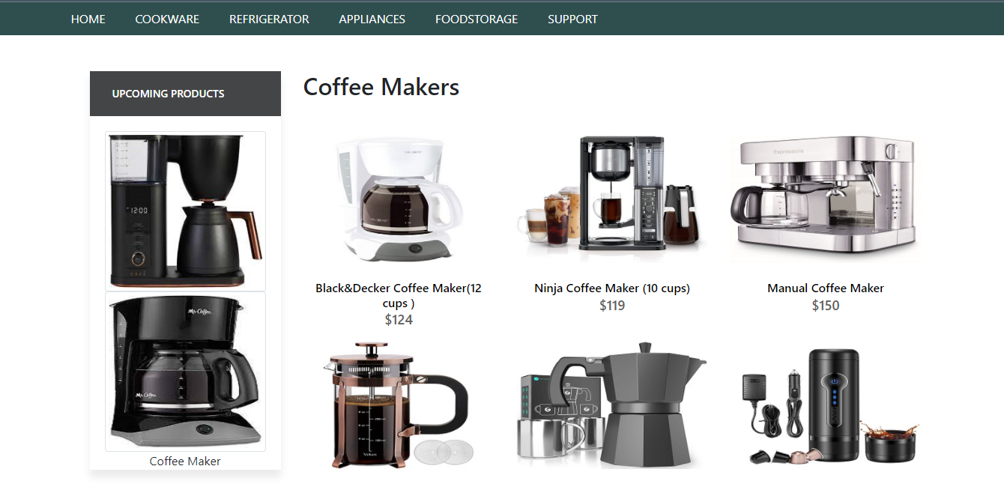

Coffee Makers

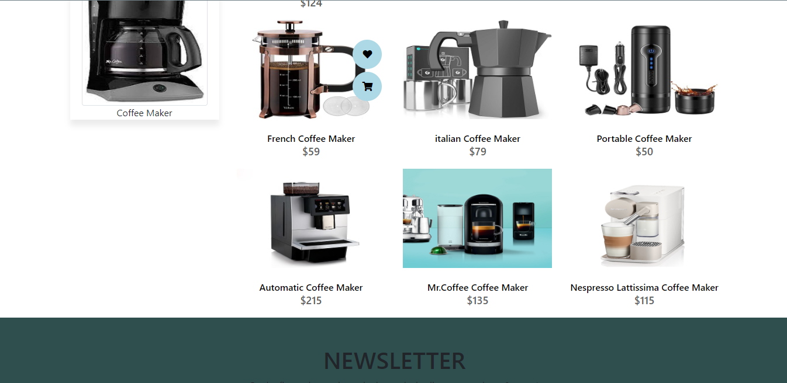

Coffee Maker Code

<!doctype html>

<html>

<head>

<meta charset="utf-8">

<title>Untitled Document</title>

<!--CSS LINK -->

<link rel="stylesheet" type="text/css" href="../CSS/Tasha.css"/>

<link rel="stylesheet" type="text/css" href="../bootstraps/css/bootstrap.min.css"/>

<link rel="stylesheet" type="text/css" href="../bootstraps/css/bootstrap.css"/>

<link rel="stylesheet" type="text/css" href="../CSS/Links.css"/>

<!-- Latest compiled and minified CSS START-->

<link rel="stylesheet" href="https://maxcdn.bootstrapcdn.com/bootstrap/4.5.2/css/bootstrap.min.css">

<!-- Latest compiled and minified CSS END-->

<!-- jQuery library START -->

<script src="https://ajax.googleapis.com/ajax/libs/jquery/3.5.1/jquery.min.js"></script>

<!-- jQuery library END-->

<!-- Popper JS START-->

<script src="https://cdnjs.cloudflare.com/ajax/libs/popper.js/1.16.0/umd/popper.min.js"></script>

<!-- Popper JS END -->

<!-- Latest compiled JavaScript START-->

<script src="https://maxcdn.bootstrapcdn.com/bootstrap/4.5.2/js/bootstrap.min.js"></script>

<!-- Latest compiled JavaScript -->

<!--Meta Link START-->

<meta name="viewport" content="width=device-width, initial-scale=1">

<!--Meta Link END-->

<!--FONT AWESOME CDN LINK-->

<link rel="stylesheet" href="https://pro.fontawesome.com/releases/v5.10.0/css/all.css" integrity="sha384-AYmEC3Yw5cVb3ZcuHtOA93w35dYTsvhLPVnYs9eStHfGJvOvKxVfELGroGkvsg+p" crossorigin="anonymous"/>

<!--FONT AWESOME CDN LINK-->

<link rel="stylesheet" href="https://cdn.jsdelivr.net/npm/bootstrap-icons@1.6.0/font/bootstrap-icons.css" integrity="sha384-7ynz3n3tAGNUYFZD3cWe5PDcE36xj85vyFkawcF6tIwxvIecqKvfwLiaFdizhPpN" crossorigin="anonymous">

<link href="https://fonts.googleapis.com/css2?family=Open+Sans:wght@400;700&family=Poppins:wght@100;200;300;400&display=swap" rel="stylesheet">

</head>

<body>

<header>

<ul>

<li><a href="../Tasha.html">HOME</a>

</li>

<li><a href="#">COOKWARE</a>

<ul>

<li><a href="Cooking Pot.html">Cooking Pots</a></li>

<li><a href="Frying Pans.html">Frying Pans</a></li>

<li><a href="Cookware-Sets.html">Cookware Sets</a></li>

<li><a href="Egg Poached.html">Egg Poachers</a></li>

<li><a href="Grill-Pans.html">Grill Pans</a></li>

<li><a href="Steamer.html">Steamers</a></li>

</ul>

</li>

<li><a href="#">REFRIGERATOR</a>

<ul>

<li><a href="Refrigerators.html">Refrigerators</a></li>

<li><a href="Freezers.html">Freezers</a></li>

</ul>

</li>

<li><a href="#">APPLIANCES</a>

<ul>

<li><a href="Blenders.html">Blenders</a></li>

<li><a href="Bread-Maker.html">Bread Makers</a></li>

<li><a href="Coffee-Maker.html">Coffee Makers</a></li>

<li><a href="Icecream-Sorbet-Maker.html">Ice-Cream and Sorbet Makers</a></li>

<li><a href="Kettles.html">Kettles</a></li>

<li><a href="Food-Chopper.html">Food Choppers</a></li>

<li><a href="Toaster.html">Toasters</a></li>

</ul>

</li>

<li><a href="#">FOODSTORAGE</a>

<ul>

<li><a href="Flask.html">Flask</a></li>

<li><a href="Spice-Jars.html">Spice Jars</a></li>

<li><a href="Storage-Bags.html">Storage Bags</a></li>

<li><a href="Lunch-Boxes.html">Lunch Boxes</a></li>

<li><a href="Storage-Containers.html">Storage Containers</a></li>

</ul>

</li>

<li><a href="#">SUPPORT</a>

<ul>

<li><a href="Expert Tips.html">Expert Tips</a></li>

<li><a href="Register-Complain.html">Register Complain</a></li>

<li><a href="Feedback-Form.html">Feed Back</a></li>

<li><a href="Contact Us.html">Contact Us</a></li>

</ul>

</li>

</ul>

</header>

<!--NAVIGATION BAR ENDS-->

<!--NAVIGATION BAR ENDS-->

<!--SIDE NAVIGATOR STARTS-->

<section class="category">

<div class="container">

<div class="row">

<div class="col-lg-3">

<aside class="side-area product-side side-shadow mt-5">

<div class="side-title">

<h3>UpComing Products</h3>

</div>

<div class="side-content" style="margin: 20px;" >

<img src="../Images/228.jpg" class="img-thumbnail" alt="...">

<img src="../Images/229.jpg" class="img-thumbnail" alt="...">

<p style="text-align: center;">Coffee Maker</p>

</div>

</aside>

</div>

<!--SIDE NAVIGATOR ENDS-->

<!--COOKING POT STARTS-->

<div class="col-lg-9">

<div class="row">

<div class="col-lg-12">

<div class="product-top d-flex justify-content-between align-items-center" >

<div class="product-sec product-item ">

<h2 class="my-5">Coffee Makers</h2>

</div>

</div>

</div>

<div class="col-lg-4 col-sm-6">

<div class="product-cate">

<div>

<img src="../Images/115.jpeg" alt="" />

<div class="product-icon">

<ul>

<li><a href=""><i class="fa fa-heart" aria-hidden="true"></i></a></li>

<li><a href="Checkout-Form.html"><i class="fa fa-shopping-cart" aria-hidden="true"></i></a></li>

</ul>

</div>

<!---->

<div class="product-des">

<h5>Black&Decker Coffee Maker(12 cups ) </h5>

<p>$124</p>

</div>

</div>

</div>

</div>

<!---->

<div class="col-lg-4 col-sm-6">

<div class="product-cate">

<div>

<img src="../Images/116.jpg" alt="pot" />

<div class="product-icon">

<ul>

<li><a href=""><i class="fa fa-heart" aria-hidden="true"></i></a></li>

<li><a href="Checkout-Form.html"><i class="fa fa-shopping-cart" aria-hidden="true"></i></a></li>

</ul>

</div>

<!---->

<div class="product-des">

<h5>Ninja Coffee Maker (10 cups) </h5>

<p>$119</p>

</div>

</div>

</div>

</div>

<!---->

<div class="col-lg-4 col-sm-6">

<div class="product-cate">

<div>

<img src="../Images/118.jpg" alt="pot"/>

<div class="product-icon">

<ul>

<li><a href=""><i class="fa fa-heart" aria-hidden="true"></i></a></li>

<li><a href="Checkout-Form.html"><i class="fa fa-shopping-cart" aria-hidden="true"></i></a></li>

</ul>

</div>

<!---->

<div class="product-des">

<h5>Manual Coffee Maker </h5>

<p>$150</p>

</div>

</div>

</div>

</div>

<!---->

<div class="col-lg-4 col-sm-6">

<div class="product-cate">

<div>

<img src="../Images/117.jpg" alt="pot"/>

<div class="product-icon">

<ul>

<li><a href=""><i class="fa fa-heart" aria-hidden="true"></i></a></li>

<li><a href="Checkout-Form.html"><i class="fa fa-shopping-cart" aria-hidden="true"></i></a></li>

</ul>

</div>

<!---->

<div class="product-des">

<h5>French Coffee Maker</h5>

<p>$59</p>

</div>

</div>

</div>

</div>

<!---->

<div class="col-lg-4 col-sm-6">

<div class="product-cate">

<div>

<img src="../Images/119.jpg" alt="pot" />

<div class="product-icon">

<ul>

<li><a href=""><i class="fa fa-heart" aria-hidden="true"></i></a></li>

<li><a href="Checkout-Form.html"><i class="fa fa-shopping-cart" aria-hidden="true"></i></a></li>

</ul>

</div>

<!---->

<div class="product-des">

<h5>italian Coffee Maker</h5>

<p>$79</p>

</div>

</div>

</div>

</div>

<!---->

<div class="col-lg-4 col-sm-6">

<div class="product-cate">

<div>

<img src="../Images/120.jpg" alt=""/>

<div class="product-icon">

<ul>

<li><a href=""><i class="fa fa-heart" aria-hidden="true"></i></a></li>

<li><a href="Checkout-Form.html"><i class="fa fa-shopping-cart" aria-hidden="true"></i></a></li>

</ul>

</div>

<!---->

<div class="product-des">

<h5>Portable Coffee Maker</h5>

<p>$50</p>

</div>

</div>

</div>

</div>

<!---->

<div class="col-lg-4 col-sm-6">

<div class="product-cate">

<div>

<img src="../Images/121.jpg" alt="pot" />

<div class="product-icon">

<ul>

<li><a href=""><i class="fa fa-heart" aria-hidden="true"></i></a></li>

<li><a href="Checkout-Form.html"><i class="fa fa-shopping-cart" aria-hidden="true"></i></a></li>

</ul>

</div>

<!---->

<div class="product-des">

<h5>Automatic Coffee Maker</h5>

<p>$215</p>

</div>

</div>

</div>

</div>

<!---->

<div class="col-lg-4 col-sm-6">

<div class="product-cate">

<div>

<img src="../Images/122.png" alt="pot" />

<div class="product-icon">

<ul>

<li><a href=""><i class="fa fa-heart" aria-hidden="true"></i></a></li>

<li><a href="Checkout-Form.html"><i class="fa fa-shopping-cart" aria-hidden="true"></i></a></li>

</ul>

</div>

<!---->

<div class="product-des">

<h5>Mr.Coffee Coffee Maker </h5>

<p>$135 </p>

</div>

</div>

</div>

</div>

<!---->

<div class="col-lg-4 col-sm-6">

<div class="product-cate">

<div>

<img src="../Images/123.png" alt="pot" />

<div class="product-icon">

<ul>

<li><a href=""><i class="fa fa-heart" aria-hidden="true"></i></a></li>

<li><a href="Checkout-Form.html"><i class="fa fa-shopping-cart" aria-hidden="true"></i></a></li>

</ul>

</div>

<!---->

<div class="product-des">

<h5>Nespresso Lattissima Coffee Maker</h5>

<p>$115</p>

</div>

</div>

</div>

</div>

<!---->

</div>

</div>

</div>

</div>

</section>

<!--COOKING POT END-->

<!-- FOOTER STARTS -->

<footer class=" text-black pt-5 pb-4 page-footer" style="background-color: darkslategray;">

<div class="text-center">

<h1 >NEWSLETTER</h1>

<p>Be the first to know about the latest deals, discounts updates & more!</p>

<input type="email" name="email" placeholder="Enter your email here"/>

<button type="submit" onClick="onclick" > Submit </button>

</div>

<br><br>

<div class=" container text-center text-md-left ">

<div class="row text-center text-md-left ">

<div class="col-md-3 col-lg-3 col-xl-3 mx-auto mt-3">

<h5 class="text-uppercase mb-4 font-weight-bold text-warning">TASHA Kitchen-Ware</h5>

<p>TASHA- the home store is Branded Company famous for home kitchen appliances. It provides collection of n number of appliances with different category to match the fast life of the generation. The Tasha group of companies had made huge profit in the year 2013. In order to enhance its business the organization wants you to develop the website.</p>

</div>

<div class="col-md-3 col-lg-3 col-xl-3 mx-auto mt-3" >

<h5 class="text-uppercase mb-4 font-weight-bold text-warning">OFFERS</h5>

<p><a href="#" class="text-black" style="text-decoration: none; color:black; ">Deal of the Day</a></p>

<p><a href="#" class="text-black" style="text-decoration: none;color:black;">Buy 1 Get 1 Free</a></p>

<p><a href="#" class="text-black" style="text-decoration: none;color:black;">Appliance Packages Offers</a></p>

<p ><a href="#" class="text-black" style="text-decoration: none; color:black;">Reward Program</a></p>

</div>

<div class="col-md-4 col-lg-3 col-xl-3 mx-auto mt-3">

<h5 class="text-uppercase mb-4 font-weight-bold text-warning">ADDRESS</h5>

<p>

<i class="fas fa-home mr-3"></i>Plot No. G-21/23, Block-8, Khaliquzzaman Road, Clifton، Block 8 Clifton, Karachi, Karachi City, Sindh 75600

</p>

</div>

</div>

<hr class="mb-4">

<div class="row align-items-center">

<div class="col-md-7 col-lg-8">

<p>copyright all rights reserved by <a href="#" style="text-decoration: none"><strong class="text-warning">The Provider</strong></a></p></div>

<div class="col-md-5 col-lg-4">

<div class="text-center text-md-right">

<ul class="list-unstyled list-inline">

<li class="list-inline-item">

<a href="#" class="btn-floating btn-sm text-black" style="font-size:23px;"><i class="fab fa-facebook"></i></a></li>

<li class="list-inline-item">

<a href="#" class="btn-floating btn-sm text-black" style="font-size:23px;"><i class="fab fa-twitter"></i></a></li>

<li class="list-inline-item">

<a href="#" class="btn-floating btn-sm text-black" style="font-size:23px;"><i class="fab fa-instagram"></i></a></li>

<li class="list-inline-item">

<a href="#" class="btn-floating btn-sm text-black" style="font-size:23px;"><i class="fas fa-link"></i></a></li>

</ul>

</div>

</div>

</div>

</div>

</footer>

<!--FOOTER ENDS-->

</body>

</html>

Ice-Cream and Sorbet Makers

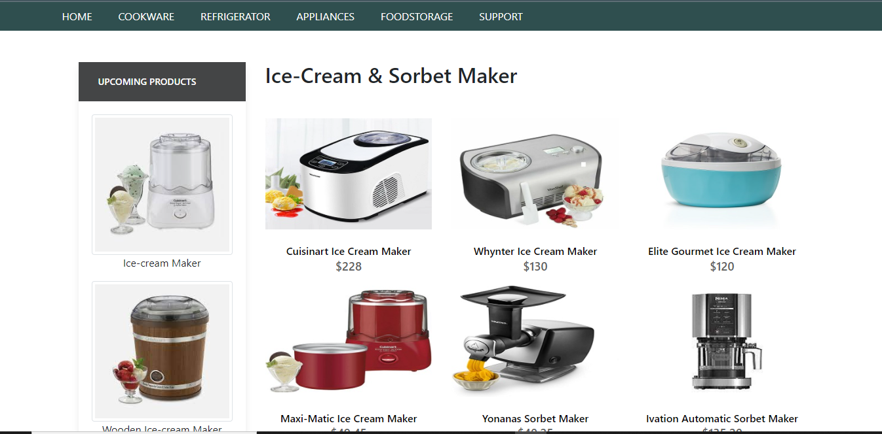

Ice-Cream and Sorbet Makers



Ice-Cream and Sorbet Makers Code

<!doctype html>

<html>

<head>

<meta charset="utf-8">

<title>Untitled Document</title>

<!--CSS LINK -->

<link rel="stylesheet" type="text/css" href="../CSS/Tasha.css"/>

<link rel="stylesheet" type="text/css" href="../bootstraps/css/bootstrap.min.css"/>

<link rel="stylesheet" type="text/css" href="../bootstraps/css/bootstrap.css"/>

<link rel="stylesheet" type="text/css" href="../CSS/Links.css"/>

<!-- Latest compiled and minified CSS START-->

<link rel="stylesheet" href="https://maxcdn.bootstrapcdn.com/bootstrap/4.5.2/css/bootstrap.min.css">

<!-- Latest compiled and minified CSS END-->

<!-- jQuery library START -->

<script src="https://ajax.googleapis.com/ajax/libs/jquery/3.5.1/jquery.min.js"></script>

<!-- jQuery library END-->

<!-- Popper JS START-->

<script src="https://cdnjs.cloudflare.com/ajax/libs/popper.js/1.16.0/umd/popper.min.js"></script>

<!-- Popper JS END -->

<!-- Latest compiled JavaScript START-->

<script src="https://maxcdn.bootstrapcdn.com/bootstrap/4.5.2/js/bootstrap.min.js"></script>

<!-- Latest compiled JavaScript -->

<!--Meta Link START-->

<meta name="viewport" content="width=device-width, initial-scale=1">

<!--Meta Link END-->

<!--FONT AWESOME CDN LINK-->

<link rel="stylesheet" href="https://pro.fontawesome.com/releases/v5.10.0/css/all.css" integrity="sha384-AYmEC3Yw5cVb3ZcuHtOA93w35dYTsvhLPVnYs9eStHfGJvOvKxVfELGroGkvsg+p" crossorigin="anonymous"/>

<!--FONT AWESOME CDN LINK-->

<link rel="stylesheet" href="https://cdn.jsdelivr.net/npm/bootstrap-icons@1.6.0/font/bootstrap-icons.css" integrity="sha384-7ynz3n3tAGNUYFZD3cWe5PDcE36xj85vyFkawcF6tIwxvIecqKvfwLiaFdizhPpN" crossorigin="anonymous">

<link href="https://fonts.googleapis.com/css2?family=Open+Sans:wght@400;700&family=Poppins:wght@100;200;300;400&display=swap" rel="stylesheet">

</head>

<body>

<!--NAVIGATION BAR STARTS-->

<header>

<ul>

<li><a href="../Tasha.html">HOME</a>

</li>

<li><a href="#">COOKWARE</a>

<ul>

<li><a href="Cooking Pot.html">Cooking Pots</a></li>

<li><a href="Frying Pans.html">Frying Pans</a></li>

<li><a href="Cookware-Sets.html">Cookware Sets</a></li>

<li><a href="Egg Poached.html">Egg Poachers</a></li>

<li><a href="Grill-Pans.html">Grill Pans</a></li>

<li><a href="Steamer.html">Steamers</a></li>

</ul>

</li>

<li><a href="#">REFRIGERATOR</a>

<ul>

<li><a href="Refrigerators.html">Refrigerators</a></li>

<li><a href="Freezers.html">Freezers</a></li>

</ul>

</li>

<li><a href="#">APPLIANCES</a>

<ul>

<li><a href="Blenders.html">Blenders</a></li>

<li><a href="Bread-Maker.html">Bread Makers</a></li>

<li><a href="Coffee-Maker.html">Coffee Makers</a></li>

<li><a href="Icecream-Sorbet-Maker.html">Ice-Cream and Sorbet Makers</a></li>

<li><a href="Kettles.html">Kettles</a></li>

<li><a href="Food-Chopper.html">Food Choppers</a></li>

<li><a href="Toaster.html">Toasters</a></li>

</ul>

</li>

<li><a href="#">FOODSTORAGE</a>

<ul>

<li><a href="Flask.html">Flask</a></li>

<li><a href="Spice-Jars.html">Spice Jars</a></li>

<li><a href="Storage-Bags.html">Storage Bags</a></li>

<li><a href="Lunch-Boxes.html">Lunch Boxes</a></li>

<li><a href="Storage-Containers.html">Storage Containers</a></li>

</ul>

</li>

<li><a href="#">SUPPORT</a>

<ul>

<li><a href="Expert Tips.html">Expert Tips</a></li>

<li><a href="Register-Complain.html">Register Complain</a></li>

<li><a href="Feedback-Form.html">Feed Back</a></li>

<li><a href="Contact Us.html">Contact Us</a></li>

</ul>

</li>

</ul>

</header>

<!--NAVIGATION BAR ENDS-->

<section class="category">

<div class="container">

<div class="row">

<div class="col-lg-3">

<aside class="side-area product-side side-shadow mt-5">

<div class="side-title">

<h3>UpComing Products</h3>

</div>

<div class="side-content" style="margin: 20px;" >

<img src="../Images/197.jpg" class="img-thumbnail" alt="...">

<p style="text-align: center;">Ice-cream Maker </p>

<img src="../Images/198.jpg" class="img-thumbnail" alt="...">

<p style="text-align: center;">Wooden Ice-cream Maker</p>

</div>

</aside>

</div>

<!--SIDE NAVIGATOR ENDS-->

<!--COOKING POT STARTS-->

<div class="col-lg-9">

<div class="row">

<div class="col-lg-12">

<div class="product-top d-flex justify-content-between align-items-center" >

<div class="product-sec product-item ">

<h2 class="my-5">Ice-Cream & Sorbet Maker</h2>

</div>

</div>

</div>

<div class="col-lg-4 col-sm-6">

<div class="product-cate">

<div>

<img src="../Images/124.jpg" alt="" />

<div class="product-icon">

<ul>

<li><a href=""><i class="fa fa-heart" aria-hidden="true"></i></a></li>

<li><a href="Checkout-Form.html"><i class="fa fa-shopping-cart" aria-hidden="true"></i></a></li>

</ul>

</div>

<!---->

<div class="product-des">

<h5>Cuisinart Ice Cream Maker</h5>

<p>$228</p>

</div>

</div>

</div>

</div>

<!---->

<div class="col-lg-4 col-sm-6">

<div class="product-cate">

<div>

<img src="../Images/125.jpg" alt="pot" />

<div class="product-icon">

<ul>

<li><a href=""><i class="fa fa-heart" aria-hidden="true"></i></a></li>

<li><a href="Checkout-Form.html"><i class="fa fa-shopping-cart" aria-hidden="true"></i></a></li>

</ul>

</div>

<!---->

<div class="product-des">

<h5>Whynter Ice Cream Maker</h5>

<p>$130</p>

</div>

</div>

</div>

</div>

<!---->

<div class="col-lg-4 col-sm-6">

<div class="product-cate">

<div>

<img src="../Images/126.jpg" alt="pot"/>

<div class="product-icon">

<ul>

<li><a href=""><i class="fa fa-heart" aria-hidden="true"></i></a></li>

<li><a href="Checkout-Form.html"><i class="fa fa-shopping-cart" aria-hidden="true"></i></a></li>

</ul>

</div>

<!---->

<div class="product-des">

<h5>Elite Gourmet Ice Cream Maker </h5>

<p>$120</p>

</div>

</div>

</div>

</div>

<!---->

<div class="col-lg-4 col-sm-6">

<div class="product-cate">

<div>

<img src="../Images/129.jpg" alt="pot" class="img-fluid"/>

<div class="product-icon">

<ul>

<li><a href=""><i class="fa fa-heart" aria-hidden="true"></i></a></li>

<li><a href="Checkout-Form.html"><i class="fa fa-shopping-cart" aria-hidden="true"></i></a></li>

</ul>

</div>

<!---->

<div class="product-des">

<h5>Maxi-Matic Ice Cream Maker</h5>

<p>$49.45</p>

</div>

</div>

</div>

</div>

<!---->

<div class="col-lg-4 col-sm-6">

<div class="product-cate">

<div>

<img src="../Images/127.jpg" alt="pot" />

<div class="product-icon">

<ul>

<li><a href=""><i class="fa fa-heart" aria-hidden="true"></i></a></li>

<li><a href="Checkout-Form.html"><i class="fa fa-shopping-cart" aria-hidden="true"></i></a></li>

</ul>

</div>

<!---->

<div class="product-des">

<h5>Yonanas Sorbet Maker</h5>

<p>$40.25</p>

</div>

</div>

</div>

</div>

<!---->

<div class="col-lg-4 col-sm-6">

<div class="product-cate">

<div>

<img src="../Images/128.jpg" alt=""/>

<div class="product-icon">

<ul>

<li><a href=""><i class="fa fa-heart" aria-hidden="true"></i></a></li>

<li><a href="Checkout-Form.html"><i class="fa fa-shopping-cart" aria-hidden="true"></i></a></li>

</ul>

</div>

<!---->

<div class="product-des">

<h5>Ivation Automatic Sorbet Maker</h5>

<p>$135.20</p>

</div>

</div>

</div>

</div>

<!---->

</div>

</div>

</div>

</div>

</section>

<!--COOKING POT END-->

<!-- FOOTER STARTS -->

<footer class=" text-black pt-5 pb-4 page-footer" style="background-color: darkslategray;">

<div class="text-center">

<h1 >NEWSLETTER</h1>

<p>Be the first to know about the latest deals, discounts updates & more!</p>

<input type="email" name="email" placeholder="Enter your email here"/>

<button type="submit" onClick="onclick" > Submit </button>

</div>

<br><br>

<div class=" container text-center text-md-left ">

<div class="row text-center text-md-left ">

<div class="col-md-3 col-lg-3 col-xl-3 mx-auto mt-3">

<h5 class="text-uppercase mb-4 font-weight-bold text-warning">TASHA Kitchen-Ware</h5>

<p>TASHA- the home store is Branded Company famous for home kitchen appliances. It provides collection of n number of appliances with different category to match the fast life of the generation. The Tasha group of companies had made huge profit in the year 2013. In order to enhance its business the organization wants you to develop the website.</p>

</div>

<div class="col-md-3 col-lg-3 col-xl-3 mx-auto mt-3" >

<h5 class="text-uppercase mb-4 font-weight-bold text-warning">OFFERS</h5>

<p><a href="#" class="text-black" style="text-decoration: none; color:black; ">Deal of the Day</a></p>

<p><a href="#" class="text-black" style="text-decoration: none;color:black;">Buy 1 Get 1 Free</a></p>

<p><a href="#" class="text-black" style="text-decoration: none;color:black;">Appliance Packages Offers</a></p>

<p ><a href="#" class="text-black" style="text-decoration: none; color:black;">Reward Program</a></p>

</div>

<div class="col-md-4 col-lg-3 col-xl-3 mx-auto mt-3">

<h5 class="text-uppercase mb-4 font-weight-bold text-warning">ADDRESS</h5>

<p>

<i class="fas fa-home mr-3"></i>Plot No. G-21/23, Block-8, Khaliquzzaman Road, Clifton، Block 8 Clifton, Karachi, Karachi City, Sindh 75600

</p>

</div>

</div>

<hr class="mb-4">

<div class="row align-items-center">

<div class="col-md-7 col-lg-8">

<p>copyright all rights reserved by <a href="#" style="text-decoration: none"><strong class="text-warning">The Provider</strong></a></p></div>

<div class="col-md-5 col-lg-4">

<div class="text-center text-md-right">

<ul class="list-unstyled list-inline">

<li class="list-inline-item">

<a href="#" class="btn-floating btn-sm text-black" style="font-size:23px;"><i class="fab fa-facebook"></i></a></li>

<li class="list-inline-item">

<a href="#" class="btn-floating btn-sm text-black" style="font-size:23px;"><i class="fab fa-twitter"></i></a></li>

<li class="list-inline-item">

<a href="#" class="btn-floating btn-sm text-black" style="font-size:23px;"><i class="fab fa-instagram"></i></a></li>

<li class="list-inline-item">

<a href="#" class="btn-floating btn-sm text-black" style="font-size:23px;"><i class="fas fa-link"></i></a></li>

</ul>

</div>

</div>

</div>

</div>

</footer>

<!--FOOTER ENDS-->

</body>

</html>

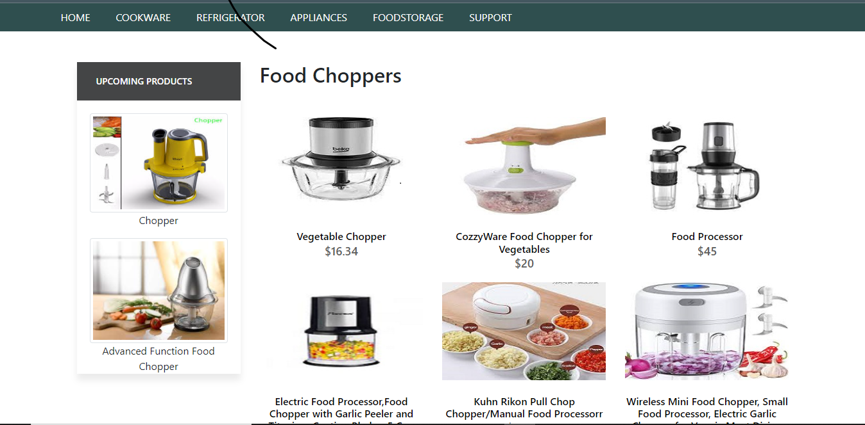

Food Choppers

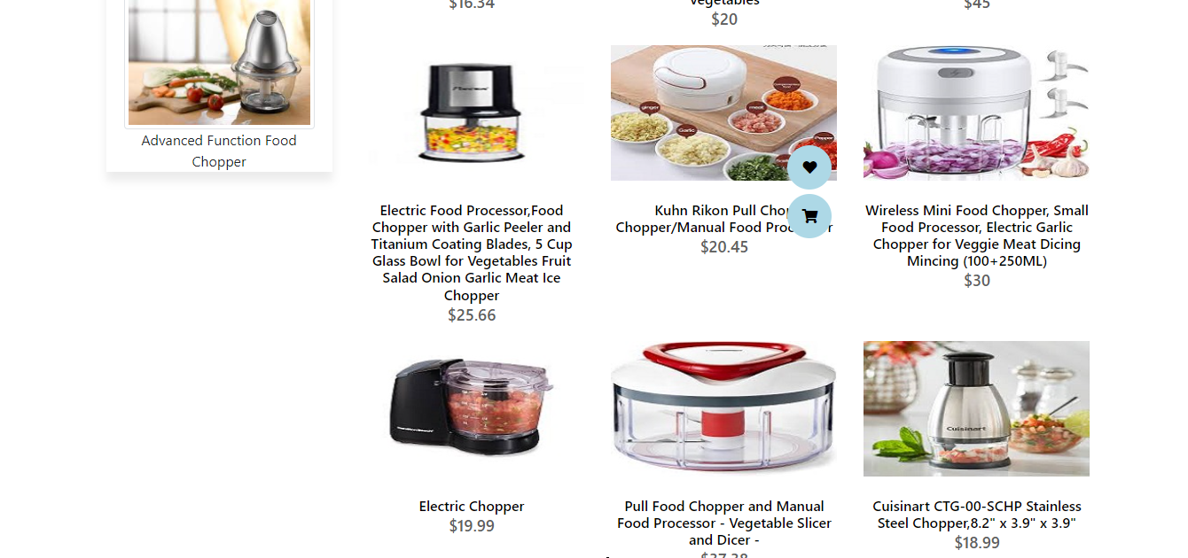

Food Choppers

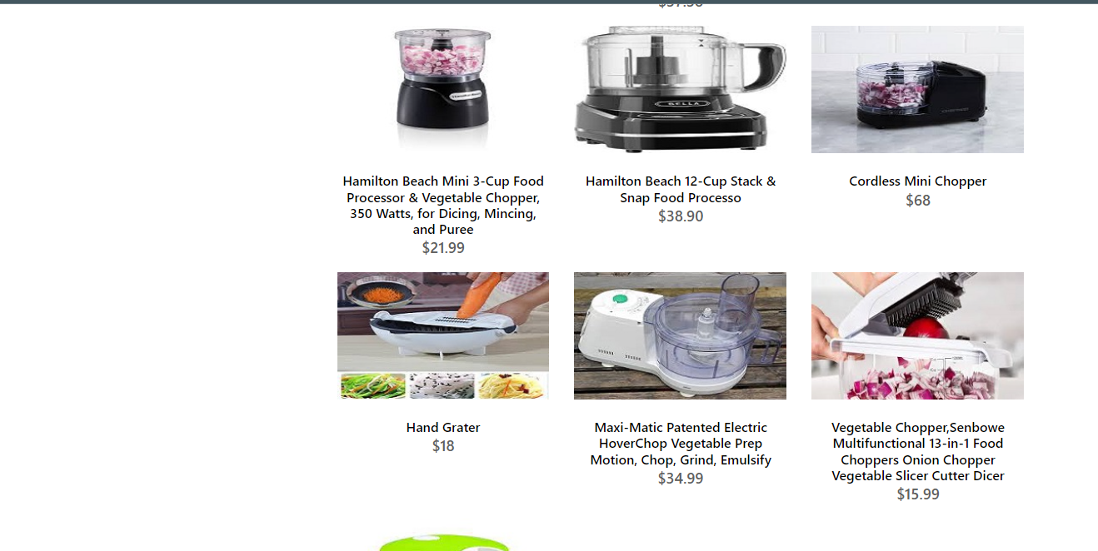

Food Choppers

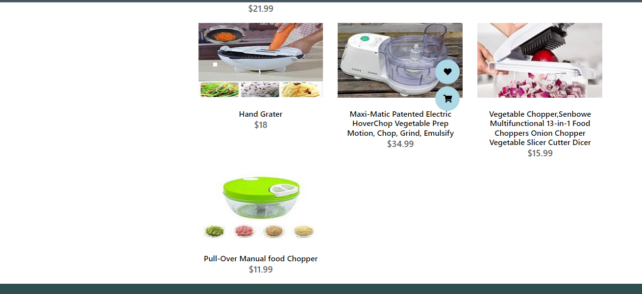

Food Choppers

**Food Choppers**



Food Chopper Code

+*-

<!doctype html>

<html>

<head>

<meta charset="utf-8">

<title>Untitled Document</title>

<!--CSS LINK -->

<link rel="stylesheet" type="text/css" href="../CSS/Tasha.css"/>

<link rel="stylesheet" type="text/css" href="../bootstraps/css/bootstrap.min.css"/>

<link rel="stylesheet" type="text/css" href="../bootstraps/css/bootstrap.css"/>

<link rel="stylesheet" type="text/css" href="../CSS/Links.css"/>

<!-- Latest compiled and minified CSS START-->

<link rel="stylesheet" href="https://maxcdn.bootstrapcdn.com/bootstrap/4.5.2/css/bootstrap.min.css">

<!-- Latest compiled and minified CSS END-->

<!-- jQuery library START -->

<script src="https://ajax.googleapis.com/ajax/libs/jquery/3.5.1/jquery.min.js"></script>

<!-- jQuery library END-->

<!-- Popper JS START-->

<script src="https://cdnjs.cloudflare.com/ajax/libs/popper.js/1.16.0/umd/popper.min.js"></script>

<!-- Popper JS END -->

<!-- Latest compiled JavaScript START-->

<script src="https://maxcdn.bootstrapcdn.com/bootstrap/4.5.2/js/bootstrap.min.js"></script>

<!-- Latest compiled JavaScript -->

<!--Meta Link START-->

<meta name="viewport" content="width=device-width, initial-scale=1">

<!--Meta Link END-->

<!--FONT AWESOME CDN LINK-->

<link rel="stylesheet" href="https://pro.fontawesome.com/releases/v5.10.0/css/all.css" integrity="sha384-AYmEC3Yw5cVb3ZcuHtOA93w35dYTsvhLPVnYs9eStHfGJvOvKxVfELGroGkvsg+p" crossorigin="anonymous"/>

<!--FONT AWESOME CDN LINK-->

<link rel="stylesheet" href="https://cdn.jsdelivr.net/npm/bootstrap-icons@1.6.0/font/bootstrap-icons.css" integrity="sha384-7ynz3n3tAGNUYFZD3cWe5PDcE36xj85vyFkawcF6tIwxvIecqKvfwLiaFdizhPpN" crossorigin="anonymous">

<link href="https://fonts.googleapis.com/css2?family=Open+Sans:wght@400;700&family=Poppins:wght@100;200;300;400&display=swap" rel="stylesheet">

</head>

<body>

<header>

<ul>

<li><a href="../Tasha.html">HOME</a>

</li>

<li><a href="#">COOKWARE</a>

<ul>

<li><a href="Cooking Pot.html">Cooking Pots</a></li>

<li><a href="Frying Pans.html">Frying Pans</a></li>

<li><a href="Cookware-Sets.html">Cookware Sets</a></li>

<li><a href="Egg Poached.html">Egg Poachers</a></li>

<li><a href="Grill-Pans.html">Grill Pans</a></li>

<li><a href="Steamer.html">Steamers</a></li>

</ul>

</li>

<li><a href="#">REFRIGERATOR</a>

<ul>

<li><a href="Refrigerators.html">Refrigerators</a></li>

<li><a href="Freezers.html">Freezers</a></li>

</ul>

</li>

<li><a href="#">APPLIANCES</a>

<ul>

<li><a href="Blenders.html">Blenders</a></li>

<li><a href="Bread-Maker.html">Bread Makers</a></li>

<li><a href="Coffee-Maker.html">Coffee Makers</a></li>

<li><a href="Icecream-Sorbet-Maker.html">Ice-Cream and Sorbet Makers</a></li>

<li><a href="Kettles.html">Kettles</a></li>

<li><a href="Food-Chopper.html">Food Choppers</a></li>

<li><a href="Toaster.html">Toasters</a></li>

</ul>

</li>

<li><a href="#">FOODSTORAGE</a>

<ul>

<li><a href="Flask.html">Flask</a></li>

<li><a href="Spice-Jars.html">Spice Jars</a></li>

<li><a href="Storage-Bags.html">Storage Bags</a></li>

<li><a href="Lunch-Boxes.html">Lunch Boxes</a></li>

<li><a href="Storage-Containers.html">Storage Containers</a></li>

</ul>

</li>

<li><a href="#">SUPPORT</a>

<ul>

<li><a href="Expert Tips.html">Expert Tips</a></li>

<li><a href="Register-Complain.html">Register Complain</a></li>

<li><a href="Feedback-Form.html">Feed Back</a></li>

<li><a href="Contact Us.html">Contact Us</a></li>

</ul>

</li>

</ul>

</header>

<!--NAVIGATION BAR ENDS-->

<section class="category">

<div class="container">

<div class="row">

<div class="col-lg-3">

<aside class="side-area product-side side-shadow mt-5">

<div class="side-title">

<h3>UpComing Products</h3>

</div>

<div class="side-content" style="margin: 20px;" >

<img src="../Images/211.jpg" class="img-thumbnail" alt="...">

<p style="text-align: center;">Chopper </p>

<img src="../Images/212.jpg" class="img-thumbnail" alt="...">

<p style="text-align: center;">Advanced Function Food Chopper</p>

</div>

</aside>

</div>

<!--SIDE NAVIGATOR ENDS-->

<!--COOKING POT STARTS-->

<div class="col-lg-9">

<div class="row">

<div class="col-lg-12">

<div class="product-top d-flex justify-content-between align-items-center" >

<div class="product-sec product-item ">

<h2 class="my-5">Food Choppers</h2>

</div>

</div>

</div>

<div class="col-lg-4 col-sm-6">

<div class="product-cate">

<div>

<img src="../Images/140.jpg" alt="" />

<div class="product-icon">

<ul>

<li><a href=""><i class="fa fa-heart" aria-hidden="true"></i></a></li>

<li><a href="Checkout-Form.html"><i class="fa fa-shopping-cart" aria-hidden="true"></i></a></li>

</ul>

</div>

<!---->

<div class="product-des">

<h5>Vegetable Chopper</h5>

<p>$16.34</p>

</div>

</div>

</div>

</div>

<!---->

<div class="col-lg-4 col-sm-6">

<div class="product-cate">

<div>

<img src="../Images/141.jpg" alt="pot" />

<div class="product-icon">

<ul>

<li><a href=""><i class="fa fa-heart" aria-hidden="true"></i></a></li>

<li><a href="Checkout-Form.html"><i class="fa fa-shopping-cart" aria-hidden="true"></i></a></li>

</ul>

</div>

<!---->

<div class="product-des">

<h5>CozzyWare Food Chopper for Vegetables </h5>

<p>$20</p>

</div>

</div>

</div>

</div>

<!---->

<div class="col-lg-4 col-sm-6">

<div class="product-cate">

<div>

<img src="../Images/142.jpg" alt="pot"/>

<div class="product-icon">

<ul>

<li><a href=""><i class="fa fa-heart" aria-hidden="true"></i></a></li>

<li><a href="Checkout-Form.html"><i class="fa fa-shopping-cart" aria-hidden="true"></i></a></li>

</ul>

</div>

<!---->

<div class="product-des">

<h5>Food Processor </h5>

<p>$45</p>

</div>

</div>

</div>

</div>

<!---->

<div class="col-lg-4 col-sm-6">

<div class="product-cate">

<div>

<img src="../Images/143.jpg" alt="pot" class="img-fluid"/>

<div class="product-icon">

<ul>

<li><a href=""><i class="fa fa-heart" aria-hidden="true"></i></a></li>

<li><a href="Checkout-Form.html"><i class="fa fa-shopping-cart" aria-hidden="true"></i></a></li>

</ul>

</div>

<!---->

<div class="product-des">

<h5>Electric Food Processor,Food Chopper with Garlic Peeler and Titanium Coating Blades, 5 Cup Glass Bowl for Vegetables Fruit Salad Onion Garlic Meat Ice Chopper </h5>

<p>$25.66</p>

</div>

</div>

</div>

</div>

<!---->

<div class="col-lg-4 col-sm-6">

<div class="product-cate">

<div>

<img src="../Images/144.jpg" alt="pot" />

<div class="product-icon">

<ul>

<li><a href=""><i class="fa fa-heart" aria-hidden="true"></i></a></li>

<li><a href="Checkout-Form.html"><i class="fa fa-shopping-cart" aria-hidden="true"></i></a></li>

</ul>

</div>

<!---->

<div class="product-des">

<h5>Kuhn Rikon Pull Chop Chopper/Manual Food Processorr</h5>

<p>$20.45</p>

</div>

</div>

</div>

</div>

<!---->

<div class="col-lg-4 col-sm-6">

<div class="product-cate">

<div>

<img src="../Images/145.jpg" alt=""/>

<div class="product-icon">

<ul>

<li><a href=""><i class="fa fa-heart" aria-hidden="true"></i></a></li>

<li><a href="Checkout-Form.html"><i class="fa fa-shopping-cart" aria-hidden="true"></i></a></li>

</ul>

</div>

<!---->

<div class="product-des">

<h5>Wireless Mini Food Chopper, Small Food Processor, Electric Garlic Chopper for Veggie Meat Dicing Mincing (100+250ML)</h5>

<p>$30</p>

</div>

</div>

</div>

</div>

<!---->

<div class="col-lg-4 col-sm-6">

<div class="product-cate">

<div>

<img src="../Images/146.jpg" alt="pot" />

<div class="product-icon">

<ul>

<li><a href=""><i class="fa fa-heart" aria-hidden="true"></i></a></li>

<li><a href="Checkout-Form.html"><i class="fa fa-shopping-cart" aria-hidden="true"></i></a></li>

</ul>

</div>

<!---->

<div class="product-des">

<h5>Electric Chopper</h5>

<p>$19.99</p>

</div>

</div>

</div>

</div>

<!---->

<div class="col-lg-4 col-sm-6">

<div class="product-cate">

<div>

<img src="../Images/147.jpg" alt="pot" />

<div class="product-icon">

<ul>

<li><a href=""><i class="fa fa-heart" aria-hidden="true"></i></a></li>

<li><a href="Checkout-Form.html"><i class="fa fa-shopping-cart" aria-hidden="true"></i></a></li>

</ul>

</div>

<!---->

<div class="product-des">

<h5> Pull Food Chopper and Manual Food Processor - Vegetable Slicer and Dicer -</h5>

<p>$37.38 </p>

</div>

</div>

</div>

</div>

<!---->

<div class="col-lg-4 col-sm-6">

<div class="product-cate">

<div>

<img src="../Images/148.jpg" alt="pot" />

<div class="product-icon">

<ul>

<li><a href=""><i class="fa fa-heart" aria-hidden="true"></i></a></li>

<li><a href="Checkout-Form.html"><i class="fa fa-shopping-cart" aria-hidden="true"></i></a></li>

</ul>

</div>

<!---->

<div class="product-des">

<h5>Cuisinart CTG-00-SCHP Stainless Steel Chopper,8.2" x 3.9" x 3.9"</h5>

<p>$18.99</p>

</div>

</div>

</div>

</div>

<!---->

<div class="col-lg-4 col-sm-6">

<div class="product-cate">

<div>

<img src="../Images/149.jpg" alt="pot" />

<div class="product-icon">

<ul>

<li><a href=""><i class="fa fa-heart" aria-hidden="true"></i></a></li>

<li><a href="Checkout-Form.html"><i class="fa fa-shopping-cart" aria-hidden="true"></i></a></li>

</ul>

</div>

<!---->

<div class="product-des">

<h5>Hamilton Beach Mini 3-Cup Food Processor & Vegetable Chopper, 350 Watts, for Dicing, Mincing, and Puree</h5>

<p>$21.99</p>

</div>

</div>

</div>

</div>

<!---->

<div class="col-lg-4 col-sm-6">

<div class="product-cate">

<div>

<img src="../Images/150.jpg" alt="pot" />

<div class="product-icon">

<ul>

<li><a href=""><i class="fa fa-heart" aria-hidden="true"></i></a></li>

<li><a href="Checkout-Form.html"><i class="fa fa-shopping-cart" aria-hidden="true"></i></a></li>

</ul>

</div>

<!---->

<div class="product-des">

<h5>Hamilton Beach 12-Cup Stack & Snap Food Processo</h5>

<p>$38.90</p>

</div>

</div>

</div>

</div>

<!---->

<div class="col-lg-4 col-sm-6">

<div class="product-cate">

<div>

<img src="../Images/151.jpg" alt="pot" />

<div class="product-icon">

<ul>

<li><a href=""><i class="fa fa-heart" aria-hidden="true"></i></a></li>

<li><a href="Checkout-Form.html"><i class="fa fa-shopping-cart" aria-hidden="true"></i></a></li>

</ul>

</div>

<!---->

<div class="product-des">

<h5>Cordless Mini Chopper</h5>

<p>$68</p>

</div>

</div>

</div>

</div>

<!---->

<div class="col-lg-4 col-sm-6">

<div class="product-cate">

<div>

<img src="../Images/152.jpg" alt="pot" />

<div class="product-icon">

<ul>

<li><a href=""><i class="fa fa-heart" aria-hidden="true"></i></a></li>

<li><a href="Checkout-Form.html"><i class="fa fa-shopping-cart" aria-hidden="true"></i></a></li>

</ul>

</div>

<!---->

<div class="product-des">

<h5>Hand Grater</h5>

<p>$18</p>

</div>

</div>

</div>

</div>

<!---->

<div class="col-lg-4 col-sm-6">

<div class="product-cate">

<div>

<img src="../Images/153.jpg" alt="pot" />

<div class="product-icon">

<ul>

<li><a href=""><i class="fa fa-heart" aria-hidden="true"></i></a></li>

<li><a href="Checkout-Form.html"><i class="fa fa-shopping-cart" aria-hidden="true"></i></a></li>

</ul>

</div>

<!---->

<div class="product-des">

<h5> Maxi-Matic Patented Electric HoverChop Vegetable Prep Motion, Chop, Grind, Emulsify</h5>

<p>$34.99</p>

</div>

</div>

</div>

</div>

<!---->

<div class="col-lg-4 col-sm-6">

<div class="product-cate">

<div>

<img src="../Images/154.jpg" alt="pot" />

<div class="product-icon">

<ul>

<li><a href=""><i class="fa fa-heart" aria-hidden="true"></i></a></li>

<li><a href="Checkout-Form.html"><i class="fa fa-shopping-cart" aria-hidden="true"></i></a></li>

</ul>

</div>

<!---->

<div class="product-des">

<h5>Vegetable Chopper,Senbowe Multifunctional 13-in-1 Food Choppers Onion Chopper Vegetable Slicer Cutter Dicer</h5>

<p>$15.99</p>

</div>

</div>

</div>

</div>

<!---->

<div class="col-lg-4 col-sm-6">

<div class="product-cate">

<div>

<img src="../Images/155.jpg" alt="pot" />

<div class="product-icon">

<ul>

<li><a href=""><i class="fa fa-heart" aria-hidden="true"></i></a></li>

<li><a href="Checkout-Form.html"><i class="fa fa-shopping-cart" aria-hidden="true"></i></a></li>

</ul>

</div>

<!---->

<div class="product-des">

<h5>Pull-Over Manual food Chopper</h5>

<p>$11.99</p>

</div>

</div>

</div>

</div>

</div>

</div>

</div>

</div>

</section>

<!--COOKING POT END-->

<!-- FOOTER STARTS -->

<footer class=" text-black pt-5 pb-4 page-footer" style="background-color: darkslategray;">

<div class="text-center">

<h1 >NEWSLETTER</h1>

<p>Be the first to know about the latest deals, discounts updates & more!</p>

<input type="email" name="email" placeholder="Enter your email here"/>

<button type="submit" onClick="onclick" > Submit </button>

</div>

<br><br>

<div class=" container text-center text-md-left ">

<div class="row text-center text-md-left ">

<div class="col-md-3 col-lg-3 col-xl-3 mx-auto mt-3">

<h5 class="text-uppercase mb-4 font-weight-bold text-warning">TASHA Kitchen-Ware</h5>

<p>TASHA- the home store is Branded Company famous for home kitchen appliances. It provides collection of n number of appliances with different category to match the fast life of the generation. The Tasha group of companies had made huge profit in the year 2013. In order to enhance its business the organization wants you to develop the website.</p>

</div>

<div class="col-md-3 col-lg-3 col-xl-3 mx-auto mt-3" >

<h5 class="text-uppercase mb-4 font-weight-bold text-warning">OFFERS</h5>

<p><a href="#" class="text-black" style="text-decoration: none; color:black; ">Deal of the Day</a></p>

<p><a href="#" class="text-black" style="text-decoration: none;color:black;">Buy 1 Get 1 Free</a></p>

<p><a href="#" class="text-black" style="text-decoration: none;color:black;">Appliance Packages Offers</a></p>

<p ><a href="#" class="text-black" style="text-decoration: none; color:black;">Reward Program</a></p>

</div>

<div class="col-md-4 col-lg-3 col-xl-3 mx-auto mt-3">

<h5 class="text-uppercase mb-4 font-weight-bold text-warning">ADDRESS</h5>

<p>

<i class="fas fa-home mr-3"></i>Plot No. G-21/23, Block-8, Khaliquzzaman Road, Clifton، Block 8 Clifton, Karachi, Karachi City, Sindh 75600

</p>

</div>

</div>

<hr class="mb-4">

<div class="row align-items-center">

<div class="col-md-7 col-lg-8">

<p>copyright all rights reserved by <a href="#" style="text-decoration: none"><strong class="text-warning">The Provider</strong></a></p></div>

<div class="col-md-5 col-lg-4">

<div class="text-center text-md-right">

<ul class="list-unstyled list-inline">

<li class="list-inline-item">

<a href="#" class="btn-floating btn-sm text-black" style="font-size:23px;"><i class="fab fa-facebook"></i></a></li>

<li class="list-inline-item">

<a href="#" class="btn-floating btn-sm text-black" style="font-size:23px;"><i class="fab fa-twitter"></i></a></li>

<li class="list-inline-item">

<a href="#" class="btn-floating btn-sm text-black" style="font-size:23px;"><i class="fab fa-instagram"></i></a></li>

<li class="list-inline-item">

<a href="#" class="btn-floating btn-sm text-black" style="font-size:23px;"><i class="fas fa-link"></i></a></li>

</ul>

</div>

</div>

</div>

</div>

</footer>

<!--FOOTER ENDS-->

</body>

</html>

+*-

Toasters

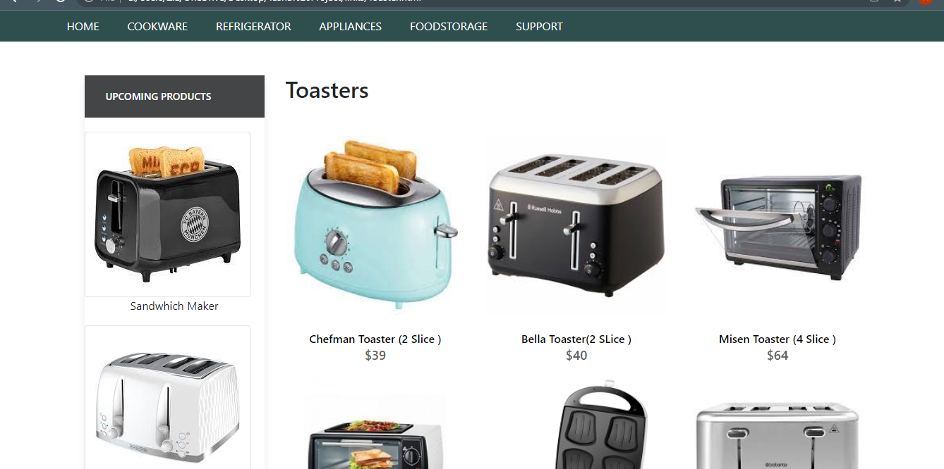

Toasters

+-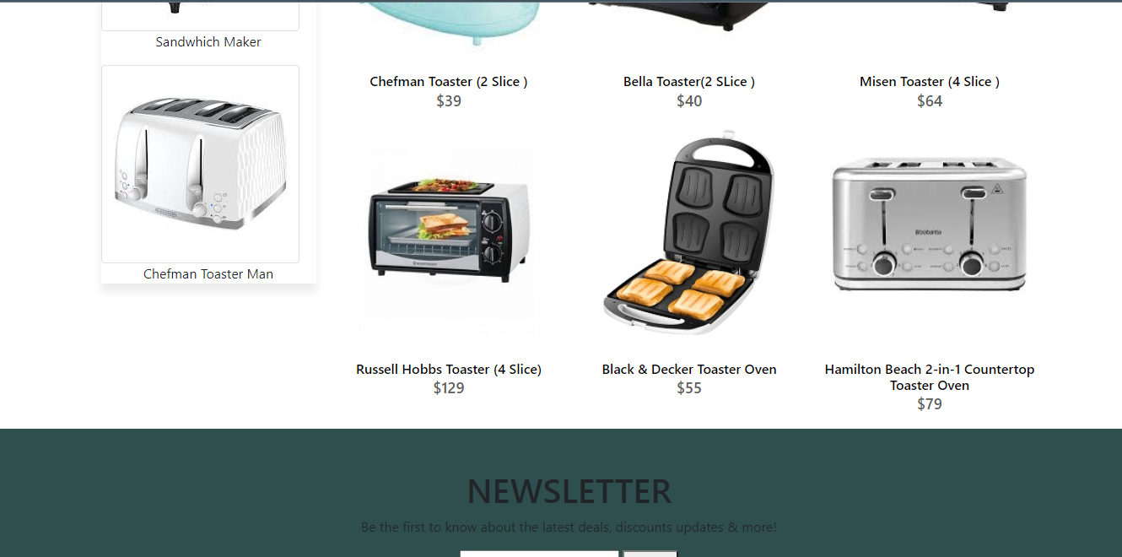

<!doctype html>

Toasters Code

<html>

<head>

<meta charset="utf-8">

<title>Untitled Document</title>

<link rel="stylesheet" type="text/css" href="../bootstraps/css/bootstrap.min.css"/>

<link rel="stylesheet" type="text/css" href="../bootstraps/css/bootstrap.css"/>

<link rel="stylesheet" type="text/css" href="../CSS/Tasha.css"/>

<!-- Latest compiled and minified CSS START-->

<link rel="stylesheet" href="https://maxcdn.bootstrapcdn.com/bootstrap/4.5.2/css/bootstrap.min.css">

<!-- Latest compiled and minified CSS END-->

<!-- jQuery library START -->

<script src="https://ajax.googleapis.com/ajax/libs/jquery/3.5.1/jquery.min.js"></script>

<!-- jQuery library END-->

<!-- Popper JS START-->

<script src="https://cdnjs.cloudflare.com/ajax/libs/popper.js/1.16.0/umd/popper.min.js"></script>

<!-- Popper JS END -->

<!-- Latest compiled JavaScript START-->

<script src="https://maxcdn.bootstrapcdn.com/bootstrap/4.5.2/js/bootstrap.min.js"></script>

<!-- Latest compiled JavaScript -->

<!--Meta Link START-->

<meta name="viewport" content="width=device-width, initial-scale=1">

<!--Meta Link END-->

<!--FONT AWESOME CDN LINK-->

<link rel="stylesheet" href="https://pro.fontawesome.com/releases/v5.10.0/css/all.css" integrity="sha384-AYmEC3Yw5cVb3ZcuHtOA93w35dYTsvhLPVnYs9eStHfGJvOvKxVfELGroGkvsg+p" crossorigin="anonymous"/>

<!--FONT AWESOME CDN LINK-->

<link rel="stylesheet" href="https://cdn.jsdelivr.net/npm/bootstrap-icons@1.6.0/font/bootstrap-icons.css" integrity="sha384-7ynz3n3tAGNUYFZD3cWe5PDcE36xj85vyFkawcF6tIwxvIecqKvfwLiaFdizhPpN" crossorigin="anonymous">

<link href="https://fonts.googleapis.com/css2?family=Open+Sans:wght@400;700&family=Poppins:wght@100;200;300;400&display=swap" rel="stylesheet">

</head>

<body>

<header>

<ul>

<li><a href="../Tasha.html">HOME</a>

</li>

<li><a href="#">COOKWARE</a>

<ul>

<li><a href="Cooking Pot.html">Cooking Pots</a></li>

<li><a href="Frying Pans.html">Frying Pans</a></li>

<li><a href="Cookware-Sets.html">Cookware Sets</a></li>

<li><a href="Egg Poached.html">Egg Poachers</a></li>

<li><a href="Grill-Pans.html">Grill Pans</a></li>

<li><a href="Steamer.html">Steamers</a></li>

</ul>

</li>

<li><a href="#">REFRIGERATOR</a>

<ul>

<li><a href="Refrigerators.html">Refrigerators</a></li>

<li><a href="Freezers.html">Freezers</a></li>

</ul>

</li>

<li><a href="#">APPLIANCES</a>

<ul>

<li><a href="Blenders.html">Blenders</a></li>

<li><a href="Bread-Maker.html">Bread Makers</a></li>

<li><a href="Coffee-Maker.html">Coffee Makers</a></li>

<li><a href="Icecream-Sorbet-Maker.html">Ice-Cream and Sorbet Makers</a></li>

<li><a href="Kettles.html">Kettles</a></li>

<li><a href="Food-Chopper.html">Food Choppers</a></li>

<li><a href="Toaster.html">Toasters</a></li>

</ul>

</li>

<li><a href="#">FOODSTORAGE</a>

<ul>

<li><a href="Flask.html">Flask</a></li>

<li><a href="Spice-Jars.html">Spice Jars</a></li>

<li><a href="Storage-Bags.html">Storage Bags</a></li>

<li><a href="Lunch-Boxes.html">Lunch Boxes</a></li>

<li><a href="Storage-Containers.html">Storage Containers</a></li>

</ul>

</li>

<li><a href="#">SUPPORT</a>

<ul>

<li><a href="Expert Tips.html">Expert Tips</a></li>

<li><a href="Register-Complain.html">Register Complain</a></li>

<li><a href="Feedback-Form.html">Feed Back</a></li>

<li><a href="Contact Us.html">Contact Us</a></li>

</ul>

</li>

</ul>

</header>

<!--NAVIGATION BAR ENDS-->

<!--cooking pot start-->

<section class="category">

<div class="container">

<div class="row">

<div class="col-lg-3">

<aside class="side-area product-side side-shadow mt-5">

<div class="side-title">

<h3>UpComing Products</h3>

</div>

<div class="side-content" >

<img src="../Images/235.jpg" class="img-thumbnail" alt="...">

<p style="text-align: center;">Sandwhich Maker </p>

<img src="../Images/236.jpg" class="img-thumbnail" alt="...">

<p style="text-align: center;"> Chefman Toaster Man </p>

</div>

</aside>

</div>

<div class="col-lg-9">

<div class="row">

<div class="col-lg-12">

<div class="product-top d-flex justify-content-between align-items-center" >

<div class="product-sec product-item ">

<h2 class="my-5">Toasters </h2>

</div>

</div>

</div>

<div class="col-lg-4 col-sm-6">

<div class="product-cate">

<div>

<img src="../Images/237.jpg" alt="" />

<div class="product-icon">

<ul>

<li><a href=""><i class="fa fa-heart" aria-hidden="true"></i></a></li>

<li><a href="Checkout-Form.html"><i class="fa fa-shopping-cart" aria-hidden="true"></i></a></li>

</ul>

</div>

<!---->

<div class="product-des">

<h5>Chefman Toaster (2 Slice )</h5>

<p>$39</p>

</div>

</div>

</div>

</div>

<!---->

<div class="col-lg-4 col-sm-6">

<div class="product-cate">

<div>

<img src="../Images/238.jpg" alt="pot" />

<div class="product-icon">

<ul>

<li><a href=""><i class="fa fa-heart" aria-hidden="true"></i></a></li>

<li><a href="Checkout-Form.html"><i class="fa fa-shopping-cart" aria-hidden="true"></i></a></li>

</ul>

</div>

<!---->

<div class="product-des">

<h5>Bella Toaster(2 SLice ) </h5>

<p>$40</p>

</div>

</div>

</div>

</div>

<!---->

<div class="col-lg-4 col-sm-6">

<div class="product-cate">

<div>

<img src="../Images/239.jpg" alt="pot"/>

<div class="product-icon">

<ul>

<li><a href=""><i class="fa fa-heart" aria-hidden="true"></i></a></li>

<li><a href="Checkout-Form.html"><i class="fa fa-shopping-cart" aria-hidden="true"></i></a></li>

</ul>

</div>

<!---->

<div class="product-des">

<h5>Misen Toaster (4 Slice )</h5>

<p>$64</p>

</div>

</div>

</div>

</div>

<!---->

<div class="col-lg-4 col-sm-6">

<div class="product-cate">

<div>

<img src="../Images/240.jpg" alt="pot" class="img-fluid"/>

<div class="product-icon">

<ul>

<li><a href=""><i class="fa fa-heart" aria-hidden="true"></i></a></li>

<li><a href="Checkout-Form.html"><i class="fa fa-shopping-cart" aria-hidden="true"></i></a></li>

</ul>

</div>

<!---->

<div class="product-des">

<h5>Russell Hobbs Toaster (4 Slice) </h5>

<p>$129</p>

</div>

</div>

</div>

</div>

<!---->

<div class="col-lg-4 col-sm-6">

<div class="product-cate">

<div>

<img src="../Images/241.jpg" alt="pot" />

<div class="product-icon">

<ul>

<li><a href=""><i class="fa fa-heart" aria-hidden="true"></i></a></li>

<li><a href="Checkout-Form.html"><i class="fa fa-shopping-cart" aria-hidden="true"></i></a></li>

</ul>

</div>

<!---->

<div class="product-des">

<h5>Black & Decker Toaster Oven </h5>

<p>$55</p>

</div>

</div>

</div>

</div>

<!---->

<div class="col-lg-4 col-sm-6">

<div class="product-cate">

<div>

<img src="../Images/242.jpg" alt=""/>

<div class="product-icon">

<ul>

<li><a href=""><i class="fa fa-heart" aria-hidden="true"></i></a></li>

<li><a href="Checkout-Form.html"><i class="fa fa-shopping-cart" aria-hidden="true"></i></a></li>

</ul>

</div>

<!---->

<div class="product-des">

<h5>Hamilton Beach 2-in-1 Countertop Toaster Oven </h5>

<p>$79</p>

</div>

</div>

</div>

</div>

<!---->

</div>

</div>

</div>

</div>

</section>

<!--cooking pot end-->

<!-- FOOTER STARTS -->

<footer class=" text-black pt-5 pb-4 page-footer" style="background-color: darkslategray;">

<div class="text-center">

<h1 >NEWSLETTER</h1>

<p>Be the first to know about the latest deals, discounts updates & more!</p>

<input type="email" name="email" placeholder="Enter your email here"/>

<button type="submit" onClick="onclick" > Submit </button>

</div>

<br><br>

<div class=" container text-center text-md-left ">

<div class="row text-center text-md-left ">

<div class="col-md-3 col-lg-3 col-xl-3 mx-auto mt-3">

<h5 class="text-uppercase mb-4 font-weight-bold text-warning">TASHA Kitchen-Ware</h5>

<p>TASHA- the home store is Branded Company famous for home kitchen appliances. It provides collection of n number of appliances with different category to match the fast life of the generation. The Tasha group of companies had made huge profit in the year 2013. In order to enhance its business the organization wants you to develop the website.</p>

</div>

<div class="col-md-3 col-lg-3 col-xl-3 mx-auto mt-3" >

<h5 class="text-uppercase mb-4 font-weight-bold text-warning">OFFERS</h5>

<p><a href="#" class="text-black" style="text-decoration: none; color:black; ">Deal of the Day</a></p>

<p><a href="#" class="text-black" style="text-decoration: none;color:black;">Buy 1 Get 1 Free</a></p>

<p><a href="#" class="text-black" style="text-decoration: none;color:black;">Appliance Packages Offers</a></p>

<p ><a href="#" class="text-black" style="text-decoration: none; color:black;">Reward Program</a></p>

</div>

<div class="col-md-4 col-lg-3 col-xl-3 mx-auto mt-3">

<h5 class="text-uppercase mb-4 font-weight-bold text-warning">ADDRESS</h5>

<p>

<i class="fas fa-home mr-3"></i>Plot No. G-21/23, Block-8, Khaliquzzaman Road, Clifton، Block 8 Clifton, Karachi, Karachi City, Sindh 75600

</p>

</div>

</div>

<hr class="mb-4">

<div class="row align-items-center">

<div class="col-md-7 col-lg-8">

<p>copyright all rights reserved by <a href="#" style="text-decoration: none"><strong class="text-warning">The Provider</strong></a></p></div>

<div class="col-md-5 col-lg-4">

<div class="text-center text-md-right">

<ul class="list-unstyled list-inline">

<li class="list-inline-item">

<a href="#" class="btn-floating btn-sm text-black" style="font-size:23px;"><i class="fab fa-facebook"></i></a></li>

<li class="list-inline-item">

<a href="#" class="btn-floating btn-sm text-black" style="font-size:23px;"><i class="fab fa-twitter"></i></a></li>

<li class="list-inline-item">

<a href="#" class="btn-floating btn-sm text-black" style="font-size:23px;"><i class="fab fa-instagram"></i></a></li>

<li class="list-inline-item">

<a href="#" class="btn-floating btn-sm text-black" style="font-size:23px;"><i class="fas fa-link"></i></a></li>

</ul>

</div>

</div>

</div>

</div>

</footer>

<!--FOOTER ENDS-->

</body>

</html>

Flasks

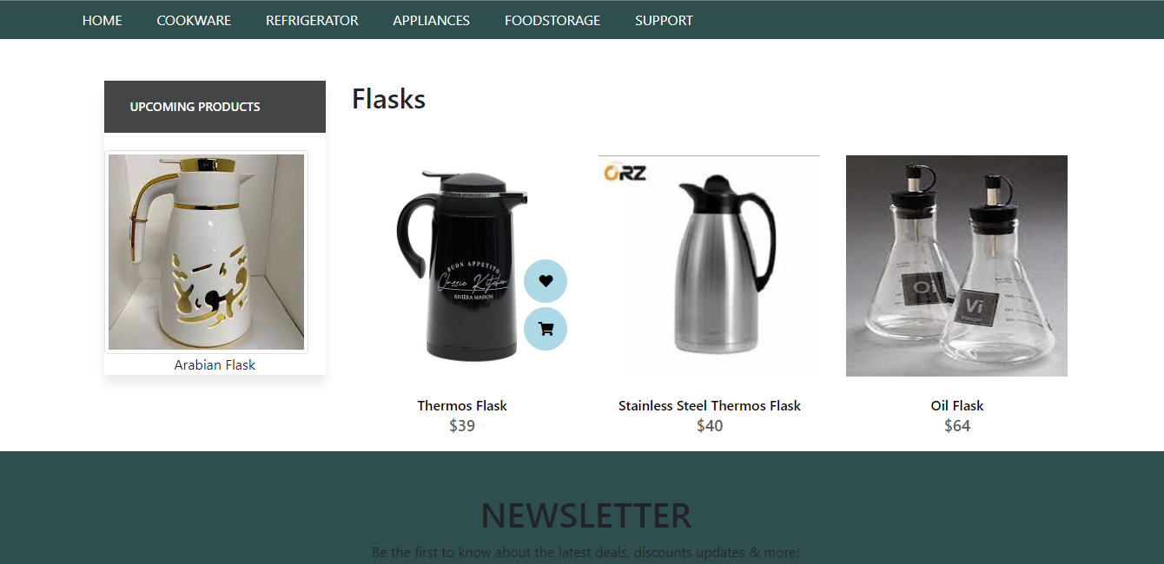

<!doctype html>

Flasks Code

<html>

<head>

<meta charset="utf-8">

<title>Untitled Document</title>

<link rel="stylesheet" type="text/css" href="../bootstraps/css/bootstrap.min.css"/>

<link rel="stylesheet" type="text/css" href="../bootstraps/css/bootstrap.css"/>

<link rel="stylesheet" type="text/css" href="../CSS/Tasha.css"/>

<!-- Latest compiled and minified CSS START-->

<link rel="stylesheet" href="https://maxcdn.bootstrapcdn.com/bootstrap/4.5.2/css/bootstrap.min.css">

<!-- Latest compiled and minified CSS END-->

<!-- jQuery library START -->

<script src="https://ajax.googleapis.com/ajax/libs/jquery/3.5.1/jquery.min.js"></script>

<!-- jQuery library END-->

<!-- Popper JS START-->

<script src="https://cdnjs.cloudflare.com/ajax/libs/popper.js/1.16.0/umd/popper.min.js"></script>

<!-- Popper JS END -->

<!-- Latest compiled JavaScript START-->

<script src="https://maxcdn.bootstrapcdn.com/bootstrap/4.5.2/js/bootstrap.min.js"></script>

<!-- Latest compiled JavaScript -->

<!--Meta Link START-->

<meta name="viewport" content="width=device-width, initial-scale=1">

<!--Meta Link END-->

<!--FONT AWESOME CDN LINK-->

<link rel="stylesheet" href="https://pro.fontawesome.com/releases/v5.10.0/css/all.css" integrity="sha384-AYmEC3Yw5cVb3ZcuHtOA93w35dYTsvhLPVnYs9eStHfGJvOvKxVfELGroGkvsg+p" crossorigin="anonymous"/>

<!--FONT AWESOME CDN LINK-->

<link rel="stylesheet" href="https://cdn.jsdelivr.net/npm/bootstrap-icons@1.6.0/font/bootstrap-icons.css" integrity="sha384-7ynz3n3tAGNUYFZD3cWe5PDcE36xj85vyFkawcF6tIwxvIecqKvfwLiaFdizhPpN" crossorigin="anonymous">

<link href="https://fonts.googleapis.com/css2?family=Open+Sans:wght@400;700&family=Poppins:wght@100;200;300;400&display=swap" rel="stylesheet">

</head>

<body>

<header>

<ul>

<li><a href="../Tasha.html">HOME</a>

</li>

<li><a href="#">COOKWARE</a>

<ul>

<li><a href="Cooking Pot.html">Cooking Pots</a></li>

<li><a href="Frying Pans.html">Frying Pans</a></li>

<li><a href="Cookware-Sets.html">Cookware Sets</a></li>

<li><a href="Egg Poached.html">Egg Poachers</a></li>

<li><a href="Grill-Pans.html">Grill Pans</a></li>

<li><a href="Steamer.html">Steamers</a></li>

</ul>

</li>

<li><a href="#">REFRIGERATOR</a>

<ul>

<li><a href="Refrigerators.html">Refrigerators</a></li>

<li><a href="Freezers.html">Freezers</a></li>

</ul>

</li>

<li><a href="#">APPLIANCES</a>

<ul>

<li><a href="Blenders.html">Blenders</a></li>

<li><a href="Bread-Maker.html">Bread Makers</a></li>

<li><a href="Coffee-Maker.html">Coffee Makers</a></li>

<li><a href="Icecream-Sorbet-Maker.html">Ice-Cream and Sorbet Makers</a></li>

<li><a href="Kettles.html">Kettles</a></li>

<li><a href="Food-Chopper.html">Food Choppers</a></li>

<li><a href="Toaster.html">Toasters</a></li>

</ul>

</li>

<li><a href="#">FOODSTORAGE</a>

<ul>

<li><a href="Flask.html">Flask</a></li>

<li><a href="Spice-Jars.html">Spice Jars</a></li>

<li><a href="Storage-Bags.html">Storage Bags</a></li>

<li><a href="Lunch-Boxes.html">Lunch Boxes</a></li>

<li><a href="Storage-Containers.html">Storage Containers</a></li>

</ul>

</li>

<li><a href="#">SUPPORT</a>

<ul>

<li><a href="Expert Tips.html">Expert Tips</a></li>

<li><a href="Register-Complain.html">Register Complain</a></li>

<li><a href="Feedback-Form.html">Feed Back</a></li>

<li><a href="Contact Us.html">Contact Us</a></li>

</ul>

</li>

</ul>

</header>

<!--NAVIGATION BAR ENDS-->

<!--cooking pot start-->

<section class="category">

<div class="container">

<div class="row">

<div class="col-lg-3">

<aside class="side-area product-side side-shadow mt-5">

<div class="side-title">

<h3>UpComing Products</h3>

</div>

<div class="side-content" >

<img src="../Images/243.jpg" class="img-thumbnail" alt="...">

<p style="text-align: center;">Arabian Flask </p>

</div>

</aside>

</div>

<div class="col-lg-9">

<div class="row">

<div class="col-lg-12">

<div class="product-top d-flex justify-content-between align-items-center" >

<div class="product-sec product-item ">

<h2 class="my-5">Flasks </h2>

</div>

</div>

</div>

<div class="col-lg-4 col-sm-6">

<div class="product-cate">

<div>

<img src="../Images/244.jpg" alt="" />

<div class="product-icon">

<ul>

<li><a href=""><i class="fa fa-heart" aria-hidden="true"></i></a></li>

<li><a href="Checkout-Form.html"><i class="fa fa-shopping-cart" aria-hidden="true"></i></a></li>

</ul>

</div>

<!---->

<div class="product-des">

<h5>Thermos Flask</h5>

<p>$39</p>

</div>

</div>

</div>

</div>

<!---->

<div class="col-lg-4 col-sm-6">

<div class="product-cate">

<div>

<img src="../Images/245.jpg" alt="pot" />

<div class="product-icon">

<ul>

<li><a href=""><i class="fa fa-heart" aria-hidden="true"></i></a></li>

<li><a href="Checkout-Form.html"><i class="fa fa-shopping-cart" aria-hidden="true"></i></a></li>

</ul>

</div>

<!---->

<div class="product-des">

<h5>Stainless Steel Thermos Flask </h5>

<p>$40</p>

</div>

</div>

</div>

</div>

<!---->

<div class="col-lg-4 col-sm-6">

<div class="product-cate">

<div>

<img src="../Images/246.jpg" alt="pot"/>

<div class="product-icon">

<ul>

<li><a href=""><i class="fa fa-heart" aria-hidden="true"></i></a></li>

<li><a href="Checkout-Form.html"><i class="fa fa-shopping-cart" aria-hidden="true"></i></a></li>

</ul>

</div>

<!---->

<div class="product-des">

<h5>Oil Flask</h5>

<p>$64</p>

</div>

</div>

</div>

</div>

<!---->

</div>

</div>

</div>

</div>

</section>

<!--cooking pot end-->

<!-- FOOTER STARTS -->

<footer class=" text-black pt-5 pb-4 page-footer" style="background-color: darkslategray;">

<div class="text-center">

<h1 >NEWSLETTER</h1>

<p>Be the first to know about the latest deals, discounts updates & more!</p>

<input type="email" name="email" placeholder="Enter your email here"/>

<button type="submit" onClick="onclick" > Submit </button>

</div>

<br><br>

<div class=" container text-center text-md-left ">

<div class="row text-center text-md-left ">

<div class="col-md-3 col-lg-3 col-xl-3 mx-auto mt-3">

<h5 class="text-uppercase mb-4 font-weight-bold text-warning">TASHA Kitchen-Ware</h5>

<p>TASHA- the home store is Branded Company famous for home kitchen appliances. It provides collection of n number of appliances with different category to match the fast life of the generation. The Tasha group of companies had made huge profit in the year 2013. In order to enhance its business the organization wants you to develop the website.</p>

</div>

<div class="col-md-3 col-lg-3 col-xl-3 mx-auto mt-3" >

<h5 class="text-uppercase mb-4 font-weight-bold text-warning">OFFERS</h5>

<p><a href="#" class="text-black" style="text-decoration: none; color:black; ">Deal of the Day</a></p>

<p><a href="#" class="text-black" style="text-decoration: none;color:black;">Buy 1 Get 1 Free</a></p>

<p><a href="#" class="text-black" style="text-decoration: none;color:black;">Appliance Packages Offers</a></p>

<p ><a href="#" class="text-black" style="text-decoration: none; color:black;">Reward Program</a></p>

</div>

<div class="col-md-4 col-lg-3 col-xl-3 mx-auto mt-3">

<h5 class="text-uppercase mb-4 font-weight-bold text-warning">ADDRESS</h5>

<p>

<i class="fas fa-home mr-3"></i>Plot No. G-21/23, Block-8, Khaliquzzaman Road, Clifton، Block 8 Clifton, Karachi, Karachi City, Sindh 75600

</p>

</div>

</div>

<hr class="mb-4">

<div class="row align-items-center">

<div class="col-md-7 col-lg-8">

<p>copyright all rights reserved by <a href="#" style="text-decoration: none"><strong class="text-warning">The Provider</strong></a></p></div>

<div class="col-md-5 col-lg-4">

<div class="text-center text-md-right">

<ul class="list-unstyled list-inline">

<li class="list-inline-item">

<a href="#" class="btn-floating btn-sm text-black" style="font-size:23px;"><i class="fab fa-facebook"></i></a></li>

<li class="list-inline-item">

<a href="#" class="btn-floating btn-sm text-black" style="font-size:23px;"><i class="fab fa-twitter"></i></a></li>

<li class="list-inline-item">

<a href="#" class="btn-floating btn-sm text-black" style="font-size:23px;"><i class="fab fa-instagram"></i></a></li>

<li class="list-inline-item">

<a href="#" class="btn-floating btn-sm text-black" style="font-size:23px;"><i class="fas fa-link"></i></a></li>

</ul>

</div>

</div>

</div>

</div>

</footer>

<!--FOOTER ENDS-->

</body>

</html>

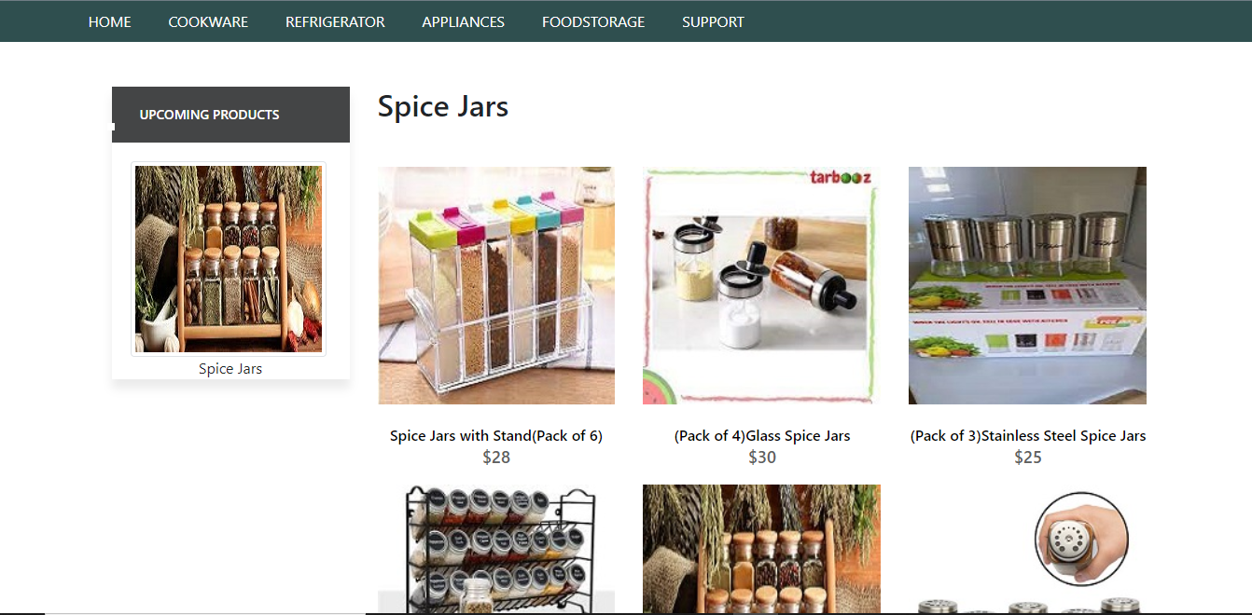

Spice Jars

Spice Jars

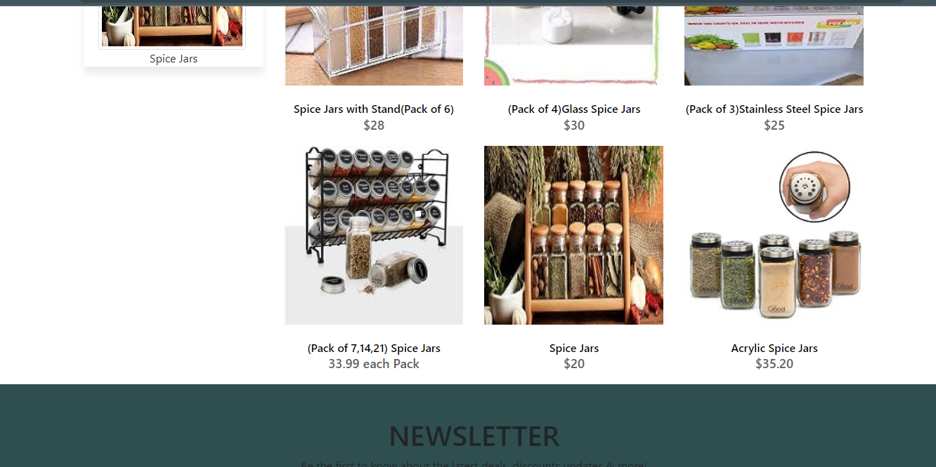

<!doctype html>

Spice Jars Code

<html>

<head>

<meta charset="utf-8">

<title>Untitled Document</title>

<!--CSS LINK -->

<link rel="stylesheet" type="text/css" href="../CSS/Tasha.css"/>

<link rel="stylesheet" type="text/css" href="../bootstraps/css/bootstrap.min.css"/>

<link rel="stylesheet" type="text/css" href="../bootstraps/css/bootstrap.css"/>

<link rel="stylesheet" type="text/css" href="../CSS/Links.css"/>

<!-- Latest compiled and minified CSS START-->

<link rel="stylesheet" href="https://maxcdn.bootstrapcdn.com/bootstrap/4.5.2/css/bootstrap.min.css">

<!-- Latest compiled and minified CSS END-->

<!-- jQuery library START -->

<script src="https://ajax.googleapis.com/ajax/libs/jquery/3.5.1/jquery.min.js"></script>

<!-- jQuery library END-->

<!-- Popper JS START-->

<script src="https://cdnjs.cloudflare.com/ajax/libs/popper.js/1.16.0/umd/popper.min.js"></script>

<!-- Popper JS END -->

<!-- Latest compiled JavaScript START-->

<script src="https://maxcdn.bootstrapcdn.com/bootstrap/4.5.2/js/bootstrap.min.js"></script>

<!-- Latest compiled JavaScript -->

<!--Meta Link START-->

<meta name="viewport" content="width=device-width, initial-scale=1">

<!--Meta Link END-->

<!--FONT AWESOME CDN LINK-->

<link rel="stylesheet" href="https://pro.fontawesome.com/releases/v5.10.0/css/all.css" integrity="sha384-AYmEC3Yw5cVb3ZcuHtOA93w35dYTsvhLPVnYs9eStHfGJvOvKxVfELGroGkvsg+p" crossorigin="anonymous"/>

<!--FONT AWESOME CDN LINK-->

<link rel="stylesheet" href="https://cdn.jsdelivr.net/npm/bootstrap-icons@1.6.0/font/bootstrap-icons.css" integrity="sha384-7ynz3n3tAGNUYFZD3cWe5PDcE36xj85vyFkawcF6tIwxvIecqKvfwLiaFdizhPpN" crossorigin="anonymous">

<link href="https://fonts.googleapis.com/css2?family=Open+Sans:wght@400;700&family=Poppins:wght@100;200;300;400&display=swap" rel="stylesheet">

</head>

<body>

<header>

<ul>

<li><a href="../Tasha.html">HOME</a>

</li>

<li><a href="#">COOKWARE</a>

<ul>

<li><a href="Cooking Pot.html">Cooking Pots</a></li>

<li><a href="Frying Pans.html">Frying Pans</a></li>

<li><a href="Cookware-Sets.html">Cookware Sets</a></li>

<li><a href="Egg Poached.html">Egg Poachers</a></li>

<li><a href="Grill-Pans.html">Grill Pans</a></li>

<li><a href="Steamer.html">Steamers</a></li>

</ul>

</li>

<li><a href="#">REFRIGERATOR</a>

<ul>

<li><a href="Refrigerators.html">Refrigerators</a></li>

<li><a href="Freezers.html">Freezers</a></li>

</ul>

</li>

<li><a href="#">APPLIANCES</a>

<ul>

<li><a href="Blenders.html">Blenders</a></li>

<li><a href="Bread-Maker.html">Bread Makers</a></li>

<li><a href="Coffee-Maker.html">Coffee Makers</a></li>

<li><a href="Icecream-Sorbet-Maker.html">Ice-Cream and Sorbet Makers</a></li>

<li><a href="Kettles.html">Kettles</a></li>

<li><a href="Food-Chopper.html">Food Choppers</a></li>

<li><a href="Toaster.html">Toasters</a></li>

</ul>

</li>

<li><a href="#">FOODSTORAGE</a>

<ul>

<li><a href="Flask.html">Flask</a></li>

<li><a href="Spice-Jars.html">Spice Jars</a></li>

<li><a href="Storage-Bags.html">Storage Bags</a></li>

<li><a href="Lunch-Boxes.html">Lunch Boxes</a></li>

<li><a href="Storage-Containers.html">Storage Containers</a></li>

</ul>

</li>

<li><a href="#">SUPPORT</a>

<ul>

<li><a href="Expert Tips.html">Expert Tips</a></li>

<li><a href="Register-Complain.html">Register Complain</a></li>

<li><a href="Feedback-Form.html">Feed Back</a></li>

<li><a href="Contact Us.html">Contact Us</a></li>

</ul>

</li>

</ul>

</header>

<!--NAVIGATION BAR ENDS-->

<!--NAVIGATION BAR ENDS-->

<!--SIDE NAVIGATOR STARTS-->

<section class="category">

<div class="container">

<div class="row">

<div class="col-lg-3">

<aside class="side-area product-side side-shadow mt-5">

<div class="side-title">

<h3>UpComing Products</h3>

</div>

<div class="side-content" style="margin: 20px;" >

<img src="../Images/217.jpg" class="img-thumbnail" alt="...">

<p style="text-align: center;">Spice Jars </p>

</div>

</aside>

</div>

<!--SIDE NAVIGATOR ENDS-->

<!--COOKING POT STARTS-->

<div class="col-lg-9">

<div class="row">

<div class="col-lg-12">

<div class="product-top d-flex justify-content-between align-items-center" >

<div class="product-sec product-item ">

<h2 class="my-5">Spice Jars</h2>

</div>

</div>

</div>

<div class="col-lg-4 col-sm-6">

<div class="product-cate">

<div>

<img src="../Images/213.jpg" alt="" />

<div class="product-icon">

<ul>

<li><a href=""><i class="fa fa-heart" aria-hidden="true"></i></a></li>

<li><a href="Checkout-Form.html"><i class="fa fa-shopping-cart" aria-hidden="true"></i></a></li>

</ul>

</div>

<!---->

<div class="product-des">

<h5>Spice Jars with Stand(Pack of 6)</h5>

<p>$28</p>

</div>

</div>

</div>

</div>

<!---->

<div class="col-lg-4 col-sm-6">

<div class="product-cate">

<div>

<img src="../Images/214.jpg" alt="pot" />

<div class="product-icon">

<ul>

<li><a href=""><i class="fa fa-heart" aria-hidden="true"></i></a></li>

<li><a href="Checkout-Form.html"><i class="fa fa-shopping-cart" aria-hidden="true"></i></a></li>

</ul>

</div>

<!---->

<div class="product-des">

<h5>(Pack of 4)Glass Spice Jars </h5>

<p>$30</p>

</div>

</div>

</div>

</div>

<!---->

<div class="col-lg-4 col-sm-6">

<div class="product-cate">

<div>

<img src="../Images/215.jpg" alt="pot"/>

<div class="product-icon">

<ul>

<li><a href=""><i class="fa fa-heart" aria-hidden="true"></i></a></li>

<li><a href="Checkout-Form.html"><i class="fa fa-shopping-cart" aria-hidden="true"></i></a></li>

</ul>

</div>

<!---->

<div class="product-des">

<h5>(Pack of 3)Stainless Steel Spice Jars </h5>

<p>$25</p>

</div>

</div>

</div>

</div>

<!---->

<div class="col-lg-4 col-sm-6">

<div class="product-cate">

<div>

<img src="../Images/216.jpg" alt="pot" class="img-fluid"/>

<div class="product-icon">

<ul>

<li><a href=""><i class="fa fa-heart" aria-hidden="true"></i></a></li>

<li><a href="Checkout-Form.html"><i class="fa fa-shopping-cart" aria-hidden="true"></i></a></li>

</ul>

</div>

<!---->

<div class="product-des">

<h5>(Pack of 7,14,21) Spice Jars </h5>

<p>33.99 each Pack</p>

</div>

</div>

</div>

</div>

<!---->

<div class="col-lg-4 col-sm-6">

<div class="product-cate">

<div>

<img src="../Images/217.jpg" alt="pot" />

<div class="product-icon">

<ul>

<li><a href=""><i class="fa fa-heart" aria-hidden="true"></i></a></li>

<li><a href="Checkout-Form.html"><i class="fa fa-shopping-cart" aria-hidden="true"></i></a></li>

</ul>

</div>

<!---->

<div class="product-des">

<h5>Spice Jars</h5>

<p>$20</p>

</div>

</div>

</div>

</div>

<!---->

<div class="col-lg-4 col-sm-6">

<div class="product-cate">

<div>

<img src="../Images/218.jpeg" alt=""/>

<div class="product-icon">

<ul>

<li><a href=""><i class="fa fa-heart" aria-hidden="true"></i></a></li>

<li><a href="Checkout-Form.html"><i class="fa fa-shopping-cart" aria-hidden="true"></i></a></li>

</ul>

</div>

<!---->

<div class="product-des">

<h5>Acrylic Spice Jars</h5>

<p>$35.20</p>

</div>

</div>

</div>

</div>

<!---->

</div>

</div>

</div>

</div>

</section>

<!--COOKING POT END-->

<!-- FOOTER STARTS -->

<footer class=" text-black pt-5 pb-4 page-footer" style="background-color: darkslategray;">

<div class="text-center">

<h1 >NEWSLETTER</h1>

<p>Be the first to know about the latest deals, discounts updates & more!</p>

<input type="email" name="email" placeholder="Enter your email here"/>

<button type="submit" onClick="onclick" > Submit </button>

</div>

<br><br>

<div class=" container text-center text-md-left ">

<div class="row text-center text-md-left ">

<div class="col-md-3 col-lg-3 col-xl-3 mx-auto mt-3">

<h5 class="text-uppercase mb-4 font-weight-bold text-warning">TASHA Kitchen-Ware</h5>

<p>TASHA- the home store is Branded Company famous for home kitchen appliances. It provides collection of n number of appliances with different category to match the fast life of the generation. The Tasha group of companies had made huge profit in the year 2013. In order to enhance its business the organization wants you to develop the website.</p>

</div>

<div class="col-md-3 col-lg-3 col-xl-3 mx-auto mt-3" >

<h5 class="text-uppercase mb-4 font-weight-bold text-warning">OFFERS</h5>

<p><a href="#" class="text-black" style="text-decoration: none; color:black; ">Deal of the Day</a></p>

<p><a href="#" class="text-black" style="text-decoration: none;color:black;">Buy 1 Get 1 Free</a></p>

<p><a href="#" class="text-black" style="text-decoration: none;color:black;">Appliance Packages Offers</a></p>

<p ><a href="#" class="text-black" style="text-decoration: none; color:black;">Reward Program</a></p>

</div>

<div class="col-md-4 col-lg-3 col-xl-3 mx-auto mt-3">

<h5 class="text-uppercase mb-4 font-weight-bold text-warning">ADDRESS</h5>

<p>

<i class="fas fa-home mr-3"></i>Plot No. G-21/23, Block-8, Khaliquzzaman Road, Clifton، Block 8 Clifton, Karachi, Karachi City, Sindh 75600

</p>

</div>

</div>

<hr class="mb-4">

<div class="row align-items-center">

<div class="col-md-7 col-lg-8">

<p>copyright all rights reserved by <a href="#" style="text-decoration: none"><strong class="text-warning">The Provider</strong></a></p></div>

<div class="col-md-5 col-lg-4">

<div class="text-center text-md-right">

<ul class="list-unstyled list-inline">

<li class="list-inline-item">

<a href="#" class="btn-floating btn-sm text-black" style="font-size:23px;"><i class="fab fa-facebook"></i></a></li>

<li class="list-inline-item">

<a href="#" class="btn-floating btn-sm text-black" style="font-size:23px;"><i class="fab fa-twitter"></i></a></li>

<li class="list-inline-item">

<a href="#" class="btn-floating btn-sm text-black" style="font-size:23px;"><i class="fab fa-instagram"></i></a></li>

<li class="list-inline-item">

<a href="#" class="btn-floating btn-sm text-black" style="font-size:23px;"><i class="fas fa-link"></i></a></li>

</ul>

</div>

</div>

</div>

</div>

</footer>

<!--FOOTER ENDS-->

</body>

</html>

Spice Bags

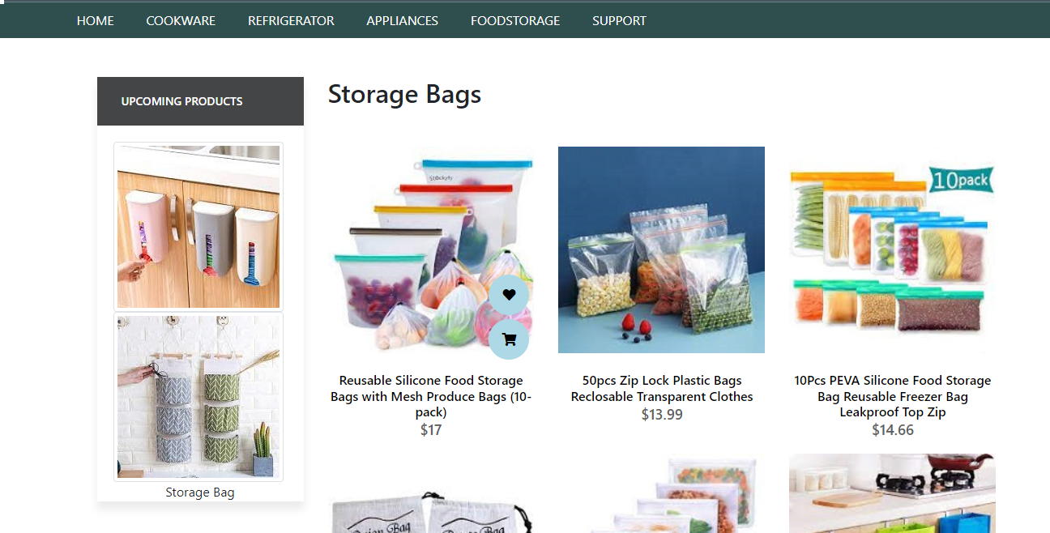

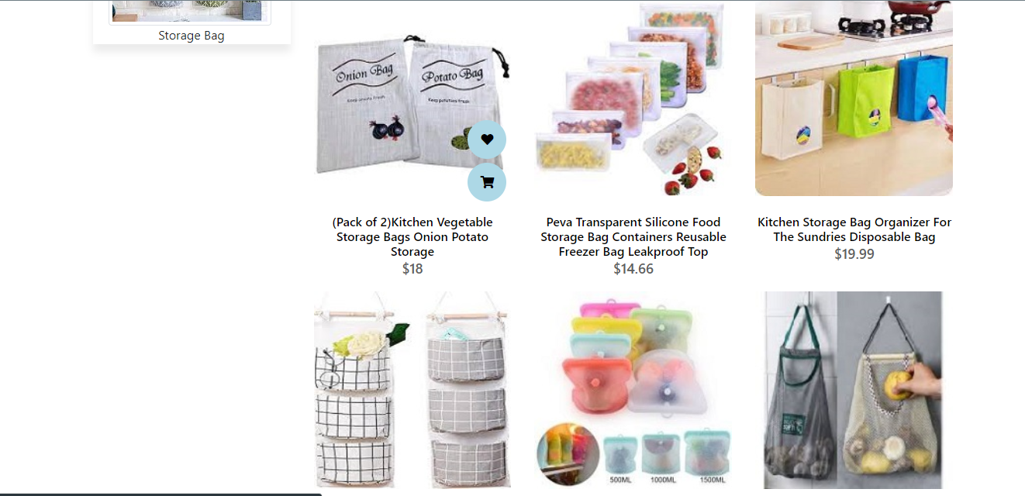

Storage Bags

Storage Bags

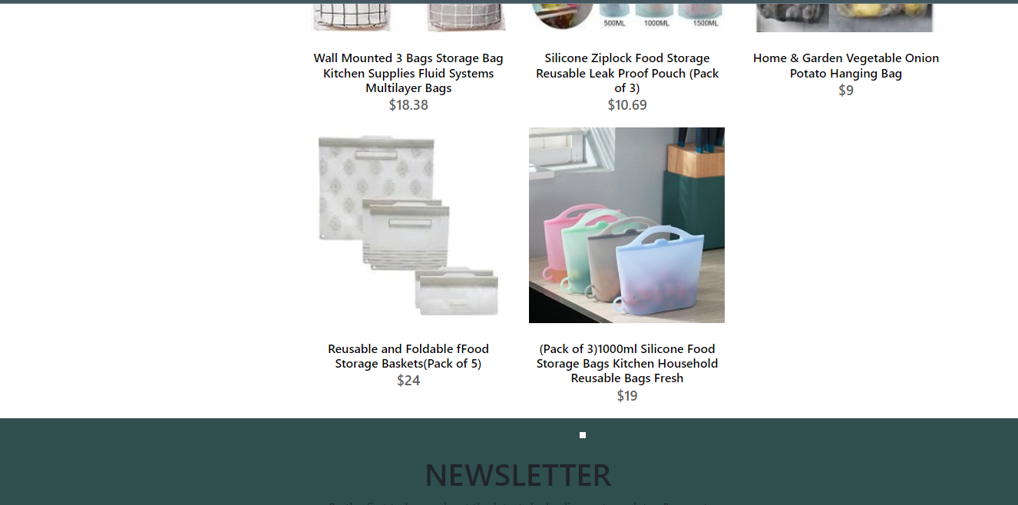

Storage Bags



<!doctype html>

Storage Bags Code

<html>

<head>

<meta charset="utf-8">

<title>Untitled Document</title>

<!--CSS LINK -->

<link rel="stylesheet" type="text/css" href="../CSS/Tasha.css"/>

<link rel="stylesheet" type="text/css" href="../bootstraps/css/bootstrap.min.css"/>

<link rel="stylesheet" type="text/css" href="../bootstraps/css/bootstrap.css"/>

<link rel="stylesheet" type="text/css" href="../CSS/Links.css"/>

<!-- Latest compiled and minified CSS START-->

<link rel="stylesheet" href="https://maxcdn.bootstrapcdn.com/bootstrap/4.5.2/css/bootstrap.min.css">

<!-- Latest compiled and minified CSS END-->

<!-- jQuery library START -->

<script src="https://ajax.googleapis.com/ajax/libs/jquery/3.5.1/jquery.min.js"></script>

<!-- jQuery library END-->

<!-- Popper JS START-->

<script src="https://cdnjs.cloudflare.com/ajax/libs/popper.js/1.16.0/umd/popper.min.js"></script>

<!-- Popper JS END -->

<!-- Latest compiled JavaScript START-->

<script src="https://maxcdn.bootstrapcdn.com/bootstrap/4.5.2/js/bootstrap.min.js"></script>

<!-- Latest compiled JavaScript -->

<!--Meta Link START-->

<meta name="viewport" content="width=device-width, initial-scale=1">

<!--Meta Link END-->

<!--FONT AWESOME CDN LINK-->

<link rel="stylesheet" href="https://pro.fontawesome.com/releases/v5.10.0/css/all.css" integrity="sha384-AYmEC3Yw5cVb3ZcuHtOA93w35dYTsvhLPVnYs9eStHfGJvOvKxVfELGroGkvsg+p" crossorigin="anonymous"/>

<!--FONT AWESOME CDN LINK-->

<link rel="stylesheet" href="https://cdn.jsdelivr.net/npm/bootstrap-icons@1.6.0/font/bootstrap-icons.css" integrity="sha384-7ynz3n3tAGNUYFZD3cWe5PDcE36xj85vyFkawcF6tIwxvIecqKvfwLiaFdizhPpN" crossorigin="anonymous">

<link href="https://fonts.googleapis.com/css2?family=Open+Sans:wght@400;700&family=Poppins:wght@100;200;300;400&display=swap" rel="stylesheet">

</head>

<body>

<header>

<ul>

<li><a href="../Tasha.html">HOME</a>

</li>

<li><a href="#">COOKWARE</a>

<ul>

<li><a href="Cooking Pot.html">Cooking Pots</a></li>

<li><a href="Frying Pans.html">Frying Pans</a></li>

<li><a href="Cookware-Sets.html">Cookware Sets</a></li>

<li><a href="Egg Poached.html">Egg Poachers</a></li>

<li><a href="Grill-Pans.html">Grill Pans</a></li>

<li><a href="Steamer.html">Steamers</a></li>

</ul>

</li>

<li><a href="#">REFRIGERATOR</a>

<ul>

<li><a href="Refrigerators.html">Refrigerators</a></li>

<li><a href="Freezers.html">Freezers</a></li>

</ul>

</li>

<li><a href="#">APPLIANCES</a>

<ul>

<li><a href="Blenders.html">Blenders</a></li>

<li><a href="Bread-Maker.html">Bread Makers</a></li>

<li><a href="Coffee-Maker.html">Coffee Makers</a></li>

<li><a href="Icecream-Sorbet-Maker.html">Ice-Cream and Sorbet Makers</a></li>

<li><a href="Kettles.html">Kettles</a></li>

<li><a href="Food-Chopper.html">Food Choppers</a></li>

<li><a href="Toaster.html">Toasters</a></li>

</ul>

</li>

<li><a href="#">FOODSTORAGE</a>

<ul>

<li><a href="Flask.html">Flask</a></li>

<li><a href="Spice-Jars.html">Spice Jars</a></li>

<li><a href="Storage-Bags.html">Storage Bags</a></li>

<li><a href="Lunch-Boxes.html">Lunch Boxes</a></li>

<li><a href="Storage-Containers.html">Storage Containers</a></li>

</ul>

</li>

<li><a href="#">SUPPORT</a>

<ul>

<li><a href="Expert Tips.html">Expert Tips</a></li>

<li><a href="Register-Complain.html">Register Complain</a></li>

<li><a href="Feedback-Form.html">Feed Back</a></li>

<li><a href="Contact Us.html">Contact Us</a></li>

</ul>

</li>

</ul>

</header>

<!--NAVIGATION BAR ENDS-->

<!--SIDE NAVIGATOR STARTS-->

<section class="category">

<div class="container">

<div class="row">

<div class="col-lg-3">

<aside class="side-area product-side side-shadow mt-5">

<div class="side-title">

<h3>UpComing Products</h3>

</div>

<div class="side-content" style="margin: 20px;" >

<img src="../Images/220.jpg" class="img-thumbnail" alt="...">

<img src="../Images/221.jpg" class="img-thumbnail" alt="...">

<p style="text-align: center;">Storage Bag</p>

</div>

</aside>

</div>

<!--SIDE NAVIGATOR ENDS-->

<!--STORAGE BAGS STARTS-->

<div class="col-lg-9">

<div class="row">

<div class="col-lg-12">

<div class="product-top d-flex justify-content-between align-items-center" >

<div class="product-sec product-item ">

<h2 class="my-5">Storage Bags</h2>

</div>

</div>

</div>

<!---->

<div class="col-lg-4 col-sm-6">

<div class="product-cate">

<div>

<img src="../Images/156.jpg" alt="pot" />

<div class="product-icon">

<ul>

<li><a href=""><i class="fa fa-heart" aria-hidden="true"></i></a></li>

<li><a href="Checkout-Form.html"><i class="fa fa-shopping-cart" aria-hidden="true"></i></a></li>

</ul>

</div>

<!---->

<div class="product-des">

<h5>Reusable Silicone Food Storage Bags with Mesh Produce Bags (10-pack) </h5>

<p>$17</p>

</div>

</div>

</div>

</div>

<!---->

<div class="col-lg-4 col-sm-6">

<div class="product-cate">

<div>

<img src="../Images/157.jpg" alt="pot"/>

<div class="product-icon">

<ul>

<li><a href=""><i class="fa fa-heart" aria-hidden="true"></i></a></li>

<li><a href="Checkout-Form.html"><i class="fa fa-shopping-cart" aria-hidden="true"></i></a></li>

</ul>

</div>

<!---->

<div class="product-des">

<h5>50pcs Zip Lock Plastic Bags Reclosable Transparent Clothes </h5>

<p>$13.99</p>

</div>

</div>

</div>

</div>

<!---->

<div class="col-lg-4 col-sm-6">

<div class="product-cate">

<div>

<img src="../Images/158.jpg" alt="pot" class="img-fluid"/>

<div class="product-icon">

<ul>

<li><a href=""><i class="fa fa-heart" aria-hidden="true"></i></a></li>

<li><a href="Checkout-Form.html"><i class="fa fa-shopping-cart" aria-hidden="true"></i></a></li>

</ul>

</div>

<!---->

<div class="product-des">

<h5>10Pcs PEVA Silicone Food Storage Bag Reusable Freezer Bag Leakproof Top Zip</h5>

<p>$14.66</p>

</div>

</div>

</div>

</div>

<!---->

<div class="col-lg-4 col-sm-6">

<div class="product-cate">

<div>

<img src="../Images/159.jpg" alt="pot" />

<div class="product-icon">

<ul>

<li><a href=""><i class="fa fa-heart" aria-hidden="true"></i></a></li>

<li><a href="Checkout-Form.html"><i class="fa fa-shopping-cart" aria-hidden="true"></i></a></li>

</ul>

</div>

<!---->

<div class="product-des">

<h5>(Pack of 2)Kitchen Vegetable Storage Bags Onion Potato Storage</h5>

<p>$18</p>

</div>

</div>

</div>

</div>

<!---->

<div class="col-lg-4 col-sm-6">

<div class="product-cate">

<div>

<img src="../Images/160.jpg" alt=""/>

<div class="product-icon">

<ul>

<li><a href=""><i class="fa fa-heart" aria-hidden="true"></i></a></li>

<li><a href="Checkout-Form.html"><i class="fa fa-shopping-cart" aria-hidden="true"></i></a></li>

</ul>

</div>

<!---->

<div class="product-des">

<h5>Peva Transparent Silicone Food Storage Bag Containers Reusable Freezer Bag Leakproof Top</h5>

<p>$14.66</p>

</div>

</div>

</div>

</div>

<!---->

<div class="col-lg-4 col-sm-6">

<div class="product-cate">

<div>

<img src="../Images/161.jpg" alt="pot" />

<div class="product-icon">

<ul>

<li><a href=""><i class="fa fa-heart" aria-hidden="true"></i></a></li>

<li><a href="Checkout-Form.html"><i class="fa fa-shopping-cart" aria-hidden="true"></i></a></li>

</ul>

</div>

<!---->

<div class="product-des">

<h5>Kitchen Storage Bag Organizer For The Sundries Disposable Bag </h5>

<p>$19.99</p>

</div>

</div>

</div>

</div>

<!---->

<div class="col-lg-4 col-sm-6">

<div class="product-cate">

<div>

<img src="../Images/162.jpg" alt="pot" />

<div class="product-icon">

<ul>

<li><a href=""><i class="fa fa-heart" aria-hidden="true"></i></a></li>

<li><a href="Checkout-Form.html"><i class="fa fa-shopping-cart" aria-hidden="true"></i></a></li>

</ul>

</div>

<!---->

<div class="product-des">

<h5>Wall Mounted 3 Bags Storage Bag Kitchen Supplies Fluid Systems Multilayer Bags</h5>

<p>$18.38 </p>

</div>

</div>

</div>

</div>

<!---->

<div class="col-lg-4 col-sm-6">

<div class="product-cate">

<div>

<img src="../Images/163.jpg" alt="pot" />

<div class="product-icon">

<ul>

<li><a href=""><i class="fa fa-heart" aria-hidden="true"></i></a></li>

<li><a href="Checkout-Form.html"><i class="fa fa-shopping-cart" aria-hidden="true"></i></a></li>

</ul>

</div>

<!---->

<div class="product-des">

<h5>Silicone Ziplock Food Storage Reusable Leak Proof Pouch

(Pack of 3)</h5>

<p>$10.69</p>

</div>

</div>

</div>

</div>

<!---->

<div class="col-lg-4 col-sm-6">

<div class="product-cate">

<div>

<img src="../Images/164.jpg" alt="pot" />

<div class="product-icon">

<ul>

<li><a href=""><i class="fa fa-heart" aria-hidden="true"></i></a></li>

<li><a href="Checkout-Form.html"><i class="fa fa-shopping-cart" aria-hidden="true"></i></a></li>

</ul>

</div>

<!---->

<div class="product-des">

<h5>Home & Garden Vegetable Onion Potato Hanging Bag </h5>

<p>$9</p>

</div>

</div>

</div>

</div>

<!---->

<div class="col-lg-4 col-sm-6">

<div class="product-cate">

<div>

<img src="../Images/165.jpg" alt="pot" />

<div class="product-icon">

<ul>

<li><a href=""><i class="fa fa-heart" aria-hidden="true"></i></a></li>

<li><a href="Checkout-Form.html"><i class="fa fa-shopping-cart" aria-hidden="true"></i></a></li>

</ul>

</div>

<!---->

<div class="product-des">

<h5>Reusable and Foldable fFood Storage Baskets(Pack of 5)</h5>

<p>$24</p>

</div>

</div>

</div>

</div>

<!---->

<div class="col-lg-4 col-sm-6">

<div class="product-cate">

<div>

<img src="../Images/166.jpg" alt="pot" />

<div class="product-icon">

<ul>

<li><a href=""><i class="fa fa-heart" aria-hidden="true"></i></a></li>

<li><a href="Checkout-Form.html"><i class="fa fa-shopping-cart" aria-hidden="true"></i></a></li>

</ul>

</div>

<!---->

<div class="product-des">

<h5>(Pack of 3)1000ml Silicone Food Storage Bags Kitchen Household Reusable Bags Fresh</h5>

<p>$19</p>

</div>

</div>

</div>

</div>

</div>

</div>

</div>

</div>

</section>

<!--STORAGE CONTAINERS END-->

<!-- FOOTER STARTS -->

<footer class=" text-black pt-5 pb-4 page-footer" style="background-color: darkslategray;">

<div class="text-center">

<h1 >NEWSLETTER</h1>

<p>Be the first to know about the latest deals, discounts updates & more!</p>

<input type="email" name="email" placeholder="Enter your email here"/>

<button type="submit" onClick="onclick" > Submit </button>

</div>

<br><br>

<div class=" container text-center text-md-left ">

<div class="row text-center text-md-left ">

<div class="col-md-3 col-lg-3 col-xl-3 mx-auto mt-3">

<h5 class="text-uppercase mb-4 font-weight-bold text-warning">TASHA Kitchen-Ware</h5>

<p>TASHA- the home store is Branded Company famous for home kitchen appliances. It provides collection of n number of appliances with different category to match the fast life of the generation. The Tasha group of companies had made huge profit in the year 2013. In order to enhance its business the organization wants you to develop the website.</p>

</div>

<div class="col-md-3 col-lg-3 col-xl-3 mx-auto mt-3" >

<h5 class="text-uppercase mb-4 font-weight-bold text-warning">OFFERS</h5>

<p><a href="#" class="text-black" style="text-decoration: none; color:black; ">Deal of the Day</a></p>

<p><a href="#" class="text-black" style="text-decoration: none;color:black;">Buy 1 Get 1 Free</a></p>

<p><a href="#" class="text-black" style="text-decoration: none;color:black;">Appliance Packages Offers</a></p>

<p ><a href="#" class="text-black" style="text-decoration: none; color:black;">Reward Program</a></p>

</div>

<div class="col-md-4 col-lg-3 col-xl-3 mx-auto mt-3">

<h5 class="text-uppercase mb-4 font-weight-bold text-warning">ADDRESS</h5>

<p>

<i class="fas fa-home mr-3"></i>Plot No. G-21/23, Block-8, Khaliquzzaman Road, Clifton، Block 8 Clifton, Karachi, Karachi City, Sindh 75600

</p>

</div>

</div>

<hr class="mb-4">

<div class="row align-items-center">

<div class="col-md-7 col-lg-8">

<p>copyright all rights reserved by <a href="#" style="text-decoration: none"><strong class="text-warning">The Provider</strong></a></p></div>

<div class="col-md-5 col-lg-4">

<div class="text-center text-md-right">

<ul class="list-unstyled list-inline">

<li class="list-inline-item">

<a href="#" class="btn-floating btn-sm text-black" style="font-size:23px;"><i class="fab fa-facebook"></i></a></li>

<li class="list-inline-item">

<a href="#" class="btn-floating btn-sm text-black" style="font-size:23px;"><i class="fab fa-twitter"></i></a></li>

<li class="list-inline-item">

<a href="#" class="btn-floating btn-sm text-black" style="font-size:23px;"><i class="fab fa-instagram"></i></a></li>

<li class="list-inline-item">

<a href="#" class="btn-floating btn-sm text-black" style="font-size:23px;"><i class="fas fa-link"></i></a></li>

</ul>

</div>

</div>

</div>

</div>

</footer>

<!--FOOTER ENDS-->

</body>

</html>

Lunch Boxes

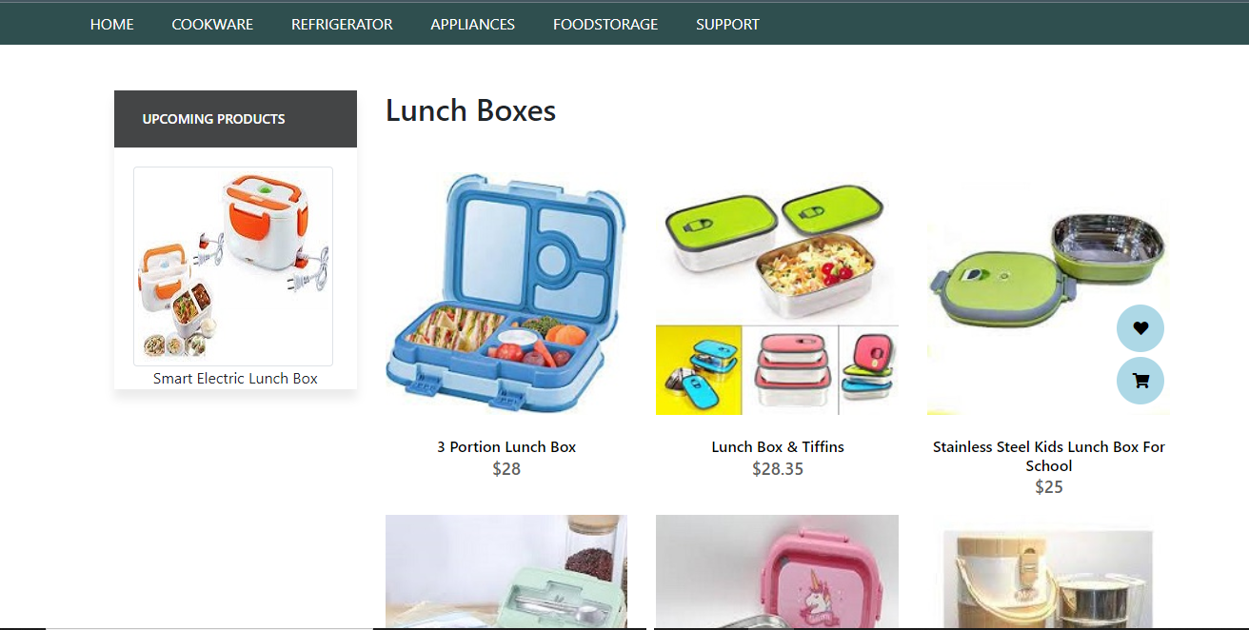

Lunch Boxes

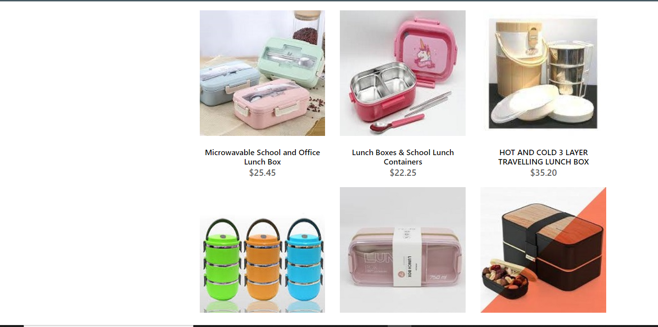

Lunch Boxes

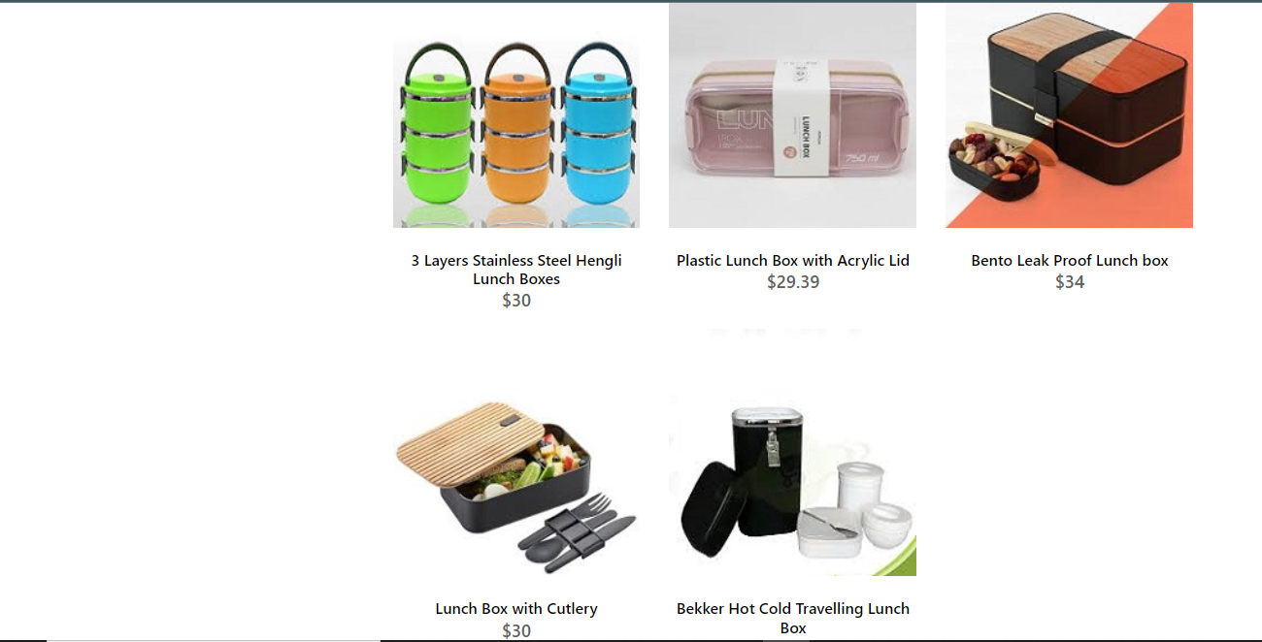

Lunch Boxes



<!doctype html>

Lunch Boxes Code

<html>

<head>

<meta charset="utf-8">

<title>Untitled Document</title>

<!--CSS LINK -->

<link rel="stylesheet" type="text/css" href="../CSS/Tasha.css"/>

<link rel="stylesheet" type="text/css" href="../bootstraps/css/bootstrap.min.css"/>

<link rel="stylesheet" type="text/css" href="../bootstraps/css/bootstrap.css"/>

<link rel="stylesheet" type="text/css" href="../CSS/Links.css"/>

<!-- Latest compiled and minified CSS START-->

<link rel="stylesheet" href="https://maxcdn.bootstrapcdn.com/bootstrap/4.5.2/css/bootstrap.min.css">

<!-- Latest compiled and minified CSS END-->

<!-- jQuery library START -->

<script src="https://ajax.googleapis.com/ajax/libs/jquery/3.5.1/jquery.min.js"></script>

<!-- jQuery library END-->

<!-- Popper JS START-->

<script src="https://cdnjs.cloudflare.com/ajax/libs/popper.js/1.16.0/umd/popper.min.js"></script>

<!-- Popper JS END -->

<!-- Latest compiled JavaScript START-->

<script src="https://maxcdn.bootstrapcdn.com/bootstrap/4.5.2/js/bootstrap.min.js"></script>

<!-- Latest compiled JavaScript -->

<!--Meta Link START-->

<meta name="viewport" content="width=device-width, initial-scale=1">

<!--Meta Link END-->

<!--FONT AWESOME CDN LINK-->

<link rel="stylesheet" href="https://pro.fontawesome.com/releases/v5.10.0/css/all.css" integrity="sha384-AYmEC3Yw5cVb3ZcuHtOA93w35dYTsvhLPVnYs9eStHfGJvOvKxVfELGroGkvsg+p" crossorigin="anonymous"/>

<!--FONT AWESOME CDN LINK-->

<link rel="stylesheet" href="https://cdn.jsdelivr.net/npm/bootstrap-icons@1.6.0/font/bootstrap-icons.css" integrity="sha384-7ynz3n3tAGNUYFZD3cWe5PDcE36xj85vyFkawcF6tIwxvIecqKvfwLiaFdizhPpN" crossorigin="anonymous">

<link href="https://fonts.googleapis.com/css2?family=Open+Sans:wght@400;700&family=Poppins:wght@100;200;300;400&display=swap" rel="stylesheet">

</head>

<body>

<header>

<ul>

<li><a href="../Tasha.html">HOME</a>

</li>

<li><a href="#">COOKWARE</a>

<ul>

<li><a href="Cooking Pot.html">Cooking Pots</a></li>

<li><a href="Frying Pans.html">Frying Pans</a></li>

<li><a href="Cookware-Sets.html">Cookware Sets</a></li>

<li><a href="Egg Poached.html">Egg Poachers</a></li>

<li><a href="Grill-Pans.html">Grill Pans</a></li>

<li><a href="Steamer.html">Steamers</a></li>

</ul>

</li>

<li><a href="#">REFRIGERATOR</a>

<ul>

<li><a href="Refrigerators.html">Refrigerators</a></li>

<li><a href="Freezers.html">Freezers</a></li>

</ul>

</li>

<li><a href="#">APPLIANCES</a>

<ul>

<li><a href="Blenders.html">Blenders</a></li>

<li><a href="Bread-Maker.html">Bread Makers</a></li>

<li><a href="Coffee-Maker.html">Coffee Makers</a></li>

<li><a href="Icecream-Sorbet-Maker.html">Ice-Cream and Sorbet Makers</a></li>

<li><a href="Kettles.html">Kettles</a></li>

<li><a href="Food-Chopper.html">Food Choppers</a></li>

<li><a href="Toaster.html">Toasters</a></li>

</ul>

</li>

<li><a href="#">FOODSTORAGE</a>

<ul>

<li><a href="Flask.html">Flask</a></li>

<li><a href="Spice-Jars.html">Spice Jars</a></li>

<li><a href="Storage-Bags.html">Storage Bags</a></li>

<li><a href="Lunch-Boxes.html">Lunch Boxes</a></li>

<li><a href="Storage-Containers.html">Storage Containers</a></li>

</ul>

</li>

<li><a href="#">SUPPORT</a>

<ul>

<li><a href="Expert Tips.html">Expert Tips</a></li>

<li><a href="Register-Complain.html">Register Complain</a></li>

<li><a href="Feedback-Form.html">Feed Back</a></li>

<li><a href="Contact Us.html">Contact Us</a></li>

</ul>

</li>

</ul>

</header>

<!--NAVIGATION BAR ENDS-->

<!--SIDE NAVIGATOR STARTS-->

<section class="category">

<div class="container">

<div class="row">

<div class="col-lg-3">

<aside class="side-area product-side side-shadow mt-5">

<div class="side-title">

<h3>UpComing Products</h3>

</div>

<div class="side-content" style="margin: 20px;" >

<img src="../Images/223.jpg" class="img-thumbnail" alt="...">

<p style="text-align: center;">Smart Electric Lunch Box </p>

</div>

</aside>

</div>

<!--SIDE NAVIGATOR ENDS-->

<!--COOKING POT STARTS-->

<div class="col-lg-9">

<div class="row">

<div class="col-lg-12">

<div class="product-top d-flex justify-content-between align-items-center" >

<div class="product-sec product-item ">

<h2 class="my-5">Lunch Boxes</h2>

</div>

</div>

</div>

<div class="col-lg-4 col-sm-6">

<div class="product-cate">

<div>

<img src="../Images/167.jpg" alt="" />

<div class="product-icon">

<ul>

<li><a href=""><i class="fa fa-heart" aria-hidden="true"></i></a></li>

<li><a href="Checkout-Form.html"><i class="fa fa-shopping-cart" aria-hidden="true"></i></a></li>

</ul>

</div>

<!---->

<div class="product-des">

<h5>3 Portion Lunch Box</h5>

<p>$28</p>

</div>

</div>

</div>

</div>

<!---->

<div class="col-lg-4 col-sm-6">

<div class="product-cate">

<div>

<img src="../Images/168.jpg" alt="pot" />

<div class="product-icon">

<ul>

<li><a href=""><i class="fa fa-heart" aria-hidden="true"></i></a></li>

<li><a href="Checkout-Form.html"><i class="fa fa-shopping-cart" aria-hidden="true"></i></a></li>

</ul>

</div>

<!---->

<div class="product-des">

<h5>Lunch Box & Tiffins </h5>

<p>$28.35</p>

</div>

</div>

</div>

</div>

<!---->

<div class="col-lg-4 col-sm-6">

<div class="product-cate">

<div>

<img src="../Images/169.jpg" alt="pot"/>

<div class="product-icon">

<ul>

<li><a href=""><i class="fa fa-heart" aria-hidden="true"></i></a></li>

<li><a href="Checkout-Form.html"><i class="fa fa-shopping-cart" aria-hidden="true"></i></a></li>

</ul>

</div>

<!---->

<div class="product-des">

<h5>Stainless Steel Kids Lunch Box For School </h5>

<p>$25</p>

</div>

</div>

</div>

</div>

<!---->

<div class="col-lg-4 col-sm-6">

<div class="product-cate">

<div>

<img src="../Images/170.jpg" alt="pot" class="img-fluid"/>

<div class="product-icon">

<ul>

<li><a href=""><i class="fa fa-heart" aria-hidden="true"></i></a></li>

<li><a href="Checkout-Form.html"><i class="fa fa-shopping-cart" aria-hidden="true"></i></a></li>

</ul>

</div>

<!---->

<div class="product-des">

<h5>Microwavable School and Office Lunch Box</h5>

<p>$25.45</p>

</div>

</div>

</div>

</div>

<!---->

<div class="col-lg-4 col-sm-6">

<div class="product-cate">

<div>

<img src="../Images/171.jpg" alt="pot" />

<div class="product-icon">

<ul>

<li><a href=""><i class="fa fa-heart" aria-hidden="true"></i></a></li>

<li><a href="Checkout-Form.html"><i class="fa fa-shopping-cart" aria-hidden="true"></i></a></li>

</ul>

</div>

<!---->

<div class="product-des">

<h5>Lunch Boxes & School Lunch Containers</h5>

<p>$22.25</p>

</div>

</div>

</div>

</div>

<!---->

<div class="col-lg-4 col-sm-6">

<div class="product-cate">

<div>

<img src="../Images/172.jpg" alt=""/>

<div class="product-icon">

<ul>

<li><a href=""><i class="fa fa-heart" aria-hidden="true"></i></a></li>

<li><a href="Checkout-Form.html"><i class="fa fa-shopping-cart" aria-hidden="true"></i></a></li>

</ul>

</div>

<!---->

<div class="product-des">

<h5>HOT AND COLD 3 LAYER TRAVELLING LUNCH BOX</h5>

<p>$35.20</p>

</div>

</div>

</div>

</div>

<!---->

<div class="col-lg-4 col-sm-6">

<div class="product-cate">

<div>

<img src="../Images/173.jpg" alt="pot" />

<div class="product-icon">

<ul>

<li><a href=""><i class="fa fa-heart" aria-hidden="true"></i></a></li>

<li><a href="Checkout-Form.html"><i class="fa fa-shopping-cart" aria-hidden="true"></i></a></li>

</ul>

</div>

<!---->

<div class="product-des">

<h5>3 Layers Stainless Steel Hengli Lunch Boxes</h5>

<p>$30</p>

</div>

</div>

</div>

</div>

<!---->

<div class="col-lg-4 col-sm-6">

<div class="product-cate">

<div>

<img src="../Images/174.jpg" alt="pot" />

<div class="product-icon">

<ul>

<li><a href=""><i class="fa fa-heart" aria-hidden="true"></i></a></li>

<li><a href="Checkout-Form.html"><i class="fa fa-shopping-cart" aria-hidden="true"></i></a></li>

</ul>

</div>

<!---->

<div class="product-des">

<h5>Plastic Lunch Box with Acrylic Lid </h5>

<p>$29.39 </p>

</div>

</div>

</div>

</div>

<!---->

<div class="col-lg-4 col-sm-6">

<div class="product-cate">

<div>

<img src="../Images/175.jpg" alt="pot" />

<div class="product-icon">

<ul>

<li><a href=""><i class="fa fa-heart" aria-hidden="true"></i></a></li>

<li><a href="Checkout-Form.html"><i class="fa fa-shopping-cart" aria-hidden="true"></i></a></li>

</ul>

</div>

<!---->

<div class="product-des">

<h5>Bento Leak Proof Lunch box</h5>

<p>$34</p>

</div>

</div>

</div>

</div>

<!---->

<div class="col-lg-4 col-sm-6">

<div class="product-cate">

<div>

<img src="../Images/176.jpg" alt="pot" />

<div class="product-icon">

<ul>

<li><a href=""><i class="fa fa-heart" aria-hidden="true"></i></a></li>

<li><a href="Checkout-Form.html"><i class="fa fa-shopping-cart" aria-hidden="true"></i></a></li>

</ul>

</div>

<!---->

<div class="product-des">

<h5>Lunch Box with Cutlery</h5>

<p>$30</p>

</div>

</div>

</div>

</div>

<!---->

<div class="col-lg-4 col-sm-6">

<div class="product-cate">

<div>

<img src="../Images/177.jpg" alt="pot" />

<div class="product-icon">

<ul>

<li><a href=""><i class="fa fa-heart" aria-hidden="true"></i></a></li>

<li><a href="Checkout-Form.html"><i class="fa fa-shopping-cart" aria-hidden="true"></i></a></li>

</ul>

</div>

<!---->

<div class="product-des">

<h5>Bekker Hot Cold Travelling Lunch Box </h5>

<p>$42</p>

</div>

</div>

</div>

</div>

</div>

</div>

</div>

</div>

</section>

<!--COOKING POT END-->

<!-- FOOTER STARTS -->

<footer class=" text-black pt-5 pb-4 page-footer" style="background-color: darkslategray;">

<div class="text-center">

<h1 >NEWSLETTER</h1>

<p>Be the first to know about the latest deals, discounts updates & more!</p>

<input type="email" name="email" placeholder="Enter your email here"/>

<button type="submit" onClick="onclick" > Submit </button>

</div>

<br><br>

<div class=" container text-center text-md-left ">

<div class="row text-center text-md-left ">

<div class="col-md-3 col-lg-3 col-xl-3 mx-auto mt-3">

<h5 class="text-uppercase mb-4 font-weight-bold text-warning">TASHA Kitchen-Ware</h5>

<p>TASHA- the home store is Branded Company famous for home kitchen appliances. It provides collection of n number of appliances with different category to match the fast life of the generation. The Tasha group of companies had made huge profit in the year 2013. In order to enhance its business the organization wants you to develop the website.</p>

</div>

<div class="col-md-3 col-lg-3 col-xl-3 mx-auto mt-3" >

<h5 class="text-uppercase mb-4 font-weight-bold text-warning">OFFERS</h5>

<p><a href="#" class="text-black" style="text-decoration: none; color:black; ">Deal of the Day</a></p>

<p><a href="#" class="text-black" style="text-decoration: none;color:black;">Buy 1 Get 1 Free</a></p>

<p><a href="#" class="text-black" style="text-decoration: none;color:black;">Appliance Packages Offers</a></p>

<p ><a href="#" class="text-black" style="text-decoration: none; color:black;">Reward Program</a></p>

</div>

<div class="col-md-4 col-lg-3 col-xl-3 mx-auto mt-3">

<h5 class="text-uppercase mb-4 font-weight-bold text-warning">ADDRESS</h5>

<p>

<i class="fas fa-home mr-3"></i>Plot No. G-21/23, Block-8, Khaliquzzaman Road, Clifton، Block 8 Clifton, Karachi, Karachi City, Sindh 75600

</p>

</div>

</div>

<hr class="mb-4">

<div class="row align-items-center">

<div class="col-md-7 col-lg-8">

<p>copyright all rights reserved by <a href="#" style="text-decoration: none"><strong class="text-warning">The Provider</strong></a></p></div>

<div class="col-md-5 col-lg-4">

<div class="text-center text-md-right">

<ul class="list-unstyled list-inline">

<li class="list-inline-item">

<a href="#" class="btn-floating btn-sm text-black" style="font-size:23px;"><i class="fab fa-facebook"></i></a></li>

<li class="list-inline-item">

<a href="#" class="btn-floating btn-sm text-black" style="font-size:23px;"><i class="fab fa-twitter"></i></a></li>

<li class="list-inline-item">

<a href="#" class="btn-floating btn-sm text-black" style="font-size:23px;"><i class="fab fa-instagram"></i></a></li>

<li class="list-inline-item">

<a href="#" class="btn-floating btn-sm text-black" style="font-size:23px;"><i class="fas fa-link"></i></a></li>

</ul>

</div>

</div>

</div>

</div>

</footer>

<!--FOOTER ENDS-->

</body>

</html>

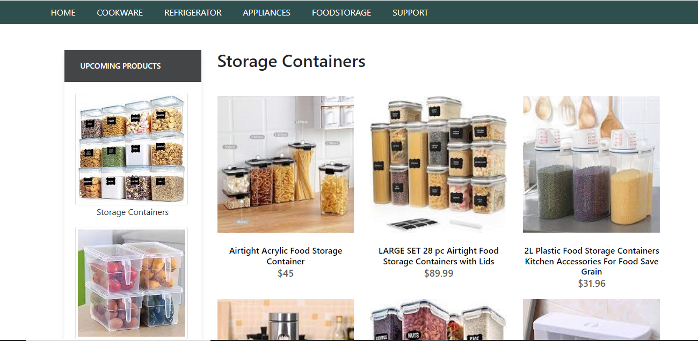

Storage Containers

Storage Containers

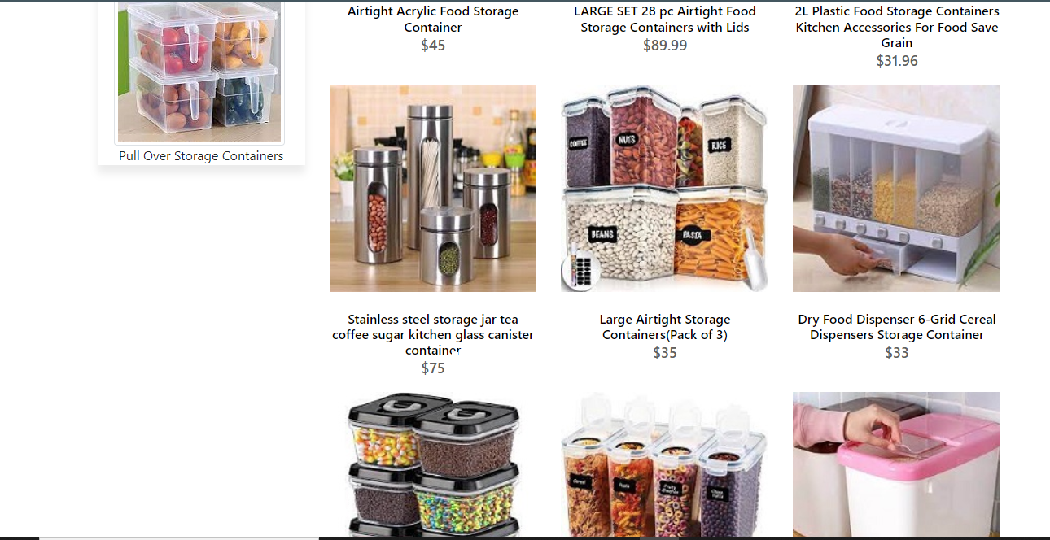

Storage Containers

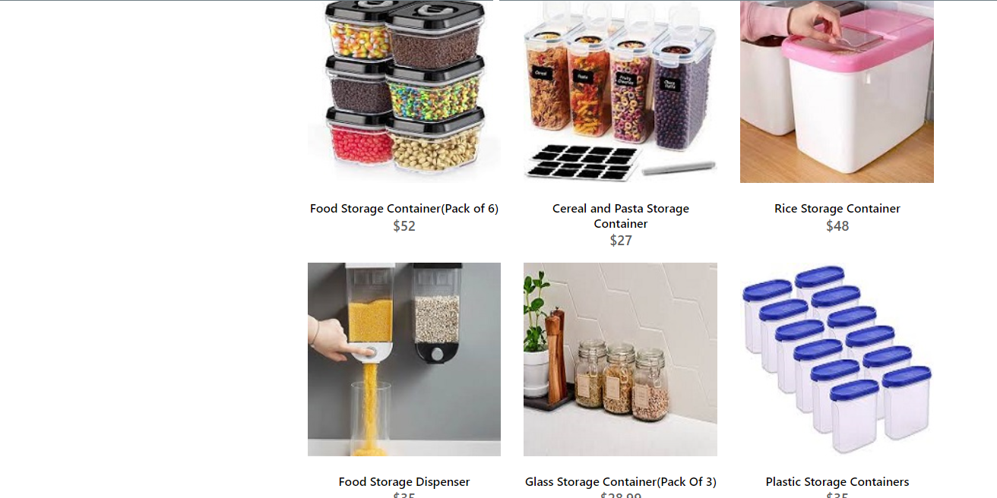

Storage Containers Code

<!doctype html>

<html>

<head>

<meta charset="utf-8">

<title>Untitled Document</title>

<!--CSS LINK -->

<link rel="stylesheet" type="text/css" href="../CSS/Tasha.css"/>

<link rel="stylesheet" type="text/css" href="../bootstraps/css/bootstrap.min.css"/>

<link rel="stylesheet" type="text/css" href="../bootstraps/css/bootstrap.css"/>

<link rel="stylesheet" type="text/css" href="../CSS/Links.css"/>

<!-- Latest compiled and minified CSS START-->

<link rel="stylesheet" href="https://maxcdn.bootstrapcdn.com/bootstrap/4.5.2/css/bootstrap.min.css">

<!-- Latest compiled and minified CSS END-->

<!-- jQuery library START -->

<script src="https://ajax.googleapis.com/ajax/libs/jquery/3.5.1/jquery.min.js"></script>

<!-- jQuery library END-->

<!-- Popper JS START-->

<script src="https://cdnjs.cloudflare.com/ajax/libs/popper.js/1.16.0/umd/popper.min.js"></script>

<!-- Popper JS END -->

<!-- Latest compiled JavaScript START-->

<script src="https://maxcdn.bootstrapcdn.com/bootstrap/4.5.2/js/bootstrap.min.js"></script>

<!-- Latest compiled JavaScript -->

<!--Meta Link START-->

<meta name="viewport" content="width=device-width, initial-scale=1">

<!--Meta Link END-->

<!--FONT AWESOME CDN LINK-->

<link rel="stylesheet" href="https://pro.fontawesome.com/releases/v5.10.0/css/all.css" integrity="sha384-AYmEC3Yw5cVb3ZcuHtOA93w35dYTsvhLPVnYs9eStHfGJvOvKxVfELGroGkvsg+p" crossorigin="anonymous"/>

<!--FONT AWESOME CDN LINK-->

<link rel="stylesheet" href="https://cdn.jsdelivr.net/npm/bootstrap-icons@1.6.0/font/bootstrap-icons.css" integrity="sha384-7ynz3n3tAGNUYFZD3cWe5PDcE36xj85vyFkawcF6tIwxvIecqKvfwLiaFdizhPpN" crossorigin="anonymous">

<link href="https://fonts.googleapis.com/css2?family=Open+Sans:wght@400;700&family=Poppins:wght@100;200;300;400&display=swap" rel="stylesheet">

</head>

<body>

< <header>

<ul>

<li><a href="../Tasha.html">HOME</a>

</li>

<li><a href="#">COOKWARE</a>

<ul>

<li><a href="Cooking Pot.html">Cooking Pots</a></li>

<li><a href="Frying Pans.html">Frying Pans</a></li>

<li><a href="Cookware-Sets.html">Cookware Sets</a></li>

<li><a href="Egg Poached.html">Egg Poachers</a></li>

<li><a href="Grill-Pans.html">Grill Pans</a></li>

<li><a href="Steamer.html">Steamers</a></li>

</ul>

</li>

<li><a href="#">REFRIGERATOR</a>

<ul>

<li><a href="Refrigerators.html">Refrigerators</a></li>

<li><a href="Freezers.html">Freezers</a></li>

</ul>

</li>

<li><a href="#">APPLIANCES</a>

<ul>

<li><a href="Blenders.html">Blenders</a></li>

<li><a href="Bread-Maker.html">Bread Makers</a></li>

<li><a href="Coffee-Maker.html">Coffee Makers</a></li>

<li><a href="Icecream-Sorbet-Maker.html">Ice-Cream and Sorbet Makers</a></li>

<li><a href="Kettles.html">Kettles</a></li>

<li><a href="Food-Chopper.html">Food Choppers</a></li>

<li><a href="Toaster.html">Toasters</a></li>

</ul>

</li>

<li><a href="#">FOODSTORAGE</a>

<ul>

<li><a href="Flask.html">Flask</a></li>

<li><a href="Spice-Jars.html">Spice Jars</a></li>

<li><a href="Storage-Bags.html">Storage Bags</a></li>

<li><a href="Lunch-Boxes.html">Lunch Boxes</a></li>

<li><a href="Storage-Containers.html">Storage Containers</a></li>

</ul>

</li>

<li><a href="#">SUPPORT</a>

<ul>

<li><a href="Expert Tips.html">Expert Tips</a></li>

<li><a href="Register-Complain.html">Register Complain</a></li>

<li><a href="Feedback-Form.html">Feed Back</a></li>

<li><a href="Contact Us.html">Contact Us</a></li>

</ul>

</li>

</ul>

</header>

<!--NAVIGATION BAR ENDS-->

<!--cooking pot start-->

<section class="category">

<div class="container">

<div class="row">

<div class="col-lg-3">

<aside class="side-area product-side side-shadow mt-5">

<div class="side-title">

<h3>UpComing Products</h3>

</div>

<div class="side-content" style="margin: 20px;" >

<img src="../Images/178.jpg" class="img-thumbnail" alt="...">

<p style="text-align: center;">Storage Containers </p>

<img src="../Images/179.jpg" class="img-thumbnail" alt="...">

<p style="text-align: center;">Pull Over Storage Containers</p>

</div>

</aside>

</div>

<div class="col-lg-9">

<div class="row">

<div class="col-lg-12">

<div class="product-top d-flex justify-content-between align-items-center" >

<div class="product-sec product-item ">

<h2 class="my-5">Storage Containers</h2>

</div>

</div>

</div>

<div class="col-lg-4 col-sm-6">

<div class="product-cate">

<div>

<img src="../Images/180.jpg" alt="" />

<div class="product-icon">

<ul>

<li><a href=""><i class="fa fa-heart" aria-hidden="true"></i></a></li>

<li><a href="Checkout-Form.html"><i class="fa fa-shopping-cart" aria-hidden="true"></i></a></li>

</ul>

</div>

<!---->

<div class="product-des">

<h5>Airtight Acrylic Food Storage Container</h5>

<p>$45</p>

</div>

</div>

</div>

</div>

<!---->

<div class="col-lg-4 col-sm-6">

<div class="product-cate">

<div>

<img src="../Images/181.jpg" alt="pot" />

<div class="product-icon">

<ul>

<li><a href=""><i class="fa fa-heart" aria-hidden="true"></i></a></li>

<li><a href="Checkout-Form.html"><i class="fa fa-shopping-cart" aria-hidden="true"></i></a></li>

</ul>

</div>

<!---->

<div class="product-des">

<h5>LARGE SET 28 pc Airtight Food Storage Containers with Lids </h5>

<p>$89.99</p>

</div>

</div>

</div>

</div>

<!---->

<div class="col-lg-4 col-sm-6">

<div class="product-cate">

<div>

<img src="../Images/182.jpg" alt="pot"/>

<div class="product-icon">

<ul>

<li><a href=""><i class="fa fa-heart" aria-hidden="true"></i></a></li>

<li><a href="Checkout-Form.html"><i class="fa fa-shopping-cart" aria-hidden="true"></i></a></li>

</ul>

</div>

<!---->

<div class="product-des">

<h5>2L Plastic Food Storage Containers Kitchen Accessories For Food Save Grain </h5>

<p>$31.96</p>

</div>

</div>

</div>

</div>

<!---->

<div class="col-lg-4 col-sm-6">

<div class="product-cate">

<div>

<img src="../Images/183.jpg" alt="pot" class="img-fluid"/>

<div class="product-icon">

<ul>

<li><a href=""><i class="fa fa-heart" aria-hidden="true"></i></a></li>

<li><a href="Checkout-Form.html"><i class="fa fa-shopping-cart" aria-hidden="true"></i></a></li>

</ul>

</div>

<!---->

<div class="product-des">

<h5>Stainless steel storage jar tea coffee sugar kitchen glass canister container </h5>

<p>$75</p>

</div>

</div>

</div>

</div>

<!---->

<div class="col-lg-4 col-sm-6">

<div class="product-cate">

<div>

<img src="../Images/184.jpg" alt="pot" />

<div class="product-icon">

<ul>

<li><a href=""><i class="fa fa-heart" aria-hidden="true"></i></a></li>

<li><a href="Checkout-Form.html"><i class="fa fa-shopping-cart" aria-hidden="true"></i></a></li>

</ul>

</div>

<!---->

<div class="product-des">

<h5>Large Airtight Storage Containers(Pack of 3)</h5>

<p>$35</p>

</div>

</div>

</div>

</div>

<!---->

<div class="col-lg-4 col-sm-6">

<div class="product-cate">

<div>

<img src="../Images/185.jpg" alt=""/>

<div class="product-icon">

<ul>

<li><a href=""><i class="fa fa-heart" aria-hidden="true"></i></a></li>

<li><a href="Checkout-Form.html"><i class="fa fa-shopping-cart" aria-hidden="true"></i></a></li>

</ul>

</div>

<!---->

<div class="product-des">

<h5>Dry Food Dispenser 6-Grid Cereal Dispensers Storage Container</h5>

<p>$33</p>

</div>

</div>

</div>

</div>

<!---->

<div class="col-lg-4 col-sm-6">

<div class="product-cate">

<div>

<img src="../Images/186.jpg" alt="pot" />

<div class="product-icon">

<ul>

<li><a href=""><i class="fa fa-heart" aria-hidden="true"></i></a></li>

<li><a href="Checkout-Form.html"><i class="fa fa-shopping-cart" aria-hidden="true"></i></a></li>

</ul>

</div>

<!---->

<div class="product-des">

<h5>Food Storage Container(Pack of 6)</h5>

<p>$52</p>

</div>

</div>

</div>

</div>

<!---->

<div class="col-lg-4 col-sm-6">

<div class="product-cate">

<div>

<img src= "../Images/187.jpg" alt="pot"/>

<div class="product-icon">

<ul>

<li><a href=""><i class="fa fa-heart" aria-hidden="true"></i></a></li>

<li><a href="Checkout-Form.html"><i class="fa fa-shopping-cart" aria-hidden="true"></i></a></li>

</ul>

</div>

<!---->

<div class="product-des">

<h5>Cereal and Pasta Storage Container</h5>

<p>$27</p>

</div>

</div>

</div>

</div>

<!---->

<div class="col-lg-4 col-sm-6">

<div class="product-cate">

<div>

<img src="../Images/188.jpg" alt="pot"/>

<div class="product-icon">

<ul>

<li><a href=""><i class="fa fa-heart" aria-hidden="true"></i></a></li>

<li><a href="Checkout-Form.html"><i class="fa fa-shopping-cart" aria-hidden="true"></i></a></li>

</ul>

</div>

<!---->

<div class="product-des">

<h5>Rice Storage Container </h5>

<p>$48</p>

</div>

</div>

</div>

</div>

<!---->

<!---->

<div class="col-lg-4 col-sm-6">

<div class="product-cate">

<div>

<img src="../Images/190.jpg" alt=""/>

<div class="product-icon">

<ul>

<li><a href=""><i class="fa fa-heart" aria-hidden="true"></i></a></li>

<li><a href="Checkout-Form.html"><i class="fa fa-shopping-cart" aria-hidden="true"></i></a></li>

</ul>

</div>

<!---->

<div class="product-des">

<h5>Food Storage Dispenser</h5>

<p>$35</p>

</div>

</div>

</div>

</div>

<!---->

<!---->

<div class="col-lg-4 col-sm-6">

<div class="product-cate">

<div>

<img src="../Images/191.jpg" alt=""/>

<div class="product-icon">

<ul>

<li><a href=""><i class="fa fa-heart" aria-hidden="true"></i></a></li>

<li><a href="Checkout-Form.html"><i class="fa fa-shopping-cart" aria-hidden="true"></i></a></li>

</ul>

</div>

<!---->

<div class="product-des">

<h5>Glass Storage Container(Pack Of 3) </h5>

<p>$28.99</p>

</div>

</div>

</div>

</div>

<!---->

<!---->

<div class="col-lg-4 col-sm-6">

<div class="product-cate">

<div>

<img src="../Images/192.jpg" alt=""/>

<div class="product-icon">

<ul>

<li><a href=""><i class="fa fa-heart" aria-hidden="true"></i></a></li>

<li><a href="Checkout-Form.html"><i class="fa fa-shopping-cart" aria-hidden="true"></i></a></li>

</ul>

</div>

<!---->

<div class="product-des">

<h5>Plastic Storage Containers</h5>

<p>$35</p>

</div>

</div>

</div>

</div>

<!---->

</div>

</div>

</div>

</div>

</section>

<!--cooking pot end-->

<!-- FOOTER STARTS -->

<footer class=" text-black pt-5 pb-4 page-footer" style="background-color: darkslategray;">

<div class="text-center">

<h1 >NEWSLETTER</h1>

<p>Be the first to know about the latest deals, discounts updates & more!</p>

<input type="email" name="email" placeholder="Enter your email here"/>

<button type="submit" onClick="onclick" > Submit </button>

</div>

<br><br>

<div class=" container text-center text-md-left ">

<div class="row text-center text-md-left ">

<div class="col-md-3 col-lg-3 col-xl-3 mx-auto mt-3">

<h5 class="text-uppercase mb-4 font-weight-bold text-warning">TASHA Kitchen-Ware</h5>

<p>TASHA- the home store is Branded Company famous for home kitchen appliances. It provides collection of n number of appliances with different category to match the fast life of the generation. The Tasha group of companies had made huge profit in the year 2013. In order to enhance its business the organization wants you to develop the website.</p>

</div>

<div class="col-md-3 col-lg-3 col-xl-3 mx-auto mt-3" >

<h5 class="text-uppercase mb-4 font-weight-bold text-warning">OFFERS</h5>

<p><a href="#" class="text-black" style="text-decoration: none; color:black; ">Deal of the Day</a></p>

<p><a href="#" class="text-black" style="text-decoration: none;color:black;">Buy 1 Get 1 Free</a></p>

<p><a href="#" class="text-black" style="text-decoration: none;color:black;">Appliance Packages Offers</a></p>

<p ><a href="#" class="text-black" style="text-decoration: none; color:black;">Reward Program</a></p>

</div>

<div class="col-md-4 col-lg-3 col-xl-3 mx-auto mt-3">

<h5 class="text-uppercase mb-4 font-weight-bold text-warning">ADDRESS</h5>

<p>

<i class="fas fa-home mr-3"></i>Plot No. G-21/23, Block-8, Khaliquzzaman Road, Clifton، Block 8 Clifton, Karachi, Karachi City, Sindh 75600

</p>

</div>

</div>

<hr class="mb-4">

<div class="row align-items-center">

<div class="col-md-7 col-lg-8">

<p>copyright all rights reserved by <a href="#" style="text-decoration: none"><strong class="text-warning">The Provider</strong></a></p></div>

<div class="col-md-5 col-lg-4">

<div class="text-center text-md-right">

<ul class="list-unstyled list-inline">

<li class="list-inline-item">

<a href="#" class="btn-floating btn-sm text-black" style="font-size:23px;"><i class="fab fa-facebook"></i></a></li>

<li class="list-inline-item">

<a href="#" class="btn-floating btn-sm text-black" style="font-size:23px;"><i class="fab fa-twitter"></i></a></li>

<li class="list-inline-item">

<a href="#" class="btn-floating btn-sm text-black" style="font-size:23px;"><i class="fab fa-instagram"></i></a></li>

<li class="list-inline-item">

<a href="#" class="btn-floating btn-sm text-black" style="font-size:23px;"><i class="fas fa-link"></i></a></li>

</ul>

</div>

</div>

</div>

</div>

</footer>

<!--FOOTER ENDS-->

</body>

</html>

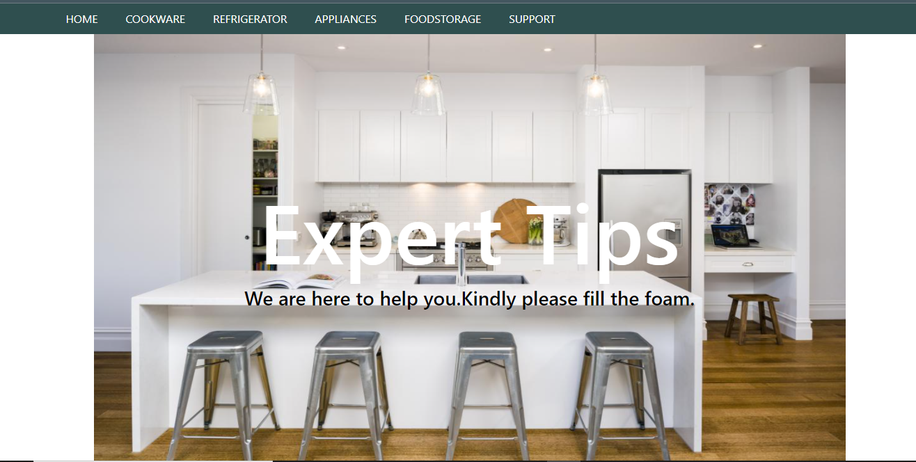

Expert Tips

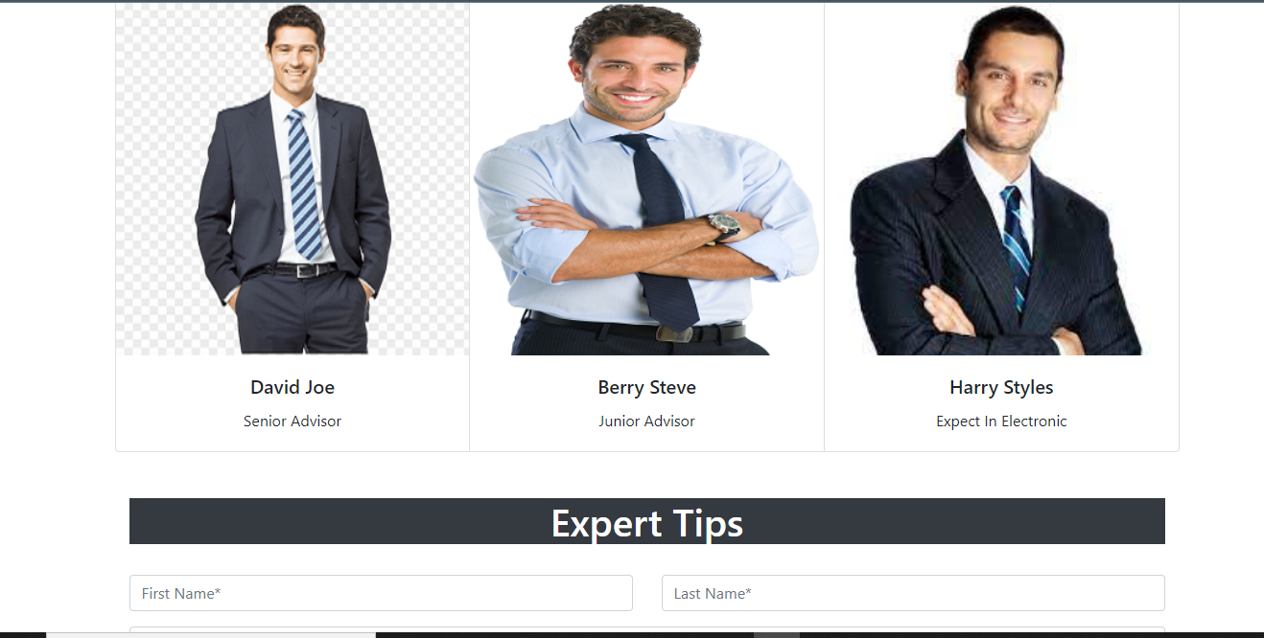

Expert Tips

/’

Expert Tips

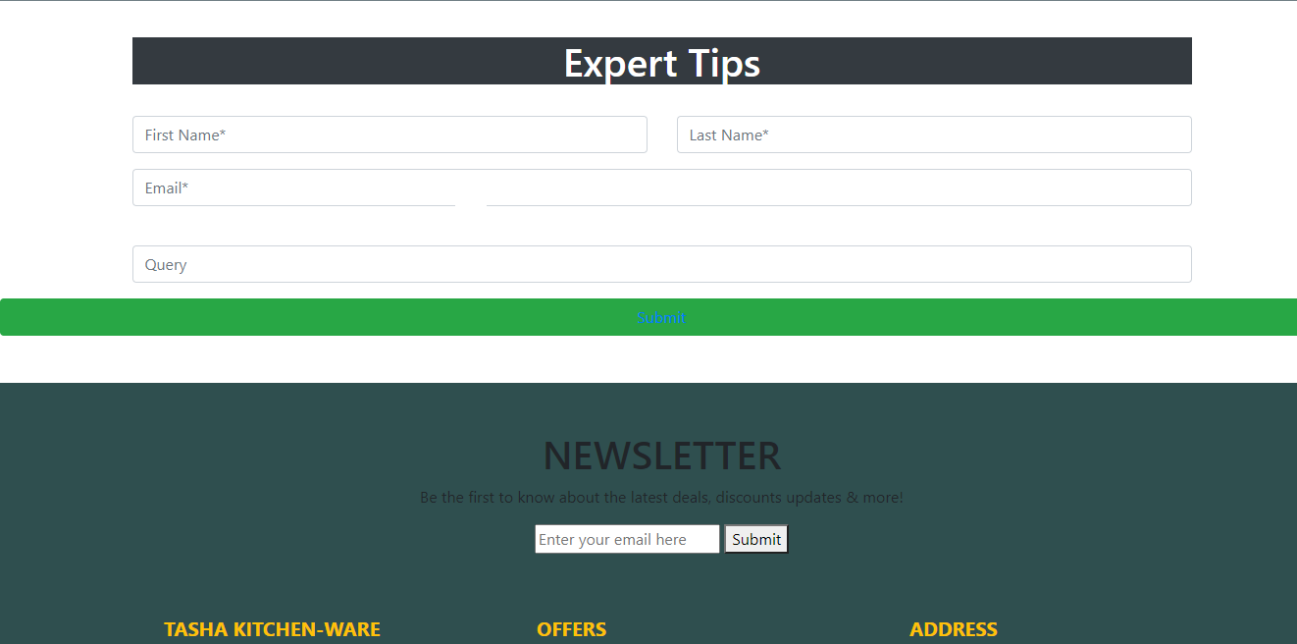

Expert Tips

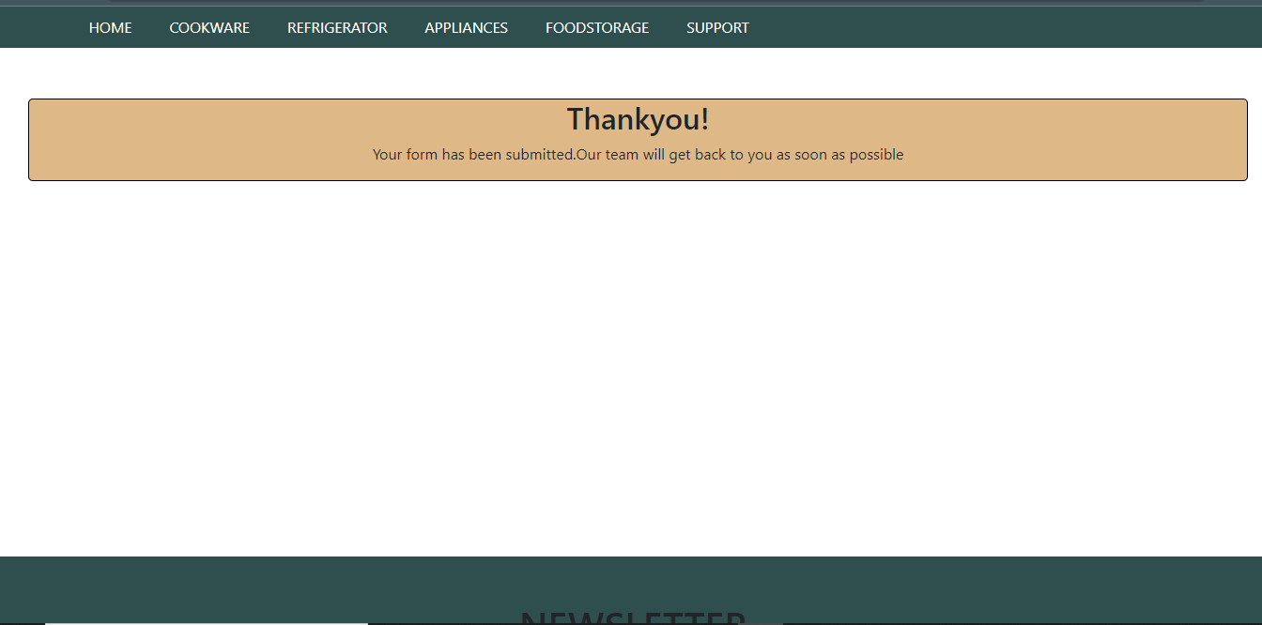

Expert Tips Code

<!doctype html>

<html>

<head>

<meta charset="utf-8">

<title>Untitled Document</title>

<!--CSS LINK -->

<link rel="stylesheet" type="text/css" href="../CSS/Tasha.css"/>

<!-- Latest compiled and minified CSS START-->

<link rel="stylesheet" href="https://maxcdn.bootstrapcdn.com/bootstrap/4.5.2/css/bootstrap.min.css">

<!-- Latest compiled and minified CSS END-->

<!-- jQuery library START -->

<script src="https://ajax.googleapis.com/ajax/libs/jquery/3.5.1/jquery.min.js"></script>

<!-- jQuery library END-->

<!-- Popper JS START-->

<script src="https://cdnjs.cloudflare.com/ajax/libs/popper.js/1.16.0/umd/popper.min.js"></script>

<!-- Popper JS END -->

<!-- Latest compiled JavaScript START-->

<script src="https://maxcdn.bootstrapcdn.com/bootstrap/4.5.2/js/bootstrap.min.js"></script>

<!-- Latest compiled JavaScript -->

<!--Meta Link START-->

<meta name="viewport" content="width=device-width, initial-scale=1">

<!--Meta Link END-->

<!--FONT AWESOME CDN LINK-->

<link rel="stylesheet" href="https://pro.fontawesome.com/releases/v5.10.0/css/all.css" integrity="sha384-AYmEC3Yw5cVb3ZcuHtOA93w35dYTsvhLPVnYs9eStHfGJvOvKxVfELGroGkvsg+p" crossorigin="anonymous"/>

<!--FONT AWESOME CDN LINK-->

</head>

<body>

<header>

<ul>

<li><a href="../Tasha.html">HOME</a>

</li>

<li><a href="#">COOKWARE</a>

<ul>

<li><a href="Cooking Pot.html">Cooking Pots</a></li>

<li><a href="Frying Pans.html">Frying Pans</a></li>

<li><a href="Cookware-Sets.html">Cookware Sets</a></li>

<li><a href="Egg Poached.html">Egg Poachers</a></li>

<li><a href="Grill-Pans.html">Grill Pans</a></li>

<li><a href="Steamer.html">Steamers</a></li>

</ul>

</li>

<li><a href="#">REFRIGERATOR</a>

<ul>

<li><a href="Refrigerators.html">Refrigerators</a></li>

<li><a href="Freezers.html">Freezers</a></li>

</ul>

</li>

<li><a href="#">APPLIANCES</a>

<ul>

<li><a href="Blenders.html">Blenders</a></li>

<li><a href="Bread-Maker.html">Bread Makers</a></li>

<li><a href="Coffee-Maker.html">Coffee Makers</a></li>

<li><a href="Icecream-Sorbet-Maker.html">Ice-Cream and Sorbet Makers</a></li>

<li><a href="Kettles.html">Kettles</a></li>

<li><a href="Food-Chopper.html">Food Choppers</a></li>

<li><a href="Toaster.html">Toasters</a></li>

</ul>

</li>

<li><a href="#">FOODSTORAGE</a>

<ul>

<li><a href="Flask.html">Flask</a></li>

<li><a href="Spice-Jars.html">Spice Jars</a></li>

<li><a href="Storage-Bags.html">Storage Bags</a></li>

<li><a href="Lunch-Boxes.html">Lunch Boxes</a></li>

<li><a href="Storage-Containers.html">Storage Containers</a></li>

</ul>

</li>

<li><a href="#">SUPPORT</a>

<ul>

<li><a href="Expert Tips.html">Expert Tips</a></li>

<li><a href="Register-Complain.html">Register Complain</a></li>

<li><a href="Feedback-Form.html">Feed Back</a></li>

<li><a href="Contact Us.html">Contact Us</a></li>

</ul>

</li>

</ul>

</header>

<!--NAVIGATION BAR ENDS-->

<!-- card start-->

<div class="container">

<div class="col-md-12">

<img src="../Images/247.jpg" alt="" width="100%" height="650px"/>

<div class="carousel-caption">

<h1 style="margin-top: -400px; font-size: 120px; color:white;">Expert Tips </h1>

<h3 style="color: black;">We are here to help you.Kindly please fill the foam.</h3>

</div>

</div>

<br>

<div class="card-group">

<div class="card">

<img src="../Images/249.png" class="card-img-top" alt="...">

<div class="card-body">

<h5 class="card-title" style="text-align: center;">David Joe </h5>

<p class="card-text" style="text-align: center;">Senior Advisor </p>

</div>

</div>

<div class="card">

<img src="../Images/348.png" class="card-img-top" alt="...">

<div class="card-body">

<h5 class="card-title" style="text-align: center;">Berry Steve</h5>

<p class="card-text" style="text-align: center;">Junior Advisor </p>

</div>

</div>

<div class="card">

<img src="../Images/249.jpg" class="card-img-top" alt="...">

<div class="card-body">

<h5 class="card-title" style="text-align: center;">Harry Styles </h5>

<p class="card-text" style="text-align: center;">Expect In Electronic </p>

</div>

</div>

</div>

<!--card end -->

<!--FORM START-->

<br/>

<br/>

<div class="col-md-12">

<h1 class="bg-dark text-white text-center">Expert Tips </h1>

<br>

<form>

<div class="row">

<div class="col-md-6">

<input type="text" name="name" placeholder="First Name*" class="form-control form-group" required>

</div>

<div class="col-md-6">

<input type="text" name="name" placeholder="Last Name*" class="form-control form-group" required>

</div>

</div>

<input type="email" name="email" placeholder="Email*" class="form-control form-group" required>

<label class="form-label"></label>

<input type="email" name="email" placeholder="Query" class="form-control form-group" required>

</div>

</form>

</div>

<button class="btn btn-success btn-block"><a href="Submitted.html">Submit</a></button>

<br>

<br>

</div>

<!--FORM END-->

<!-- FOOTER STARTS -->

<footer class=" text-black pt-5 pb-4 page-footer" style="background-color: darkslategray;">

<div class="text-center">

<h1 >NEWSLETTER</h1>

<p>Be the first to know about the latest deals, discounts updates & more!</p>

<input type="email" name="email" placeholder="Enter your email here"/>

<button type="submit" onClick="onclick" > Submit </button>

</div>

<br><br>

<div class=" container text-center text-md-left ">

<div class="row text-center text-md-left ">

<div class="col-md-3 col-lg-3 col-xl-3 mx-auto mt-3">

<h5 class="text-uppercase mb-4 font-weight-bold text-warning">TASHA Kitchen-Ware</h5>

<p>TASHA- the home store is Branded Company famous for home kitchen appliances. It provides collection of n number of appliances with different category to match the fast life of the generation. The Tasha group of companies had made huge profit in the year 2013. In order to enhance its business the organization wants you to develop the website.</p>

</div>

<div class="col-md-3 col-lg-3 col-xl-3 mx-auto mt-3" >

<h5 class="text-uppercase mb-4 font-weight-bold text-warning">OFFERS</h5>

<p><a href="#" class="text-black" style="text-decoration: none; color:black; ">Deal of the Day</a></p>

<p><a href="#" class="text-black" style="text-decoration: none;color:black;">Buy 1 Get 1 Free</a></p>

<p><a href="#" class="text-black" style="text-decoration: none;color:black;">Appliance Packages Offers</a></p>

<p ><a href="#" class="text-black" style="text-decoration: none; color:black;">Reward Program</a></p>

</div>

<div class="col-md-4 col-lg-3 col-xl-3 mx-auto mt-3">

<h5 class="text-uppercase mb-4 font-weight-bold text-warning">ADDRESS</h5>

<p>

<i class="fas fa-home mr-3"></i>Plot No. G-21/23, Block-8, Khaliquzzaman Road, Clifton، Block 8 Clifton, Karachi, Karachi City, Sindh 75600

</p>

</div>

</div>

<hr class="mb-4">

<div class="row align-items-center">

<div class="col-md-7 col-lg-8">

<p>copyright all rights reserved by <a href="#" style="text-decoration: none"><strong class="text-warning">The Provider</strong></a></p></div>

<div class="col-md-5 col-lg-4">

<div class="text-center text-md-right">

<ul class="list-unstyled list-inline">

<li class="list-inline-item">

<a href="#" class="btn-floating btn-sm text-black" style="font-size:23px;"><i class="fab fa-facebook"></i></a></li>

<li class="list-inline-item">

<a href="#" class="btn-floating btn-sm text-black" style="font-size:23px;"><i class="fab fa-twitter"></i></a></li>

<li class="list-inline-item">

<a href="#" class="btn-floating btn-sm text-black" style="font-size:23px;"><i class="fab fa-instagram"></i></a></li>

<li class="list-inline-item">

<a href="#" class="btn-floating btn-sm text-black" style="font-size:23px;"><i class="fas fa-link"></i></a></li>

</ul>

</div>

</div>

</div>

</div>

</footer>

<!--FOOTER ENDS-->

</body>

</html>

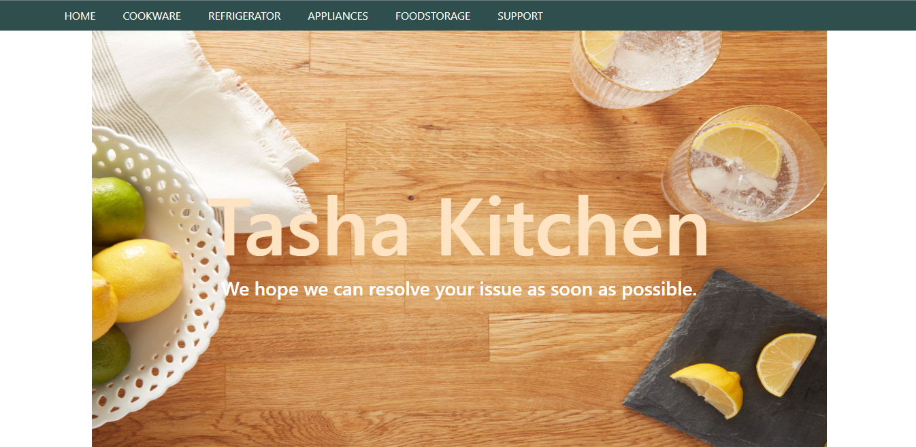

Register Complain

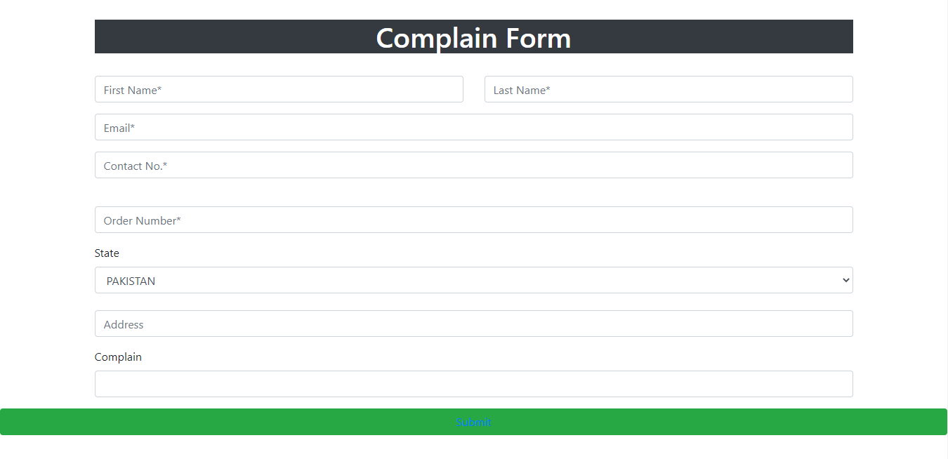

Register Complain

<!doctype html>

Register Complain Code

<html>

<head>

<meta charset="utf-8">

<title>Untitled Document</title>

<!--CSS LINK -->

<link rel="stylesheet" type="text/css" href="../CSS/Tasha.css"/>

<!-- Latest compiled and minified CSS START-->

<link rel="stylesheet" href="https://maxcdn.bootstrapcdn.com/bootstrap/4.5.2/css/bootstrap.min.css">

<!-- Latest compiled and minified CSS END-->

<!-- jQuery library START -->

<script src="https://ajax.googleapis.com/ajax/libs/jquery/3.5.1/jquery.min.js"></script>

<!-- jQuery library END-->

<!-- Popper JS START-->

<script src="https://cdnjs.cloudflare.com/ajax/libs/popper.js/1.16.0/umd/popper.min.js"></script>

<!-- Popper JS END -->

<!-- Latest compiled JavaScript START-->

<script src="https://maxcdn.bootstrapcdn.com/bootstrap/4.5.2/js/bootstrap.min.js"></script>

<!-- Latest compiled JavaScript -->

<!--Meta Link START-->

<meta name="viewport" content="width=device-width, initial-scale=1">

<!--Meta Link END-->

<!--FONT AWESOME CDN LINK-->

<link rel="stylesheet" href="https://pro.fontawesome.com/releases/v5.10.0/css/all.css" integrity="sha384-AYmEC3Yw5cVb3ZcuHtOA93w35dYTsvhLPVnYs9eStHfGJvOvKxVfELGroGkvsg+p" crossorigin="anonymous"/>

<!--FONT AWESOME CDN LINK-->

</head>

<body>

<header>

<ul>

<li><a href="../Tasha.html">HOME</a>

</li>

<li><a href="#">COOKWARE</a>

<ul>

<li><a href="Cooking Pot.html">Cooking Pots</a></li>

<li><a href="Frying Pans.html">Frying Pans</a></li>

<li><a href="Cookware-Sets.html">Cookware Sets</a></li>

<li><a href="Egg Poached.html">Egg Poachers</a></li>

<li><a href="Grill-Pans.html">Grill Pans</a></li>

<li><a href="Steamer.html">Steamers</a></li>

</ul>

</li>

<li><a href="#">REFRIGERATOR</a>

<ul>

<li><a href="Refrigerators.html">Refrigerators</a></li>

<li><a href="Freezers.html">Freezers</a></li>

</ul>

</li>

<li><a href="#">APPLIANCES</a>

<ul>

<li><a href="Blenders.html">Blenders</a></li>

<li><a href="Bread-Maker.html">Bread Makers</a></li>

<li><a href="Coffee-Maker.html">Coffee Makers</a></li>

<li><a href="Icecream-Sorbet-Maker.html">Ice-Cream and Sorbet Makers</a></li>

<li><a href="Kettles.html">Kettles</a></li>

<li><a href="Food-Chopper.html">Food Choppers</a></li>

<li><a href="Toaster.html">Toasters</a></li>

</ul>

</li>

<li><a href="#">FOODSTORAGE</a>

<ul>

<li><a href="Flask.html">Flask</a></li>

<li><a href="Spice-Jars.html">Spice Jars</a></li>

<li><a href="Storage-Bags.html">Storage Bags</a></li>

<li><a href="Lunch-Boxes.html">Lunch Boxes</a></li>

<li><a href="Storage-Containers.html">Storage Containers</a></li>

</ul>

</li>

<li><a href="#">SUPPORT</a>

<ul>

<li><a href="Expert Tips.html">Expert Tips</a></li>

<li><a href="Register-Complain.html">Register Complain</a></li>

<li><a href="Feedback-Form.html">Feed Back</a></li>

<li><a href="Contact Us.html">Contact Us</a></li>

</ul>

</li>

</ul>

</header>

<!--NAVIGATION BAR ENDS-->

<div class="container">

<div class="col-md-12">

<img src="../Images/8.jpg" width="100%" height="650px"/>

<div class="carousel-caption">

<h1 style="margin-top: -400px; font-size: 120px; color:bisque;" >Tasha Kitchen</h1>

<h3>We hope we can resolve your issue as soon as possible. </h3>

</div>

</div>

<br/>

<br/>

<div class="col-md-12">

<h1 class="bg-dark text-white text-center">Complain Form</h1>

<br>

<form>

<div class="row">

<div class="col-md-6">

<input type="text" name="name" placeholder="First Name*" class="form-control form-group" required>

</div>

<div class="col-md-6">

<input type="text" name="name" placeholder="Last Name*" class="form-control form-group" required>

</div>

</div>

<input type="email" name="email" placeholder="Email*" class="form-control form-group" required>

<input type="tel" name="contact no" placeholder="Contact No.*" class="form-control form-group" required>

<br>

<input type="number" name="number" placeholder="Order Number*" class="form-control form-group" required>

<label>State</label>

<select class="form-control" required>

<option>PAKISTAN</option>

<option>UAE</option>

<option>USA</option>

<option>UK</option>

<option>LONDON</option>

<option>CANADA</option>

<option>NEITHERLAND</option>

</select>

<br>

<input type="address" name="Address" placeholder="Address" class="form-control form-group" required>

<label class="form-label">Complain</label>

<input type="text" name="text" class="form-control form-group" required>

</div>

</form>

</div>

<button class="btn btn-success btn-block"><a href="Submitted.html">Submit</a></button>

<br>

<br>

</div>

<!--FORM END-->

<!-- FOOTER STARTS -->

<footer class=" text-black pt-5 pb-4 page-footer" style="background-color: darkslategray;">

<div class="text-center">

<h1 >NEWSLETTER</h1>

<p>Be the first to know about the latest deals, discounts updates & more!</p>

<input type="email" name="email" placeholder="Enter your email here"/>

<button type="submit" onClick="onclick" > Submit </button>

</div>

<br><br>

<div class=" container text-center text-md-left ">

<div class="row text-center text-md-left ">

<div class="col-md-3 col-lg-3 col-xl-3 mx-auto mt-3">

<h5 class="text-uppercase mb-4 font-weight-bold text-warning">TASHA Kitchen-Ware</h5>

<p>TASHA- the home store is Branded Company famous for home kitchen appliances. It provides collection of n number of appliances with different category to match the fast life of the generation. The Tasha group of companies had made huge profit in the year 2013. In order to enhance its business the organization wants you to develop the website.</p>

</div>

<div class="col-md-3 col-lg-3 col-xl-3 mx-auto mt-3" >

<h5 class="text-uppercase mb-4 font-weight-bold text-warning">OFFERS</h5>

<p><a href="#" class="text-black" style="text-decoration: none; color:black; ">Deal of the Day</a></p>

<p><a href="#" class="text-black" style="text-decoration: none;color:black;">Buy 1 Get 1 Free</a></p>

<p><a href="#" class="text-black" style="text-decoration: none;color:black;">Appliance Packages Offers</a></p>

<p ><a href="#" class="text-black" style="text-decoration: none; color:black;">Reward Program</a></p>

</div>

<div class="col-md-4 col-lg-3 col-xl-3 mx-auto mt-3">

<h5 class="text-uppercase mb-4 font-weight-bold text-warning">ADDRESS</h5>

<p>

<i class="fas fa-home mr-3"></i>Plot No. G-21/23, Block-8, Khaliquzzaman Road, Clifton، Block 8 Clifton, Karachi, Karachi City, Sindh 75600

</p>

</div>

</div>

<hr class="mb-4">

<div class="row align-items-center">

<div class="col-md-7 col-lg-8">

<p>copyright all rights reserved by <a href="#" style="text-decoration: none"><strong class="text-warning">The Provider</strong></a></p></div>

<div class="col-md-5 col-lg-4">

<div class="text-center text-md-right">

<ul class="list-unstyled list-inline">

<li class="list-inline-item">

<a href="#" class="btn-floating btn-sm text-black" style="font-size:23px;"><i class="fab fa-facebook"></i></a></li>

<li class="list-inline-item">

<a href="#" class="btn-floating btn-sm text-black" style="font-size:23px;"><i class="fab fa-twitter"></i></a></li>

<li class="list-inline-item">

<a href="#" class="btn-floating btn-sm text-black" style="font-size:23px;"><i class="fab fa-instagram"></i></a></li>

<li class="list-inline-item">

<a href="#" class="btn-floating btn-sm text-black" style="font-size:23px;"><i class="fas fa-link"></i></a></li>

</ul>

</div>

</div>

</div>

</div>

</footer>

<!--FOOTER ENDS-->

</body>

</html>

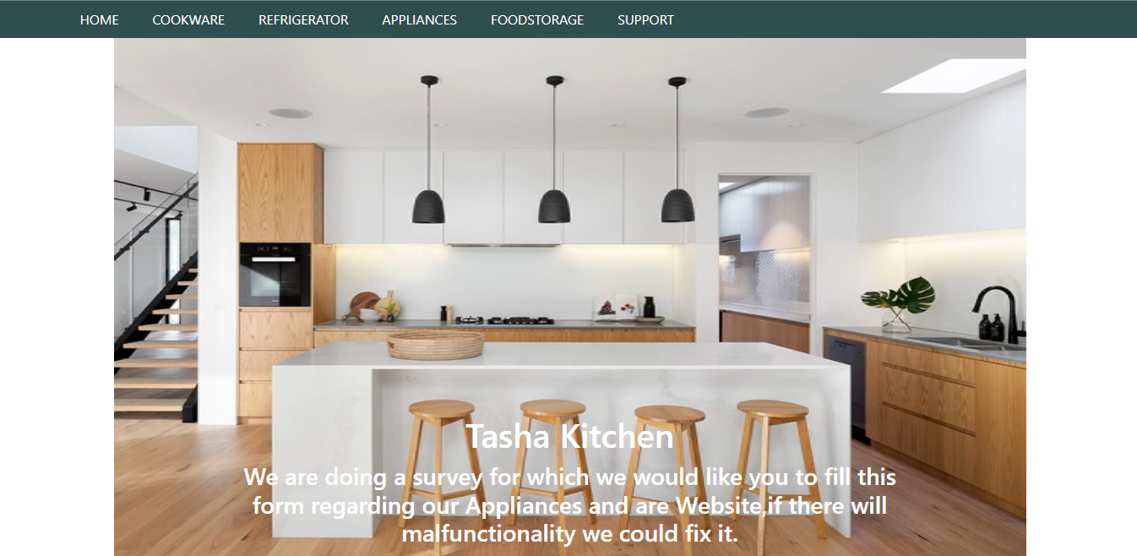

Feedback Form

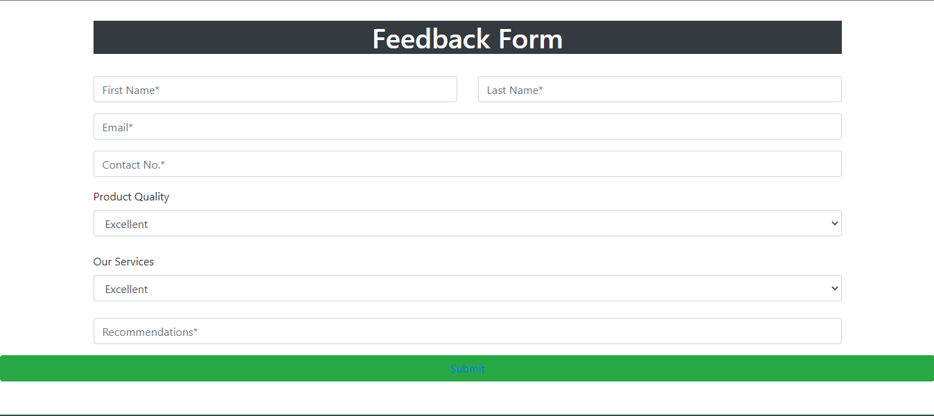

Feedback Form

<!doctype html>

Feedback Form Code

<html>

<head>

<meta charset="utf-8">

<title>Untitled Document</title>

<!--CSS LINK -->

<link rel="stylesheet" type="text/css" href="../CSS/Tasha.css"/>

<!-- Latest compiled and minified CSS START-->

<link rel="stylesheet" href="https://maxcdn.bootstrapcdn.com/bootstrap/4.5.2/css/bootstrap.min.css">

<!-- Latest compiled and minified CSS END-->

<!-- jQuery library START -->

<script src="https://ajax.googleapis.com/ajax/libs/jquery/3.5.1/jquery.min.js"></script>

<!-- jQuery library END-->

<!-- Popper JS START-->

<script src="https://cdnjs.cloudflare.com/ajax/libs/popper.js/1.16.0/umd/popper.min.js"></script>

<!-- Popper JS END -->

<!-- Latest compiled JavaScript START-->

<script src="https://maxcdn.bootstrapcdn.com/bootstrap/4.5.2/js/bootstrap.min.js"></script>

<!-- Latest compiled JavaScript -->

<!--Meta Link START-->

<meta name="viewport" content="width=device-width, initial-scale=1">

<!--Meta Link END-->

<!--FONT AWESOME CDN LINK-->

<link rel="stylesheet" href="https://pro.fontawesome.com/releases/v5.10.0/css/all.css" integrity="sha384-AYmEC3Yw5cVb3ZcuHtOA93w35dYTsvhLPVnYs9eStHfGJvOvKxVfELGroGkvsg+p" crossorigin="anonymous"/>

<!--FONT AWESOME CDN LINK-->

</head>

<body>

<header>

<ul>

<li><a href="../Tasha.html">HOME</a>

</li>

<li><a href="#">COOKWARE</a>

<ul>

<li><a href="Cooking Pot.html">Cooking Pots</a></li>

<li><a href="Frying Pans.html">Frying Pans</a></li>

<li><a href="Cookware-Sets.html">Cookware Sets</a></li>

<li><a href="Egg Poached.html">Egg Poachers</a></li>

<li><a href="Grill-Pans.html">Grill Pans</a></li>

<li><a href="Steamer.html">Steamers</a></li>

</ul>

</li>

<li><a href="#">REFRIGERATOR</a>

<ul>

<li><a href="Refrigerators.html">Refrigerators</a></li>

<li><a href="Freezers.html">Freezers</a></li>

</ul>

</li>

<li><a href="#">APPLIANCES</a>

<ul>

<li><a href="Blenders.html">Blenders</a></li>

<li><a href="Bread-Maker.html">Bread Makers</a></li>

<li><a href="Coffee-Maker.html">Coffee Makers</a></li>

<li><a href="Icecream-Sorbet-Maker.html">Ice-Cream and Sorbet Makers</a></li>

<li><a href="Kettles.html">Kettles</a></li>

<li><a href="Food-Chopper.html">Food Choppers</a></li>

<li><a href="Toaster.html">Toasters</a></li>

</ul>

</li>

<li><a href="#">FOODSTORAGE</a>

<ul>

<li><a href="Flask.html">Flask</a></li>

<li><a href="Spice-Jars.html">Spice Jars</a></li>

<li><a href="Storage-Bags.html">Storage Bags</a></li>

<li><a href="Lunch-Boxes.html">Lunch Boxes</a></li>

<li><a href="Storage-Containers.html">Storage Containers</a></li>

</ul>

</li>

<li><a href="#">SUPPORT</a>

<ul>

<li><a href="Expert Tips.html">Expert Tips</a></li>

<li><a href="Register-Complain.html">Register Complain</a></li>

<li><a href="Feedback-Form.html">Feed Back</a></li>

<li><a href="Contact Us.html">Contact Us</a></li>

</ul>

</li>

</ul>

</header>

<!--NAVIGATION BAR ENDS-->

<!--FORM START-->

<div class="container">

<div class="col-md-12">

<img src="../Images/25.jpg" width="100%" height="650px"/>

<div class="carousel-caption">

<h1>Tasha Kitchen</h1>

<h3>We are doing a survey for which we would like you to fill this form regarding our Appliances and are Website,if there will malfunctionality we could fix it. </h3>

</div>

</div>

<br/>

<br/>

<div class="col-md-12">

<h1 class="bg-dark text-white text-center">Feedback Form</h1>

<br>

<form>

<div class="row">

<div class="col-md-6">

<input type="text" name="name" placeholder="First Name*" class="form-control form-group" required>

</div>

<div class="col-md-6">

<input type="text" name="name" placeholder="Last Name*" class="form-control form-group" required>

</div>

</div>

<input type="email" name="email" placeholder="Email*" class="form-control form-group" required>

<input type="tel" name="contact no" placeholder="Contact No.*" class="form-control form-group" required>

<label>Product Quality</label>

<select class="form-control" required>

<option>Excellent</option>

<option>Good</option>

<option>Bad</option>

<option>Poor</option>

<option>Others</option>

</select>

<br>

<label>Our Services</label>

<select class="form-control" required>

<option>Excellent</option>

<option>Good</option>

<option>Bad</option>

<option>Poor</option>

</select>

<label class="form-label"></label>

<input type="email" name="email" placeholder="Recommendations*" class="form-control form-group" required>

</div>

</form>

</div>

<button class="btn btn-success btn-block"><a href="Submitted.html">Submit</a></button>

<br>

<br>

</div>

<!--FORM END-->

<!-- FOOTER STARTS -->

<footer class=" text-black pt-5 pb-4 page-footer" style="background-color: darkslategray;">

<div class="text-center">

<h1 >NEWSLETTER</h1>

<p>Be the first to know about the latest deals, discounts updates & more!</p>

<input type="email" name="email" placeholder="Enter your email here"/>

<button type="submit" onClick="onclick" > Submit </button>

</div>

<br><br>

<div class=" container text-center text-md-left ">

<div class="row text-center text-md-left ">

<div class="col-md-3 col-lg-3 col-xl-3 mx-auto mt-3">

<h5 class="text-uppercase mb-4 font-weight-bold text-warning">TASHA Kitchen-Ware</h5>

<p>TASHA- the home store is Branded Company famous for home kitchen appliances. It provides collection of n number of appliances with different category to match the fast life of the generation. The Tasha group of companies had made huge profit in the year 2013. In order to enhance its business the organization wants you to develop the website.</p>

</div>

<div class="col-md-3 col-lg-3 col-xl-3 mx-auto mt-3" >

<h5 class="text-uppercase mb-4 font-weight-bold text-warning">OFFERS</h5>

<p><a href="#" class="text-black" style="text-decoration: none; color:black; ">Deal of the Day</a></p>

<p><a href="#" class="text-black" style="text-decoration: none;color:black;">Buy 1 Get 1 Free</a></p>

<p><a href="#" class="text-black" style="text-decoration: none;color:black;">Appliance Packages Offers</a></p>

<p ><a href="#" class="text-black" style="text-decoration: none; color:black;">Reward Program</a></p>

</div>

<div class="col-md-4 col-lg-3 col-xl-3 mx-auto mt-3">

<h5 class="text-uppercase mb-4 font-weight-bold text-warning">ADDRESS</h5>

<p>

<i class="fas fa-home mr-3"></i>Plot No. G-21/23, Block-8, Khaliquzzaman Road, Clifton، Block 8 Clifton, Karachi, Karachi City, Sindh 75600

</p>

</div>

</div>

<hr class="mb-4">

<div class="row align-items-center">

<div class="col-md-7 col-lg-8">

<p>copyright all rights reserved by <a href="#" style="text-decoration: none"><strong class="text-warning">The Provider</strong></a></p></div>

<div class="col-md-5 col-lg-4">

<div class="text-center text-md-right">

<ul class="list-unstyled list-inline">

<li class="list-inline-item">

<a href="#" class="btn-floating btn-sm text-black" style="font-size:23px;"><i class="fab fa-facebook"></i></a></li>

<li class="list-inline-item">

<a href="#" class="btn-floating btn-sm text-black" style="font-size:23px;"><i class="fab fa-twitter"></i></a></li>

<li class="list-inline-item">

<a href="#" class="btn-floating btn-sm text-black" style="font-size:23px;"><i class="fab fa-instagram"></i></a></li>

<li class="list-inline-item">

<a href="#" class="btn-floating btn-sm text-black" style="font-size:23px;"><i class="fas fa-link"></i></a></li>

</ul>

</div>

</div>

</div>

</div>

</footer>

<!--FOOTER ENDS-->

</body>

</html>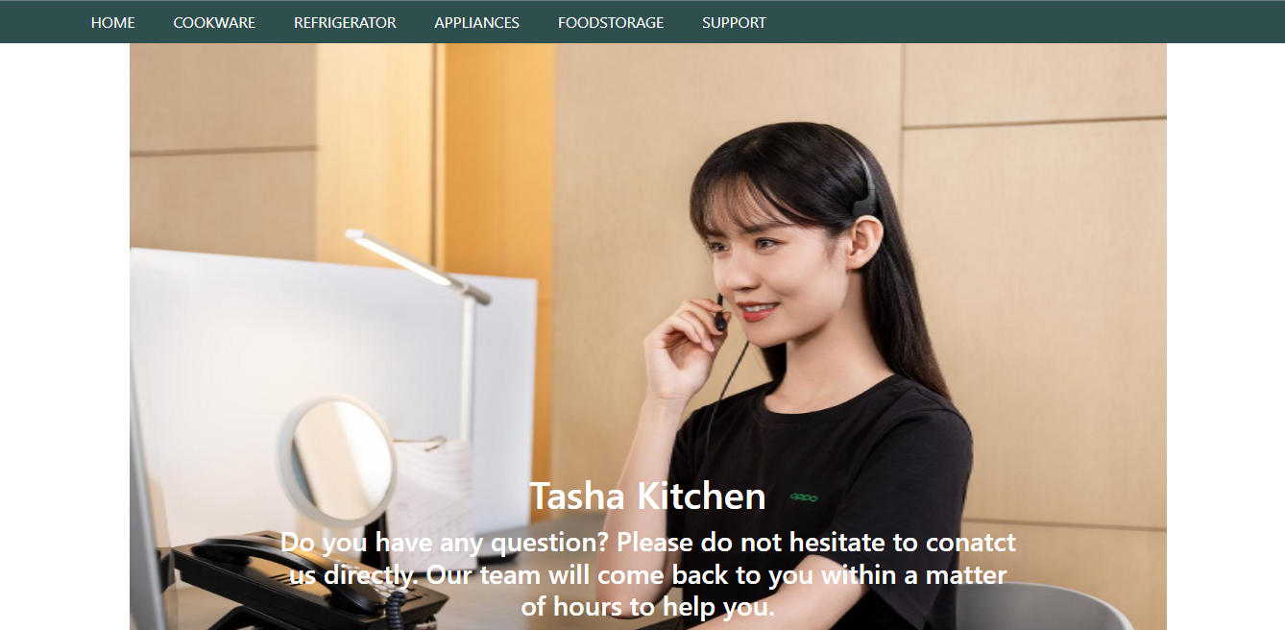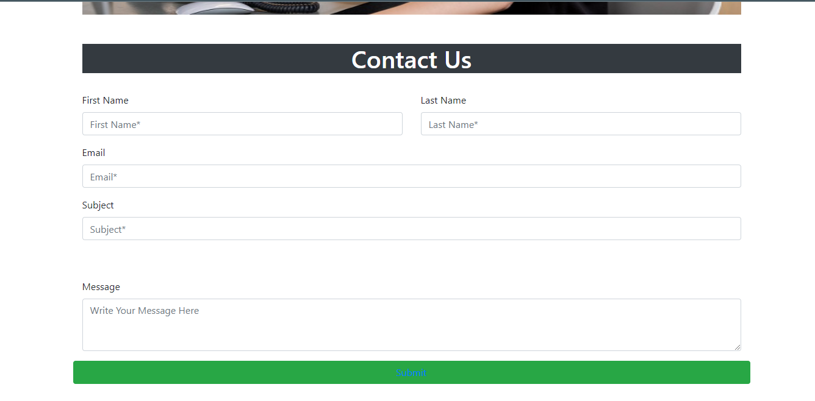

Contact Us

Contact Us

<!doctype html>

Contact Us Code

<html>

<head>

<meta charset="utf-8">

<title>Untitled Document</title>

<!--CSS LINK -->

<link rel="stylesheet" type="text/css" href="../CSS/Tasha.css"/>

<!-- Latest compiled and minified CSS START-->

<link rel="stylesheet" href="https://maxcdn.bootstrapcdn.com/bootstrap/4.5.2/css/bootstrap.min.css">

<!-- Latest compiled and minified CSS END-->

<!-- jQuery library START -->

<script src="https://ajax.googleapis.com/ajax/libs/jquery/3.5.1/jquery.min.js"></script>

<!-- jQuery library END-->

<!-- Popper JS START-->

<script src="https://cdnjs.cloudflare.com/ajax/libs/popper.js/1.16.0/umd/popper.min.js"></script>

<!-- Popper JS END -->

<!-- Latest compiled JavaScript START-->

<script src="https://maxcdn.bootstrapcdn.com/bootstrap/4.5.2/js/bootstrap.min.js"></script>

<!-- Latest compiled JavaScript -->

<!--Meta Link START-->

<meta name="viewport" content="width=device-width, initial-scale=1">

<!--Meta Link END-->

<!--FONT AWESOME CDN LINK-->

<link rel="stylesheet" href="https://pro.fontawesome.com/releases/v5.10.0/css/all.css" integrity="sha384-AYmEC3Yw5cVb3ZcuHtOA93w35dYTsvhLPVnYs9eStHfGJvOvKxVfELGroGkvsg+p" crossorigin="anonymous"/>

<!--FONT AWESOME CDN LINK-->

</head>

<body>

<header>

<ul>

<li><a href="../Tasha.html">HOME</a>

</li>

<li><a href="#">COOKWARE</a>

<ul>

<li><a href="Cooking Pot.html">Cooking Pots</a></li>

<li><a href="Frying Pans.html">Frying Pans</a></li>

<li><a href="Cookware-Sets.html">Cookware Sets</a></li>

<li><a href="Egg Poached.html">Egg Poachers</a></li>

<li><a href="Grill-Pans.html">Grill Pans</a></li>

<li><a href="Steamer.html">Steamers</a></li>

</ul>

</li>

<li><a href="#">REFRIGERATOR</a>

<ul>

<li><a href="Refrigerators.html">Refrigerators</a></li>

<li><a href="Freezers.html">Freezers</a></li>

</ul>

</li>

<li><a href="#">APPLIANCES</a>

<ul>

<li><a href="Blenders.html">Blenders</a></li>

<li><a href="Bread-Maker.html">Bread Makers</a></li>

<li><a href="Coffee-Maker.html">Coffee Makers</a></li>

<li><a href="Icecream-Sorbet-Maker.html">Ice-Cream and Sorbet Makers</a></li>

<li><a href="Kettles.html">Kettles</a></li>

<li><a href="Food-Chopper.html">Food Choppers</a></li>

<li><a href="Toaster.html">Toasters</a></li>

</ul>

</li>

<li><a href="#">FOODSTORAGE</a>

<ul>

<li><a href="Flask.html">Flask</a></li>

<li><a href="Spice-Jars.html">Spice Jars</a></li>

<li><a href="Storage-Bags.html">Storage Bags</a></li>

<li><a href="Lunch-Boxes.html">Lunch Boxes</a></li>

<li><a href="Storage-Containers.html">Storage Containers</a></li>

</ul>

</li>

<li><a href="#">SUPPORT</a>

<ul>

<li><a href="Expert Tips.html">Expert Tips</a></li>

<li><a href="Register-Complain.html">Register Complain</a></li>

<li><a href="Feedback-Form.html">Feed Back</a></li>

<li><a href="Contact Us.html">Contact Us</a></li>

</ul>

</li>

</ul>

</header>

<!--NAVIGATION BAR ENDS-->

<!--FORM START-->

<div class="container">

<div class="col-md-12">

<img src="../Images/27.jpg" width="100%" height="650px"/>

<div class="carousel-caption">

<h1>Tasha Kitchen</h1>

<h3>Do you have any question? Please do not hesitate to conatct us directly. Our team will come back to you within a matter of hours to help you.</h3>

</div>

</div>

<br/>

<br/>

<div class="col-md-12">

<h1 class="bg-dark text-white text-center">Contact Us</h1>

<br>

<form>

<div class="row">

<div class="col-md-6">

<label class="form-label">First Name</label>

<input type="text" name="name" placeholder="First Name*" class="form-control form-group" required>

</div>

<div class="col-md-6">

<label class="form-label">Last Name</label>

<input type="text" name="name" placeholder="Last Name*" class="form-control form-group" required>

</div>

</div>

<label class="form-label">Email</label>

<input type="email" name="email" placeholder="Email*" class="form-control form-group" required>

<label class="form-label">Subject</label>

<input type="tel" name="contact no." placeholder="Subject*" class="form-control form-group" required>

<br>

<br>

<div class=" mb-3">

<label class="form-label">Message</label>

<textarea name="" class="form-control" rows="3" placeholder="Write Your Message Here " required></textarea>

</div>

</div>

<button class="btn btn-success btn-block"><a href="Submitted.html">Submit</a></button>

<br>

<br>

</div>

</form>

<!--FORM END-->

<!-- FOOTER STARTS -->

<footer class=" text-black pt-5 pb-4 " style="background-color: darkslategray;">

<div class=" container text-center text-md-left ">

<div class="row text-center text-md-left ">

<div class="col-md-3 col-lg-3 col-xl-3 mx-auto mt-3">

<h5 class="text-uppercase mb-4 font-weight-bold text-warning">TASHA Kitchen-Ware</h5>

<p>TASHA- the home store is Branded Company famous for home kitchen appliances. It provides collection of n number of appliances with different category to match the fast life of the generation. The Tasha group of companies had made huge profit in the year 2013. In order to enhance its business the organization wants you to develop the website.</p>

</div>

<div class="col-md-3 col-lg-3 col-xl-3 mx-auto mt-3" >

<h5 class="text-uppercase mb-4 font-weight-bold text-warning">OFFERS</h5>

<p><a href="#" class="text-black" style="text-decoration: none; color:black; ">Deal of the Day</a></p>

<p><a href="#" class="text-black" style="text-decoration: none;color:black;">Buy 1 Get 1 Free</a></p>

<p><a href="#" class="text-black" style="text-decoration: none;color:black;">Appliance Packages Offers</a></p>

<p ><a href="#" class="text-black" style="text-decoration: none; color:black;">Reward Program</a></p>

</div>

<div class="col-md-4 col-lg-3 col-xl-3 mx-auto mt-3">

<h5 class="text-uppercase mb-4 font-weight-bold text-warning">ADDRESS</h5>

<p>

<i class="fas fa-home mr-3"></i>Plot No. G-21/23, Block-8, Khaliquzzaman Road, Clifton، Block 8 Clifton, Karachi, Karachi City, Sindh 75600

</p>

</div>

</div>

<hr class="mb-4">

<div class="row align-items-center">

<div class="col-md-7 col-lg-8">

<p>copyright all rights reserved by <a href="#" style="text-decoration: none"><strong class="text-warning">The Provider</strong></a></p></div>

<div class="col-md-5 col-lg-4">

<div class="text-center text-md-right">

<ul class="list-unstyled list-inline">

<li class="list-inline-item">

<a href="#" class="btn-floating btn-sm text-black" style="font-size:23px;"><i class="fab fa-facebook"></i></a></li>

<li class="list-inline-item">

<a href="#" class="btn-floating btn-sm text-black" style="font-size:23px;"><i class="fab fa-twitter"></i></a></li>

<li class="list-inline-item">

<a href="#" class="btn-floating btn-sm text-black" style="font-size:23px;"><i class="fab fa-instagram"></i></a></li>

<li class="list-inline-item">

<a href="#" class="btn-floating btn-sm text-black" style="font-size:23px;"><i class="fas fa-link"></i></a></li>

</ul>

</div>

</div>

</div>

</div>

</footer>

<!--FOOTER ENDS-->

</body>

</html>